John A. Sutter Chapter #1841

Charter Doins Board Meeting Agenda, Meeting Date: 06JAN14

Call to Order: s/b at or about 6:30pm

Roll Call of Board Members:
P = Present, A = Absent, X = Xcused absence
___ NGH Russell "Christ" Holder
___ VNGH Gary “Everready” Karl
___ GNR Bob Farrell
___ GDR Dean Hupp
___ Hangman Kevin "Stinky" Jenkins
___ Damn Fool Doorkeeper Paul "Sparks" Laue
___ Board Member at Large Fred "Mr Magoo" Willcox
___ Board Member at Large David "Dave the dick" Andre
___ Board Member at Large Kieth "Hardshell" Kinne
___ Graybeard Gary “Everready” Karl
___ Graybeard Mike “Gunshot” Young
___ Clampatriarch Bob "Iron Horse" Stevenson

Charter Doins Committes’ Co-Humbugs:
- Mike “Gunshot” Young
- Bob “Ironhorse” Stevenson
- Russell “Christ” Holder

Charter Doins Committes - Mike "Gunshot" Young:

1) Facilities, Chairman: Mike "Gunshot" Young . . . . . backup: Bob Farrell
2) Grounds, Chairman: Gary "Everready" Karl . . . . . . backup: Dean Hupp
3) Signage, Chairman: Kevin "Stinky" Jenkins . . . . . backup: Keith Kinne
4) Entertainment, Chairman: Mike “Gunshot” Young . . . backup: Bob Farrell
5) Libation, Chairman: Dean Hupp . . . . . . . . . . . backup: Gary Karl

Charter Doins Committes - Bob “Ironhorse” Stevenson:
6) Food/Cook, Chairman: Dean "Mr.Clean" Hupp . . . . . backup: Gary Karl
7) Plaque, Chairman: Kevin Jenkins . . . . . . . . . . backup: Keith Kinne
8) Initiation, Chairman: Kevin "Stinky" Jenkins . . . backup: Paul Laue
9) Hawker, Chairman: Gary Karl . . . . . . . . . . . . backup: Dean Hupp
10) Raffle, Chairman: Kieth Kinne . . . . . . . . . . . backup: Gary Klinke*

Charter Doins Committes - Russell "Christ" Holder:
11) Location, Chairman: Russell "Christ" Holder . . . backup: Bob Farrell
12) Sign-In, Chairman: Dean Hupp . . . . . . . . . . . backup: Gary Karl
13) Charter Doins T-Shirts, Chairman: Bob Farrell . . . backup: Dean Hupp
14) Security, Chairman: Paul Laue . . . . . . . . . . . backup: Fred Wilcox
15) Publication, Chairman: Russell "Christ" Holder . . backup: Bob Farrell
16) Closing Ceremony/Wrap-up Committee, Chairman Russell "Christ" Holder

* redo: Gary Klinke is not a board member, therefore not a committee chairman
***Fred, can we put you down as Keith’s backup?...

NOTE: some folks have volunteered to work in several areas, e.g., Fred Willcox volunteered to help where ever he is needed (Sign-in Table, Door Keeper assistance, Hawker, Raffle assistance, Hangman assistance, Cooking Crew assistance, etc.); consideration s/b given to over use/schedualing conflicts (cannot be in 2 places at one time).

QUESTION: WHAT ARE WE DOING TO MAKE THIS CHARTER DOINS “OFF-THE-HOOK” ?

Charter Doins Board Meeting Agenda Continued, Meeting Date: 06JAN14

Charter Doins Committee Reports - Mike "Gunshot" Young:

REPORT “1” – Facilities
Chairman: Mike "Gunshot" Young?
Committee Member(s): Walter Hales? Bob Farrell _____? _____?

- REVIEW EACH OF THE FOLLOWING & estimate date of completion...
- _______: (next)committee meeting...
- DONE __: Pavillion exists at chosen location...
- DONE___: On-site/off-site refrigeration In regards to this item we will consider getting a refrigeration unit other then the beer wagon
- DONE___: commercial grade refer unit; Mike Young will provide and we will use the beer truck for frozen foods; keys will be held by Gary Karl and Dean Hupp
- _______: need 5 canopys (for... .)
- DONE __: tent 2 ea 10X20 (in case of rain); Mike Young
- DONE __: tent 1 ea 8X8 for the beer wagon (in case of rain); Paul Laue
- DONE __: tent 1 ea 8X6 for the kitchen area (in case of rain); Gary Karl
- DONE __: pop up 3 ea 10X10; Mike Young, on an needed basis.
- DONE __: tables 2 ea 8’ for registration; Mike Young
- DONE __: tables 2 ea 8’ for raffle; Mike Young
- DONE __: tables 4 ea 6’ for cook shack; Mike Young
- _______: tables some???; Gary Karl
- _______: chairs
- _______: determine what cook gear will be needed (Dean Hupp and Gary Karl)
- _______: 1841 BBQ
- _______: IOOF BBQ (Mike young, talk to son IOOF ???)
- _______: Cosumes FD BBQ on trailer (Gary Karl, talk to son Bill ???)
- DONE __: 2-burner stove (Gary)
- _______: 2-burner stove (YB1, Floyd ???)
- _______: 2-burner stove (49 cook gear ???)
- _______: locate LPG supplyer in area that is open on Saturday.
- _______: cook gear (Chewey ???)
- DONE___: electric power is available at the site
- DONE __: generator(s)? Mike Young has a 15 K generator and a 3.5 K generator
- DONE __: power turned off to the RV spots (so we will have ample power for the kitchen and cook crew area); Mike Young
- DONE __: Electric job box; Mike Young
- DONE __: lighting (popups and strings); Mike Young
- DONE __: power to the beer truck; Mike Young
- DONE __: power for the band; Mike Young
- _______: stage of some sort for the band; Mike Young
- _______: consider chalk machine or bag(s) of lime/flour for parking lines
- DONE __: warsh tubs; Mike Young
- Note We will not need any special permits for the Doin’s. We can serve beer at no charge without a letter from the YMCA. We can have a band as long as they are done by 10 PM and are not obnoxious (Gangster Rap) This information is from Athena at the YMCA and Kelley Hutchinson Director with the YMCA is in concurrence.
Charter Doins Board Meeting Agenda Continued, Meeting Date: 06JAN14

Charter Doins Committee Reports - Mike "Gunshot" Young, continued:

REPORT “2” – Grounds
Chairman: Gary "Everready" Karl
Committee Member(s): Kevin Jenkins, Dean Hupp _____? _____?

- REVIEW EACH OF THE FOLLOWING & estimate date of completion...
- _______: (next)committee meeting...
- Dumpster from Ramona at Waste Management; GaryK
  - Dumpster will be dropped off on Friday morning & picked up Sunday morning
  - DONE __: $_$214.71_+$35.00 if over 2 tons
  - DONE __: drop-off: __3_ APR14
  - DONE __: pick-up: 6,7 APR14, location: outside gate_
  - DONE __: any drop-off/pick-up coordination btwn Dumpster & YMCA? NO
  - _______: Pay by: ________
- PortaPot from Mark @ Yolo Pumping Service; GaryK
  - DONE __: $_110+tax_ ea, wash stands are $80 each.
  - DONE __: quantity: _7 or 8, probably 6 porta pottys and 2 warsh stations How many do we need?
  - DONE __: drop-off: _3_APR14
  - DONE __: pick-up: 6_APR14
  - _______: location(s): ___
  - DONE __: any drop-off/pick-up coordination btwn PPotty & YMCA?.We can call for a gate opening by contacting Steve Miller at 530-383-2560. We will need to make advanced notice with Steve so he can be on site to open up.
  - _______: Pay by: ________
- Trash Cleanup
  - Paul Laue will be in charge of clean up
  - PBC’s (only through HOCO; through Sunday morning by PaulL’s crew)
- Latrine Cleanup
  - Paul Laue will be in charge of clean up
  - PBC’s we can ask PBC’s if they will help with the clean up on Sunday morning
- DONE __: pipe for creating the PBC area; Mike Young
- DONE __: caution tape for marking the PBC area; Mike Young
- DONE __: caution tape for parking guidelines; Mike Young
- DONE __: cones; Mike Young
- Note: We can make arrangements for Dumpster and Porta Potty pick up after the doin’s. The contractors can call the YMCA at 530-383-2560 and make arrangements for pick up after 1PM on a given day (Monday or Tuesday would be best)
- Note: We can call for a ground inspection by contacting Steve Miller at 530-383-2560. We will need to make advanced notice with Steve so he can be on site to open up for us.

Charter Doins Board Meeting Agenda Continued, Meeting Date: 06JAN14

Charter Doins Committee Reports - Mike "Gunshot" Young, continued:

REPORT “3” – Signage
Chairman: Kevin "Stinky" Jenkins
Committee Member(s): BobF, ___Keith Kinne__? _____? _____?

- oops... forgot who, KevinJ or BobF, said they would make needed signs...

- REVIEW EACH OF THE FOLLOWING & estimate date of completion...
- ______: (next)committee meeting...
- __2___: Freeway exit sign, descdription: _1 from North, 1 from South_
  - ______: status: started? In progress? Completed?
- ______: 1st turn, descdription: _____________________________________
- ______: Grounds entrance, descdription: _____________________________
- Note: PBC maintenance and removal of signs

Charter Doins Board Meeting Agenda Continued, Meeting Date: 06JAN14

Charter Doins Committee Reports - Mike "Gunshot" Young, continued:

REPORT “4” – Entertainment
Chairman: Mike “Gunshot” Young?
Committee Member(s): Rusl Holder, Kevin Jenkins, _____?

- REVIEW EACH OF THE FOLLOWING & estimate date of completion...
- ATTENTION: ON FLYER “THIS IS A RED-SHIRT EVENT, NO CITIZENS ALLOWED!”
- ______: (next)committee meeting...
- DONE__: Rubber Band: booked for a 4 hour set on Friday Saturday; will have two sets, one 2 hour set on Saturday afternoon before the HOCO and the other on Saturday evening after Chow, but not during the HOCO.
- DONE__: need to know of any noise ordinances. There are no ordinaces. We can have a band as long as they are done by 10 PM
- ______: Other Band: 12NOV13: Haven't looked into
- ______: Lonnie Rueb & friend: 12NOV13: Need to discuss further with Gary
- ______: PA system:
  - 12NOV13: PA not practical from layout stand point, look into;
  - 09DEC13: need to look at speaker placement w/cables that won’t interfere w/walking & vehicle traffic
- DONE__: bull horn: 12NOV13: Have a bull horn
- ______: The “Mystery Tent” :
  - 12NOV13: Need input here as to what it will entail to determine if it will be present
    - Cat house (red lite inside w/used panites), TicTacToe chicken,...
  - 09DEC13: tabled in absence of feedback
- ______: Hot Rod and MC show:
  - 12NOV13/09DEC13: This will attract too many non-redshirts to a Red shirt event... NO; LET US RE-CONSIDER... SEE “ATTENTION” ABOVE...
- ______: Woodland Truck & Tractor Museum tour:
  - 12NOV13: need to get information & pricing as well as travel arrangements worked out, this can't be finalized until after we see what the draw will be.
  - 09DEC13: may be dedicating a plaque
- ______: 2 sets Horse shoes:
  - 12NOV13: Have 1 set available, Mike Young
  - 12NOV13: the other set from...???
- ______: Karaoke: 12NOV13: Good idea, need to know if noise will be a factor and if anyone has a machine.
- ______: Talent contest: 12NOV13: tabled, Red shirts and talent.... not in the same sentence or same location.
- ______: Other...

Charter Doins Board Meeting Agenda Continued, Meeting Date: 06JAN14

Charter Doins Committee Reports - Mike "Gunshot" Young, continued:

REPORT “5” – Libation
Chairman: Dean Hupp
Committee Member(s): GaryK, PaulL (beer selection)

- REVIEW EACH OF THE FOLLOWING & estimate date of completion...
- _______: (next)committee meeting...
- we serving? Keg beer, liquor, sodas, water
- ____ - keg cooling
- Beer Truck:
  - Dean Hupp will report best options for the beer wagon by the December meeting and we will need to make a final decision by the Jan meeting
  - ______: #___ kegs
  - ______: $___ /keg; $___ TOTAL
  - __OK__: drop-off: _3__APR14
  - __OK__: pick-up: 6__APR14
  - __OK__: location(s): on side of road by power pole by pavilion
  - __OK__: any drop-off/pick-up coordination btwn beerTruck & YMCA?
  - Note: We do not need a letter from the YMCA to serve Beer at no charge. Also if they can not pick up the beer wagon on the 6th of Apr we can have the provider call the YMCA at 530-662-1086 and arrange for a pick up after 1PM on the 7th
  - Note: may need letter from the YMCA for the Budweiser distributor, “D.Santoni”
  - Beer trailer lockup: Gary & Dean will control keys to beer supply and distribution.
  - Dispensing/distribution: NO SELF SERVE; Paul Laue will be in charge of assigning beer servers.
  - Sinage: Paul Laue will post signs in & on the trailer w/hours of operation & “NO SELF SERVE”
.
Charter Doins Board Meeting Agenda Continued, Meeting Date: 06JAN14

Charter Doins Committee Reports - Bob “Ironhorse” Stevenson:

REPORT “6” – Food/Cook
Chairman: Dean "Mr.Clean" Hupp
Committee Member(s): Gary Karl, Bob Farrell, Ben Peccaianti, _____? _____?

- REVIEW EACH OF THE FOLLOWING & estimate date of completion...
- ______: (next)committee meeting...
- Free hat for all kitchen staff volunteers
- The menu so far has nothing in concrete.
  - see attachment “A”
- ______: Kitchen Patrol
  - _____: How many people are needed on the cook crew?
  - 1841
    - Gary Karl
    - Gary’s son Bill
    - Bob Farrell
    - Dean Hupp
    - Ben Peccaianti
    - Jerry Martin [new dude from fall doins]
    - New PBC from Dean - yes
    - New PBC from Dean - yes
    - Mike Young will help cooking the steaks
    - Fred Willcox
  - Gary Karl will arrange for help from other Chapters.
  - YB1
    - Floyd
    - Iggy – who else?
  - #49
    - Chewy
    - Toro We might be able to use Toro and Mat at the sign-in table
    - Matt
  - __11__: people on the cook crew... so far...
- Note We should consider getting large aluminum trays for holding the cooked steaks salad and beans and other meal items that will be served during the Doin’s
Charter Doins Board Meeting Agenda Continued, Meeting Date: 06JAN14

Charter Doins Committee Reports - Bob “Ironhorse” Stevenson:

REPORT “7” – Plaque
Chairman: Kevin "Stinky" Jenkins
Committee Member(s): Bob Farrell, _____? _____?

- REVIEW EACH OF THE FOLLOWING & estimate date of completion...
- ______: (next)committee meeting...
- ______: Grounds - - - - – progress on this: __NOT________________
- ______: Tractor Museum – - progress on this: _____________________
- ______: Gibson House - – - progress on this: _____________________
- ______: Jackson building – progress on this: _____________________
- ______: W.Sac VFW Hall – progress on this: _____________________
- ______: Other - - - - - – progress on this: _____________________
- Note: We are now in contact with Dave Flory, Executive director for the Gibson house and the Yolo County Historical Society and hope to get some good plaque site suggestions and help from him.
- Note: We should prepare a handout on the history the plaque is commemorating.

Charter Doins Board Meeting Agenda Continued, Meeting Date: 06JAN14

Charter Doins Committee Reports - Bob “Ironhorse” Stevenson, continued:

REPORT “8” – Initiation
Chairman: Kevin "Stinky" Jenkins
Committee Member(s): Rusl Holder, Gary Karl, Bob Farrell, _____?

- REVIEW EACH OF THE FOLLOWING & estimate date of completion...
- ______: (next)committee meeting...
- white coats will be labeled “REGULATOR”...
- _____: How many people are needed for “REGULATORS” ?
- ______: From where:
  - ______: Help from 1841:
    - Kevin Jenkins
    - Fred Willcox
    - Mark Jenkins
    - ______?
    - _____?
  - ______: Help from YB1:
    - _____?
    - _____?
  - ______: Help from #49:
    - ______?
    - _____?
  - ______: Help from LSD3:
    - BlueCrow?
    - ______?
    - _____?
- __4?__: REGULATORS... so far...
- Free hat for all volunteers
- We want 7 stations
  - Mining area: artifact ID
  - Mining area: gold panning
  - Mining area: rocky road to Dublin
  - ______: Bowling ball station from LSD3?
  - ______: other(?) station from YB1?
  - ______: other(?) station from 49?
  - ______: ass kicking station, stamp mill, other station ideas...
  - ______: plunger between the legs with roll of toilet paper...
  - ______: Bob’s boards
  - ______: Wabbit...
  - ______: Electric Chair...
  - ______: Panty hose & grapefruit...
  - ______: miner’s lunch of beans/beans/beans w/o flatware...
- Work projects:
  - Weeding
  - Cleaning
  - depending on site...
- Work details:
  - latrine duty
  - trash/garbage
  - announcements
  - dinner bell
  - what else?
- Golden Notes and E Clampus Vitus Now and Then hand outs for PBC's

Charter Doins Board Meeting Agenda Continued, Meeting Date: 06JAN14

Charter Doins Committee Reports - Bob “Ironhorse” Stevenson, continued:

REPORT “8” – Initiation ~ CONTINUED

- ______: HOCO Black Robes – Gary Karl will provide the robes
  - RH: I would be game for black OR red "robes" - found something like red cheese cloth at the new Hoby Loby by Petco in Coco's parking lot across from Arden Mall;sample looks sparse, but, would add a red color, and would BREATHE on hot days: NO

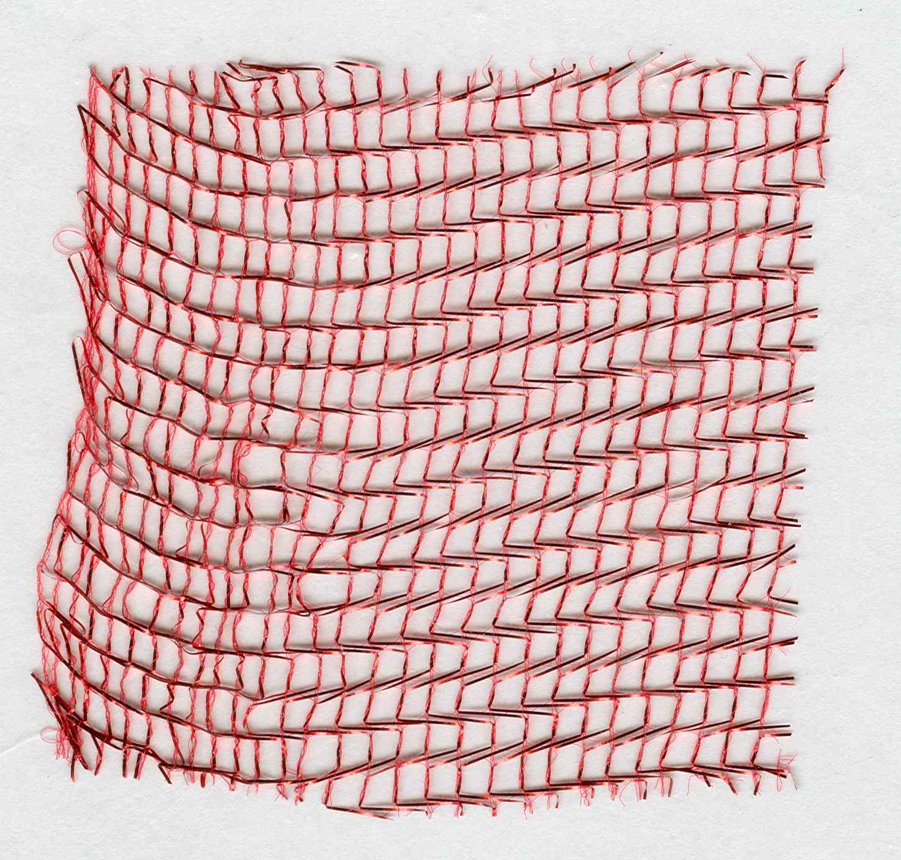
- HOCO readers (assignments by the NGH):
- ******** REDO to include Iggy, Suds, Moose *********
- *** Gene “Dickhead” Dunker from Peter LeBeck ??? ***
- - HUMBUG: The Noble Grand Humbug - Christ
- - CLAMPAT: The Clampatriarch - Ironhorse
- - RECORDER: The Grand Noble Recorder - Popeye - Iggy*
- - HANGMAN: The Grand Imperturbable Hangman - Stinky
- - MUSICIAN: The Grand Musician - Klinky
- - ISCUTIS: The Roisterous Iscutis - Sparks
- - PLATRIX: The Royal Platrix - Mr.Clean – Dan McCarthy - Suds* (will you...)
- - PETRIX: The Clamps Petrix - Dave-the-Dick (Humbugery)
- - MATRIX: The Clamps Matrix - Mr.Magoo (widows yet unwon)
- - VITRIX: The Clamps Vitrix - Dave Barnett - Moose* (Californification)
- emailed 23NOV13 ~ all are willing!!!
Charter Doins Board Meeting Agenda Continued, Meeting Date: 06JAN14

Charter Doins Committee Reports - Bob “Ironhorse” Stevenson:

REPORT “9” – Hawker
Chairman: Dean Hupp
Committee Members: Gary Karl, "Bare", Gary "Colonel Klink" Klinke, Jack Vinsant

- REVIEW EACH OF THE FOLLOWING & estimate date of completion...
- ______: (next)committee meeting...
- ______: Help from 1841: Bare,Gary Klinke,Jack Vinsant,Fred Willcox,_____?
- Fort Sutter books:
  - _DONE_: 100 by 15NOV13, _$300_ who picks them up? Gary Karl has picked up 100 books at a cost of $3 each. For a total of $300
  - ______: how many more? _____ picked up by who? ____ when? ____
- ______: Need 3 tables: 1 for hawker, 2 for raffle items (better be 20’ tables)
- ______: T-shirts... which ones? How many?
- ______: Pin-of-the-day... how many?... Stinky?
- ______: Hats..
- ______: What else for Bare?
- ______: Long sleeve red shirts
- ______: Contact Bare?
- ______: Big Ticket Item Raffle Tickets for sale at Hawker’s Table (see description under “Raffle”...

Charter Doins Board Meeting Agenda Continued, Meeting Date: 06JAN14

Charter Doins Committee Reports - Bob “Ironhorse” Stevenson, continued:

REPORT “10” – Raffle
Chairman: Kieth Kinne
Committee Members: Gary "Colonel Klink" Klinke, _____?, _____?

- REVIEW EACH OF THE FOLLOWING & estimate date of completion...
- _______: (next)committee meeting...
- Help from 1841: Gary Klinke, Fred Willcox, _____?
- ______: budget for the raffle
- ITEMs for the raffle:
  - Laptop computer
  - Notebook computer
  - Apple V
  - 19” TVs
  - 40: TV
  - Fold up camp kitchen
  - ...
  - ...
  - ...
  - ...
  - ...
  - ...
  - ...
  - ...
  - ...
- Tattoo vouchers from Tattoo Inc., Precision Ink, Sunset Design, ...
  - Rusl – contact these tattoo parlors!!!
- (Promotional) donations from local businesses ...
  - ...
  - ...
  - ...
  - ...
  - ...
  - ...
  - ...
- What BIG TICKET ITEM(S) for the raffle?
  - ...
  - ...
  - ...
  - ECV # 1841 Raffle/Drawing: $170 for the pistol (Model 1851 Confederate Navy .44 Caliber, 13-1/4” overall) and $30 for the knife (the Colt Stone Mountain, 15-1/8" overall):
.,
.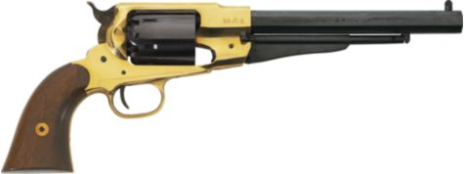 ..
.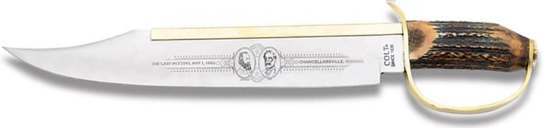

Charter Doins Board Meeting Agenda Continued, Meeting Date: 06JAN14

Charter Doins Committee Reports - Russell "Christ" Holder:

REPORT “11” – Location
Chairman: NGH (Russell "Christ" Holder)
Committee Member(s): Gary Karl, Bob Farrell, Dean Hupp

- REVIEW EACH OF THE FOLLOWING & estimate date of completion...
- ______: (next)committee meeting...
- DONE__: Location is reserved for Thu,...,Sun, 03,...,06APR14
- Location contact information, viz., YMCA Representative's contact information:
  - name name:Kelley Hutchinson
  - title: ???
  - address:Yolo County YMCA 1300 College St. Woodland Ca 95695
  - phone:530-662-6423
  - email: khutchison@ymcasuperiorcal.org
- Location deposit is paid for, deposit of $400 paid to YMCA
  - 06JUN13: Bob Farrell paid $400.00 to the YMCA
  - 17JUN13: Dean paid Bob Farrell $400.00 for reimbursement of deposit, check # T002
- Location rental fee remaining is $1000
  - 13NOV13/Popeye: due 60 days prior to use, FEB 1ST 2013
  - payable to YMCA
  - ______: [who] Dean and BobF will pay on this date
- Provide Insurance Form, due by ddmmmyy: ______
  - 29OCT13: Certificate done
  - _______: date to send to:Board Members
  - _DONE _: date due to YMCA, already done by Dean and BobF
- Provide Alcohol Form, due by ddmmmyy: ______
  - Dean is going to handle this:
  - 12NOV13: Dean will be collecting more info at the [15NOV13] meeting as to what we are actually serving to know what type of permit we need
  - ______: let whom ever know we will need a letter from the YMCA allowing us to serve liquor on the site
  - ______: At that time they (ABC) will let me know if we need county approval.
- Other permits:
  - 13NOV13/Popeye: check w/YMCA and see if they know of anything
  - 13NOV13/Popeye: Also we could check with the YOLO County folks
  - 13NOV13/Popeye: leave the pot undisturbed and just go with it
  - Ignorance is no excuse for the law.
- Flyer info: traveling north on I-5 take Exit 538, 113 North to Yuba City then turn north on N East St, then take 1st left on Coil Road & follow ECV signs
- Flyer ifto: traveling south on I-5 take Exit 538, ______________________ then turn north on N East St, then 1st left on Coil Road & follow ECV signs
- Done: GaryK & BobF visit director to Make the only valid contacts for any changes. The contacts are Russell Holder, Gary Karl, and Bob Farrell
  - On Nov 18th Bob Farrell visited the YMCA and set the valid contacts with the YMCA. Also The YMCA said that we will need no other permits, we can serve beer at no charge,(do not need a letter from the YMCA), and that we can have a band. This information came from Athena at the YMCA. Also Kelley Hutchinson the Director for the YMCA is in agreement with this information.

Charter Doins Board Meeting Agenda Continued, Meeting Date: 06JAN14

Charter Doins Committee Reports - Russell "Christ" Holder, continued:

REPORT “12” – Sign-In
Chairman: Dean Hupp
Committee Member(s): Holder, Dan McCarthy, Gene Breeland, BobS, BobF

- REVIEW EACH OF THE FOLLOWING & estimate date of completion...
- 12NOV13: Dean: No committee meeting as of yet.
- _______: (next)committee meeting...
- _DONE_: attendance limit? Yes/no; yes, what? _400__
- ______: Release of Liability forms Dean Hupp says they will have all the forms and they will have to be filled out completely
  - Review by date: _________
  - Approve by date: _________
  - Include with flyer
  - Print for on-hand at sign-in table
    - How many? _________
    - By date: _________
- ______: RSVP processing (this needs to be a single person): _Dean Hupp?_
- Pre-Pay package coantents:
  - check list of options attendee wants (shirt, pin, etc.)
  - schedule of events
  - local MOTEL locations and contact info
  - Wrist band
  - T-Shirt (or voucher for XXX)
  - Sheepskin & Traveling Card
  - Charter doins pin
  - Meal tickets or punch stubs of some kind
  - RV dump station at the KOA in West Sacramento ---- ? Charge?
  - ...
  - ...
- day of package contents:
  - check list of options attendee wants (shirt, pin, etc.)
  - schedule of events
  - local MOTEL locations and contact info
  - Wrist band
  - Meal tickets or punch stubs of some kind
  - RV dump station at the KOA in West Sacramento ---- ? Charge?
  - ...
  - ...
- _____: How many people are needed for Sign-in table attendants?
  - ______: Help from 1841:
    - Keith Kinne: chk travl card, release of liability, registration form
    - DeanH: review day-of forms, rcv payment, issue wrist bands
    - GeneB: A-M packets, review legibility
    - WalterHales: N-Z packets, review legibility
    - FredW: PBC registration
    - LonnieR: review legibility
    - _______?
  - ______: Help from YB1? Contact for more help by date: ____________
    - ______?
    - ______?
    - ______?
  - ______: Help from 49? Contact for more help by date: ____________
    - Matt (***Rusl – contact)
    - Toro (***Rusl – contact)
    - ______?

Charter Doins Board Meeting Agenda Continued, Meeting Date: 06JAN14

Charter Doins Committee Reports - Russell "Christ" Holder, continued:

REPORT “12” – Sign-In, continued...

  - ______: Help from other? Yes/no;
    - ______?
    - ______?
    - ______?
  - __8___: Sign-in table attendants... so far...
- ______: Sign-In hours of operation:
  - Prime Time: Thurs[...],Fri[...],Sat[...],Sun[...]
  - Off Hours: Thurs[...],Fri[...],Sat[...],Sun[...]
- ______: Number of staff at sign-in tables
  - prime time: [...]
  - off hours: [...]
- ______: Wrist bands... different for red-shirts vs. PBCs...
  - Dean Hupp: Neon Green wrist bands for PBC’s, Red wrist bands for Red shirts
  - ______: Review catalog & pick color(s)
  - ______: purchase
- Meal tickets or punch stubs of some kind – print and put in packets.
  - Bob Farrell: Maybe one meal ticket with all meals printed on them and we can punch out the meal as they are served. If they miss a meal, too bad, no revisiting that meal.
- ______: Red-tag info: Health problems, Allergies, etc... of attendees...
  - what all do we need to know? Where will we record it? How will be act on it?
- DONE__: first aid kit (in kitchen stuff); GaryK
- ______: MEDIC: Moose, Stix (911) – contact them
Charter Doins Board Meeting Agenda Continued, Meeting Date: 06JAN14

Charter Doins Committee Reports - Russell "Christ" Holder:

REPORT “13” – Charter Doins T-Shirts / Hats
Chairman: Chairman: Bob Farrell
Committee Member(s): Holder, GaryK, Dean Hupp

- REVIEW EACH OF THE FOLLOWING & estimate date of completion...
- 12NOV13:Dean: Gary Karl will report at [15NOV13] meeting
- _______: (next)committee meeting...
- What t-shirt ideas are there? - see attachment “K”
- Dean Hupp: We should have suggested Tee shirt designs for the December meeting and get a final approval at the Jan meeting.
- ______: Who is our new T-shirt artist? __ Steve Richardson ___________
- ______: New artist contact info: _________530-859-3967________________
- ______: Does new artist do printing? _________________________________
- ______: what do we want him to prepare?
- ______: what has he prepared?...
- ______: I know I want something really cool, not “just OK”!
- ______: Want sample ideas to consider by _____________________________
- ______: black “Charter” T-shirts for security; for all 1841 members...?
- ______: pre-pay package container is what?
- ______: pin of the day
- ______: hats (free hats for all volunteers)
  - TEXT ONLY:
ECV 1841
CHARTER
  - how many for volunteers ________
  - how many for sale? _____________

Charter Doins Board Meeting Agenda Continued, Meeting Date: 06JAN14

Charter Doins Committee Reports - Russell "Christ" Holder, continued:

REPORT “14” – Security
Chairman: Chairman: Paul Laue
Committee Member(s): Kevin Jenkins, BobS, _____? _____?

- REVIEW EACH OF THE FOLLOWING & estimate date of completion...
- _______: (next)committee meeting...
- Free hat for all security staff volunteers
- black “Charter” T-shirts for security staff
  - labeled “NOT REGULATOR”...
  - “CONTROLLER”
  - “HEAD HONCHO” / “HONCHO”
  - “DIRECTOR” / “DIRECTORATE”
  - “OVERLORD”
  - “GUARDIAN”
  - “PALADIN”
  - “VINDICATOR”
  - “SENTRY”
  - “WATCHDOG”
- 4 handy-talkies for NGH & security team members...
  - BobS has 2
  - Dean has 2
- golf cart for Paul?
- Security details
  - 7-10 security personnel will be needed and they will be set up on a rotating schedule
  - Trash Cleanup
    - Paul Laue will be in charge of clean up
    - PBC’s (only through HOCO; through Sunday morning by Security)
  - Latrine Cleanup
    - Paul Laue will be in charge of clean up
    - PBC’s we can ask PBC’s if they will help with the clean up on Sunday morning
  - Gate attendant and traffic control
  - Parking areas and parking attendants/assistants
  - Camping areas and camping attendants/assistants
  - Beer truck monitors, 2 people
- __10_: How many people are needed for SECURITY?
  - Help from 1841:
    - Paul Laue
    - Fred Willcox
    - Leo Miagi
    - _____?
    - Lud “Tele Tubby”
    - Aaron Bowie
    - _____?
    - _____?
    - _____?
  - ______: Help from YB1? Contact for more help by date: ____________
- ______?
- ______?
- ______?
  - ______: Help from 49? Contact for more help by date: ____________
- Matt? (also at sign-in table)
- Toro? (also at sign-in table)
- ______?
  - ______: Help from LSD3? Contact for more help by date: ____________
- Bluecrow?
- ______?
- ______?
  - __8___: Sign-in table attendants... so far...
Charter Doins Board Meeting Agenda Continued, Meeting Date: 06JAN14

Charter Doins Committee Reports - Russell "Christ" Holder:

REPORT “15” – Publication
Chairman: Chairman: Russell "Christ" Holder
Committee Member(s): GaryK, BobF, _____? _____?

- REVIEW EACH OF THE FOLLOWING & estimate date of completion...
- _______: (next)committee meeting...
- ATTENTION: ON FLYER “THIS IS A RED-SHIRT EVENT, NO CITIZENS ALLOWED!”
- DONE __: Preliminary flyer - see attachment “I”
- Flyer prepare for mailing by: when??? New Years Day??? Valentines day??? ASAP; ready by 13DEC13 board meeting; mail next day...
- DONE __: Flyer prepare in .jpg and .pdf format
- DONE __: $ 80 for pre-pay and $100 for PBC’s $90 on the day of for red shirts ($100 for PBC’s?)
- DONE __: Pre-paid Sign-in: check off, give sheepskin & traveling card, give T-shirt voucher
- ______: Include check list of options attendee wants (shirt, pin, etc.)
- ______: Include local MOTEL locations and contact info
- ______: NOTICE: Friday – PBCs will be on setup crew
- ______: Sign-in: LEDGIBLE, prepare/give sheepskin & traveling card, give T-shirt voucher
- ______: Sheepskins: FOUNDING/CHARTER/MEMBER; drafts in attachment “B”
- ______: Traveling Card: FOUNDING/CHARTER/MEMBER drafts in attachment “C”
- ______: Sheepskin tubes from USPO, who gets them?>>>_
- Extra mtg,not mandatory:review Officers Responsibilities,HOCO,etc:__ __
- DONE __: DIGRESSION: Dean... publishing?...
- DONE __: Pre pays will need to be in by March 1st
- DONE __: Tee shirts will be $20 for pre pay and $25 on the day of
- DONE __: Pin of the day will be included with the rub
- DONE __: Hats will be $15 pre-pay and $20 day of
- ______: RV dump station at the KOA in West Sacramento ---- ? Charge?
- DONE __: 500 flyers for Emperor Norton Day, January 11th
- DONE __: 500 flyers for LSD3 Bean Feed
Charter Doins Board Meeting Agenda Continued, Meeting Date: 06JAN14

Charter Doins Committee Reports - Russell "Christ" Holder:

REPORT “16” – Closing Ceremony/Wrap-up
Chairman: Rusl Holder
Committee Member(s): Mike Young, Bob Stevenson

- REVIEW EACH OF THE FOLLOWING AND ENUMERATE ANYTHING THAT IS DATE CRITICAL
- _______: (next)committee meeting...
- Rusl: call on GaryK
  - Gary: Peanutbutter’s vision for 1841
  - ______: Main bullets of presentation:
    - one...
    - two...
    - accepting for PeanutButter...
- Rusl: call on MikeY
  - 12NOV13/Mike: presentation of the charter will come from the sublime [Ludemann] and probably the proctor representative [Waterman] and a couple YB1 folks [Iggy, Scooter, Moose,...].
  - Gary how was this handled in Idaho & Oregon ? ?
  - Mike: receive chapter charter from proctors
- Rusl: call on BobS
  - BobS: General “THANK YOU” to YB1
  - BobS: present check to...
  - *** NOT SURE THIS WILL WORK... THIS SHOULD BE A SURPRISE TO ALL, ESPECIALLY THE RECEIPIENT BUT I HAVE BEEN HEARING THIS CHECK AND AMOUNT AND RECEIPIENT BEING DISCUSSED... SO... RECOMMENDING CANCEL THIS AND DO SOME OTHER TIME... IF EVER...
  - ______: OR, WE COULD EMAIL THE BUG AND ASK THAT HE ATTEND THE DOINS AND BE PREPARED TO RECEIVE A CHECK FOR $$$...
  - ______: OR, WE COULD PREPARE A CLAMPERIZED THANKYOU CERTIFICATE
- Rusl: announce PBC sheepskins available after grounds check...

Charter Doins Board Meeting Agenda Continued, Meeting Date: 06JAN14

______: Action Item, Rusl: send mailing list to Kevin...

AND NOW... “REGULAR” BOARD MEETING BUSINESS...

NGH Report:
- ...
- ...

VNGH Report:
- Everready...

GNR Report:

- Bob...

GDR Report:

- Dean...

Hangman Report:

- need delegate for board/general meetings; delegate: _________________________
- 1841/49 Poker Run to the WOCO... Kevin... badges???

Damn Fool Doorkeeper Report:

Appointed Reports:

Website Report: ecv1841.com is current...

Committee Reports: . . .

Monthly Board Meeting Agenda Continued, Meeting Date: 06JAN14

Financial Committee Report:
- NGH: old corp filings...
- NGH: business license...
- NGH: state & federal filings...
- NGH: done: West Sacramento Historical Society – agreement: $25 for membership
plus an illustrated advertising link on our website (which we nor-
mally sell for $75/year), total membership value equals $100.

Plaque committee Report:
- Current Chairman: Kevin Jenkins
- Sutterville Brewery monument on Sutterville road - any progress since 05NOV13
- it is up, needs work party to clean/paint, date: ______________________
- re-dedication ceremony?... ____________________________________________
- West Sac VFW hall - received permission; wording - any progress since 05NOV13
- STATUS: _____________
- research on a plaquin' spot for charter doins - any progress since 05NOV13
- STATUS: ______________
- the old Odd Fellows hall in Elk Grove - building has been plaqued, but is scheduled to be torn down; question is if the plaque still remains on the building & if it does can we get a hold of the new owners and see if we can place the plaque on the property after it has been re-done (turned into a parking lot) - any progress since 05NOV13
- STATUS: ______________
- NGH: what plaque(s) is/are DEFFINATELY planned for this year B4 GC?...

Historian Committee Report:
Current Chairman: Fred Willcox

Greetings/We-Miss-You Committee Report:
Current Chairman: Fred Willcox
- Dean, New PBCs’ phone numbers to Fred... DONE

Hawker Committee Report:
Current Chairman: Dean Hupp

Raffle Committee Report:
Current Chairman: Kieth Kinne
NGH: what items are you planning on providing for Christmas party raffle?

Parade Committee Report:
Current Chairman: Fred Willcox
- Christmas Parade, w/Fire Truck... STATUS: ______________

Security Committee Report:
Current Chairman: Sparks

Other committee(s)...

Monthly Board Meeting Agenda Continued, Meeting Date: 06JAN14

Old Business: Brother ______ “______” ______ reported
- Business Cards Any one need any?...

- Officer Duties...
  - 04NOV13:.doc file sent to Everready, Ironhorse, Popeye
  - Gary Karl - any progress since 05NOV13...
- STATUS _____________
  - electronic signatures...
___ board member

- [special award that shall not be spoken aloud or recorded in the minutes] . . . at Christmas Party . . .

Charter Doins Committes:
- Reminder: committee reports will be due at next Charter Doins Board Mtg
- Next Charter Doins Board Meeting is Friday, 13DEC13:
  - VFW Hall 8762 905 Drever Street WestSacramento 95691 (916)371-7245
  - Round Table Pizza 2105TownCenterPlaza F180 WSac95691 (916)374-8595

New Business:
- NGH:
- here is the next raffle... $5/ticket => for 400 tickets = $2000
- here tis, Confederate Navy black powder revolver for $170... . . . . . . . . . . . . . . .
.
- and, Colt® "Stone Mountain" Bowie knife to above for $30...
Tickets at $5 each or 5 for $20
Price of $170 blk pwdr revolver ←→ 34 sold tickets
Price of $030 Colt Bowie knife ←→ 06 sold tickets
profit of $1800 for remaining 360 tickets sold at $5 each...
- Want tickets ready for LSD3 Bean Feed, Saturday, 08FEB14

Monthly Board Meeting Agenda Continued, Meeting Date: 06JAN14

Good of the Order:
- what...

I would entertain a motion to adjourn...

ATTACHMENT “A” – Charter Doins Menu

What other meat dishes should be considered?
What other “green” dishes should be considered?
What other starches should be considered?
What other deserts should be considered?
What other munchies should be considered?

What other chapters help when? All together or individual meal or...

Thu-Bkfst
Thu-brunch
Thu-Lunch
Thu-linner - chips & dip
Thu-Dinner - meat loaf,green beans,macaroni salad,bread
Thursday night Stew with bread.
Thu-desert - banana cream pie
Friday morning, Breakfast Burritos.
Fri-Bkfst - sweetrolls,bananas,OJ,coffee
Fri-brunch - oatmeal cookies, apples
Fri-Lunch - foot long submarine sammiches
Friday lunch, sliders with potato salad, maybe beans, and chips.
Fri-linner - chips & dip
Fri-Dinner - steak,green salad,corn on the cob,bread
Friday night BBQ beef sandwiches with potato salad.
Fri-desert - cupcakes & icecream
Friday night mid rations ---- maybe.
Sat-Bkfst - eggs,bacon,pancakes,OJ,coffee
Saturday morning, Eggs, Sausage, biscuits and gravy, fruit, juice.
Sat-brunch - hard boiled eggs, oranges
Sat-Lunch - mustard dogs, chili dogs, Polish dogs, Krout dogs
Saturday lunch Grilled sausage sandwiches with onions, peppers and macaroni salad.
Sat-linner - crackers,salomi,cheeze
Sat-Dinner - PIG,potatoe salad,cowboy beans,bread
Saturday night, steak, beans, salad, rolls.
Sat-desert - cake & icecream
Saturday evening, ice cream.
Sun-Bkfst - eggs,sausage,biscuits,gravey,OJ,coffee
Sunday morning, Continental breakfast.
Sun-brunch
Sun-Lunch
Sun-linner
Sun-Dinner
Sun-desert

ATTACHMENT “B” – Sheepskin preliminary

Need place for Date: ________
Need other “face” pictures, but, here’s the idea...
Need rubber stamps: FOUNDING MEMBER, CHARTER MEMBER

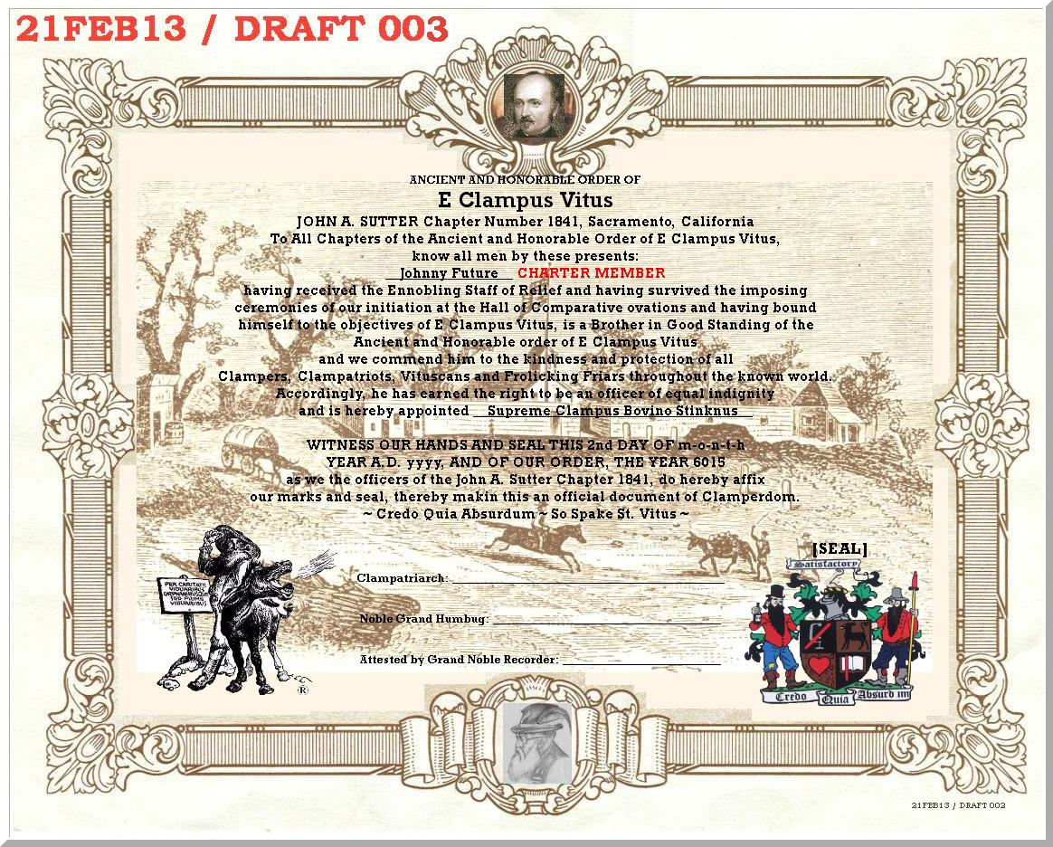

Detail of seal/date:
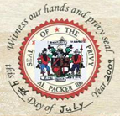

Also, consider Sutter’s Fort for background on the traveling card...
ATTACHMENT “C” – Traveling Card preliminary

Probably replace these images with “face” pictures...
Updated 00DEC13: top card ~ kill # stub; kill member#, add JAS.jpg & JAS#1841

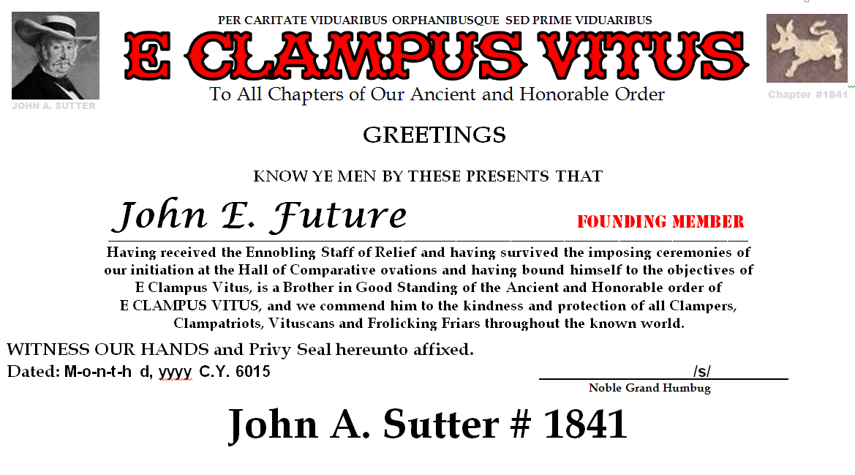 | 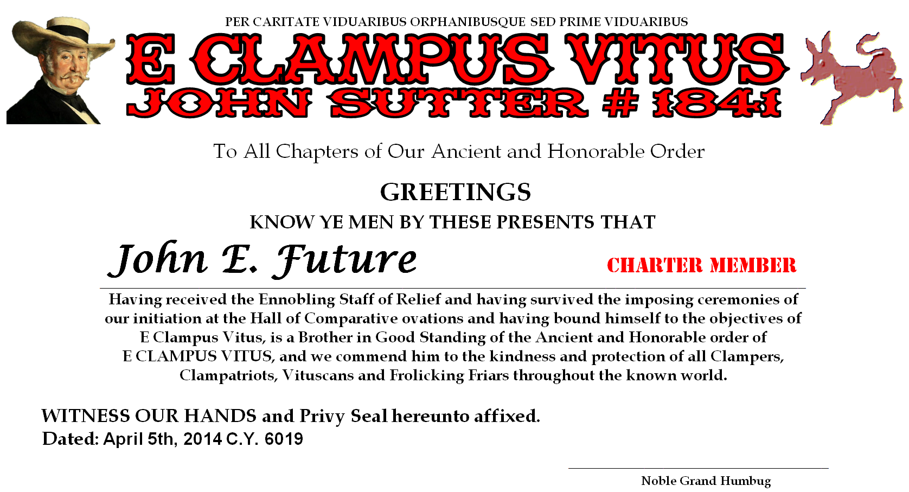
 | 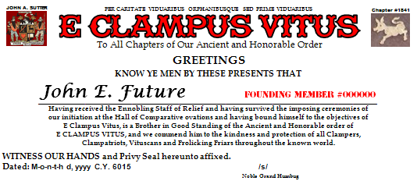
  Name: _______________________
  Phone: _______________________
  Street: _______________________
  City/Zip: _______________________
  email: _______________________
  FOUNDING
  MEMBER
  #000000
 | 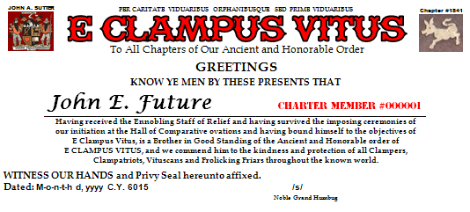
  Name: _______________________
  Phone: _______________________
  Street: _______________________
  City/Zip: _______________________
  email: _______________________
  CHARTER
  MEMBER
  #000001
 | 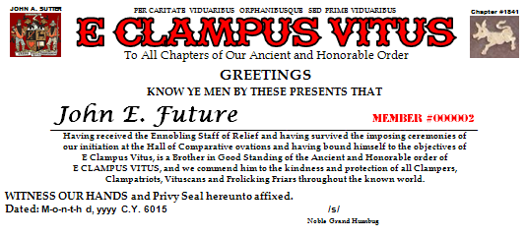
  Name: _______________________
  Phone: _______________________
  Street: _______________________
  City/Zip: _______________________
  email: _______________________
  MEMBER
  #000002

ATTACHMENT “H” –

ATTACHMENT “I” – Charter Doins Flyer

See separate document: 140403flyer_mail_002.doc
ATTACHMENT “J” – Business Cards – completed...

ATTACHMENT “K” – Charter Doins T-Shirts

Quantity | Front | &Back | w/Pocket | Total |  | Notes:
24-47 | 7.00 | 2.00 | 4.00 | 13.00
43-71 | 6.00 | 1.50 | 4.00 | 11.50 |  | w/oPocket
72-95 | 5.50 | 1.25 | 4.00 | 10.75 |  | +$2 instead of +$4
96-143 | 5.00 | 1.00 | 4.00 | 10.00
144-191 | 4.75 | 0.89 | 4.00 | 9.64 |  | w/Pocket
192-288 | 4.50 | 0.75 | 4.00 | 9.25 |  | might be +$3.50
289-575 | 4.25 | 0.60 | 4.00 | 8.85
576+ | 4.00 | 0.50 | 4.00 | 8.50 |  | 6# 100% cotton pre-shrunk

Ideas for the front, back:
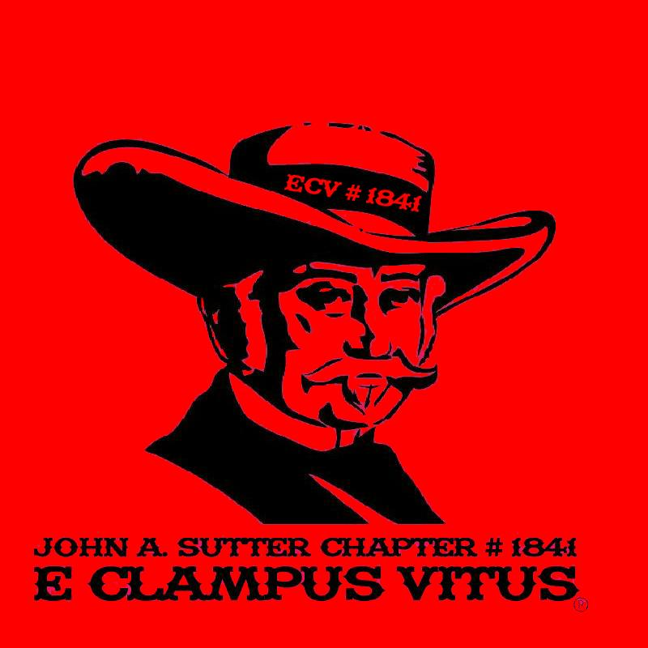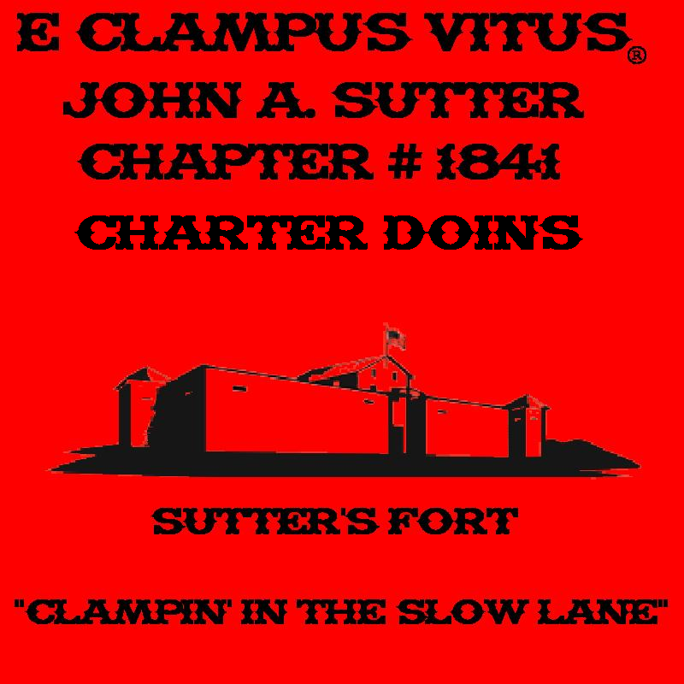

Ideas for the back:
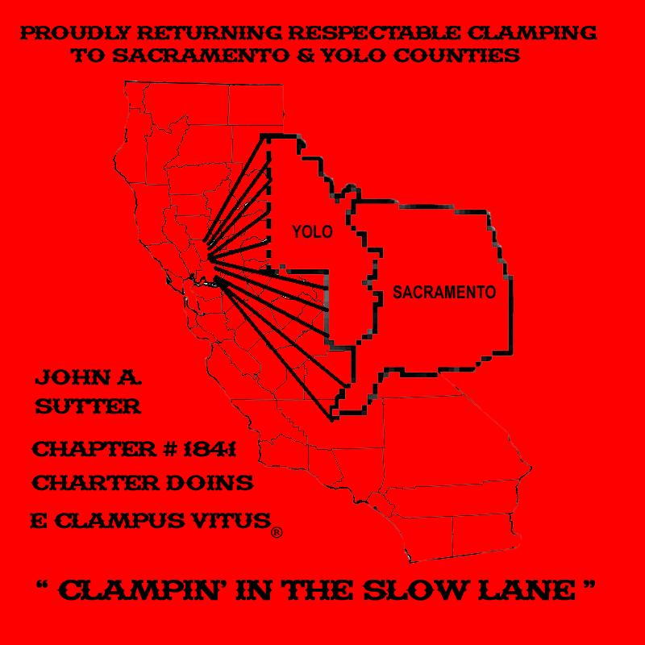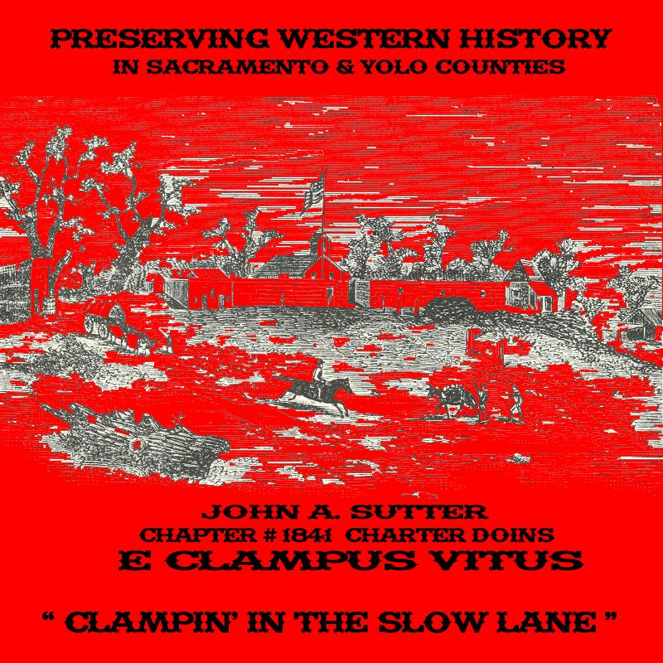
More ideas for the back:




