John A. Sutter Chapter #1841

Charter Doins Board Meeting Agenda, Meeting Date: 15NOV13

Call to Order: s/b at or about 6:30pm

Roll Call of Board Members:
P = Present, A = Absent, X = Xcused absence
___ NGH Russell "Christ" Holder
___ VNGH Gary “Everready” Karl
___ GNR Bob Farrell
___ GDR Dean Hupp
___ Hangman Kevin "Stinky" Jenkins
___ Damn Fool Doorkeeper Paul "Sparks" Laue
_X_ Board Member at Large Fred "Mr Magoo" Willcox (email of 11/7/2013 8:43 PM)
___ Board Member at Large David "Dave the dick" Andre
___ Board Member at Large Kieth "Hardshell" Kinne
___ Graybeard Gary “Everready” Karl
___ Graybeard Mike “Gunshot” Young
___ Clampatriarch Bob "Iron Horse" Stevenson

Charter Doins Committes’ Co-Humbugs:
- Mike “Gunshot” Young
- Bob “Ironhorse” Stevenson
- Russell “Christ” Holder

Charter Doins Committes - Mike "Gunshot" Young:

1) Facilities, Chairman: Mike "Gunshot" Young . . . . . backup: _______________

2) Grounds, Chairman: Gary "Everready" Karl . . . . . . backup: _______________

3) Signage, Chairman: Kevin "Stinky" Jenkins . . . . . backup: _______________

4) Entertainment, Chairman: Mike “Gunshot” Young . . . backup: _______________

5) Libation, Chairman: Dean Hupp . . . . . . . . . . . backup: _______________

Charter Doins Committes - Bob “Ironhorse” Stevenson:

6) Food/Cook, Chairman: Dean "Mr.Clean" Hupp . . . . . backup: _______________

7) Plaque, Chairman: Kevin Jenkins . . . . . . . . . . backup: _______________

8) Initiation, Chairman: Kevin "Stinky" Jenkins . . . backup: _______________

9) Hawker, Chairman: Dean Hupp . . . . . . . . . . . . backup: _______________

10) Raffle, Chairman: Kieth Kinne . . . . . . . . . . . backup: _______________

Charter Doins Committes - Russell "Christ" Holder:

11) Location, Chairman: Russell "Christ" Holder . . . backup: _______________

12) Sign-In, Chairman: Dean Hupp . . . . . . . . . . . backup: _______________

13) Charter Doins T-Shirts, Chairman: Dean Hupp . . . backup: _______________

14) Security, Chairman: Paul Laue . . . . . . . . . . backup: _______________

15) Publication, Chairman: Russell "Christ" Holder . . backup: _______________

16) Closing Ceremony/Wrap-up Committee, Chairman Russell "Christ" Holder

KNUCKLEHEADS FOREVER!

Charter Doins Board Meeting Agenda Continued, Meeting Date: 15NOV13

NOTE: some folks have volunteered to work in several areas, e.g., Fred Willcox volunteered to help where ever he is needed (Sign-in Table, Door Keeper assistance, Hawker, Raffle assistance, Hangman assistance, Cooking Crew assistance, etc.); consideration s/b given to over use/schedualing conflicts (cannot be in 2 places at one time).

Charter Doins Committee Reports - Mike "Gunshot" Young:

REPORT “1” – Facilities
Chairman: Mike "Gunshot" Young?
Committee Member(s): Walter Hales? _____? _____? _____?

- REVIEW EACH OF THE FOLLOWING & estimate date of completion...
- DONE __: Pavillion exists at chosen location...
- DONE___: electric power is available at the site
- _______: On-site/off-site refrigeration
- _______: LARGE tent(s) (in case of rain)
- _______: 1841 BBQ, IOOF BBQ, SFD BBQ on trailer
- _______: Gary 2-burner, Floyd 2-burner, 49 cook gear???
- _______: Contact YB1? 49?
- _______: need 5 canopys
- _______: generator(s)?
- _______: tables and maybe chairs for registration, cook shack, raffle, maybe other uses

REPORT “2” – Grounds
Chairman: Gary "Everready" Karl
Committee Member(s): Kevin Jenkins, _____? _____? _____?

- REVIEW EACH OF THE FOLLOWING & estimate date of completion...
- Dumpster
  - _______: $_____
  - _______: drop-off: ___APR14
  - _______: pick-up: __APR14, location: ___
  - _______: any drop-off/pick-up coordination btwn Dumpster & YMCA?.
- PortaPot
  - _______: $___ea
  - _______: quantity: ________
  - _______: drop-off: ___APR14
  - _______: pick-up: __APR14
  - _______: location(s): ___
  - _______: any drop-off/pick-up coordination btwn PPotty & YMCA?.
- Trash Cleanup
  - PBC’s (through Sunday morning when receive sheepskin)
- Latrine Cleanup
  - PBC’s (through Sunday morning when receive sheepskin)
- Caution tape (including de-malitarized zone around PBCs)
  - _______: Obtain
  - _______: Install by ________________

REPORT “3” – Signage
Chairman: Kevin "Stinky" Jenkins
Committee Member(s): BobF, _____? _____? _____?

- REVIEW EACH OF THE FOLLOWING & estimate date of completion...
- ______: Freeway exit sign, descdription: ____________________
- ______: 1st turn, descdription: _____________________________
- ______: Grounds entrance, descdription: _____________________
Charter Doins Board Meeting Agenda Continued, Meeting Date: 15NOV13

Charter Doins Committee Reports - Mike "Gunshot" Young:

REPORT “4” – Entertainment
Chairman: Mike “Gunshot” Young?
Committee Member(s): Rusl Holder, Kevin Jenkins, _____?

- REVIEW EACH OF THE FOLLOWING & estimate date of completion...
- ATTENTION: ON FLYER “THIS IS A RED-SHIRT EVENT, NO CITIZENS ALLOWED!”
- ______: Rubber Band: Available for a 4 hour set on Friday; book: yes/no
- ______: need to know of any noise ordinances.
- ______: Other Band: 12NOV13: Haven't looked into
- ______: Lonnie Rueb & friend: 12NOV13: Need to discuss further with Gary
- ______: PA system: 12NOV13: PA not practical from layout stand point
- DONE__: bull horn: 12NOV13: Have a bull horn
- ______: The “Mystery Tent” : 12NOV13: Need input here as to what it will entail to determine if it will be present
- ______: Hot Rod and MC show: 12NOV13: This will attract too many non-redshirts to a Red shirt event... NO; LET US RE-CONSIDER... SEE “ATTENTION” ABOVE...
- ______: Woodland Truck & Tractor Museum tour: 12NOV13: Discussed at last meeting, need to get information & pricing as well as travel arrangements worked out, this can't be finalized until after we see what the draw will be.
- ______: Horse shoes: 12NOV13: Have available... NEED TWO SETS OF SHOES... OK???
- ______: Karaoke: 12NOV13: Good idea, need to know if noise will be a factor and if anyone has a machine.
- ______: Talent contest: 12NOV13: Red shirts and talent.... not in the same sentence or same location.
- ______: Other...

REPORT “5” – Libation
Chairman: Dean Hupp
Committee Member(s): GaryK

- REVIEW EACH OF THE FOLLOWING & estimate date of completion...
- Holder – contact Mid-Cal Cycle re their beer trike attachment “H”
- ____ - keg cooling
- Beer Truck:
  - _______: $___
  - _______: drop-off: ___APR14
  - _______: pick-up: __APR14
  - _______: location(s): on side of road by power pole by pavilion
  - _______: any drop-off/pick-up coordination btwn beerTruck & YMCA?.

Charter Doins Board Meeting Agenda Continued, Meeting Date: 15NOV13

Charter Doins Committee Reports - Bob “Ironhorse” Stevenson:

REPORT “6” – Food/Cook
Chairman: Dean "Mr.Clean" Hupp
Committee Member(s): Gary Karl, Bob Farrell, Ben Peccaianti, _____? _____?

- REVIEW EACH OF THE FOLLOWING & estimate date of completion...
- Free hat for all kitchen staff volunteers
- ______: Menu, see attachment “A”
- Ideas for menu items?
  - BBQ Beef is a re-do
  - ______: PIG
  - ______: Hand cranked ICE CREAM
- ______: Kitchen Patrol
  - 1841
    - Gary Karl
    - Bob Farrell
    - Dean Hupp
    - Ben Peccaianti
    - Fred Willcox
    - [new dude from fall doins]
    - New PBC from Dean?
    - New PBC from Dean?
  - YB1
    - Floyd
    - Iggy – who else?
  - #49
    - Toro
    - Matt
    - Chewy

REPORT “7” – Plaque
Chairman: Kevin "Stinky" Jenkins
Committee Member(s): Bob Farrell, _____? _____?

- REVIEW EACH OF THE FOLLOWING & estimate date of completion...
- ______: Grounds - - - – progress on this: _____________________
- ______: Tractor Museum – progress on this: _____________________
- ______: Gibson House - – progress on this: _____________________
- ______: Other - - - - – progress on this: _____________________

REPORT “8” – Initiation
Chairman: Kevin "Stinky" Jenkins
Committee Member(s): Rusl Holder, Gary Karl, Bob Farrell, _____?

- REVIEW EACH OF THE FOLLOWING & estimate date of completion...
- ______: Help from 1841: Fred Willcox, Mark Jenkins, _____?, _____?
- Free hat for all volunteers
- ______: Help from YB1: _____?, _____?, _____?
- ______: Help from #49: _____?, _____?, _____?
- ______: Help from LSD3: BlueCrow?, _____?, _____?
- white coats will be labeled “REGULATOR”...
  - ______: how many ? _________
  - ______: From where? _________
- Work project: weeding, cleaning, depending on site...
- Artifact ID, gold panning, rocky road to Dublin
- ______: Bowling ball station from LSD3?
- ______: ... station from YB1?... from 49?
- ______: ... ass kicking station, stamp mill, other station ideas...
- ______: ... miner’s lunch of beans/beans/beans w/o flatware...
- ...
Charter Doins Board Meeting Agenda Continued, Meeting Date: 15NOV13

Charter Doins Committee Reports - Bob “Ironhorse” Stevenson:

REPORT “8” – Initiation ~ CONTINUED

- Work details:
  - latrine duty
  - trash/garbage
  - announcements
  - dinner bell
  - what else?
- ______: Black Robes – Gary Karl will provide the robes
  - RH: I would be game for black OR red "robes" - found something like red cheese cloth at the new Hoby Loby by Petco in Coco's parking lot across from Arden Mall;sample looks sparse, but, would add a red color, and would BREATHE on hot days:
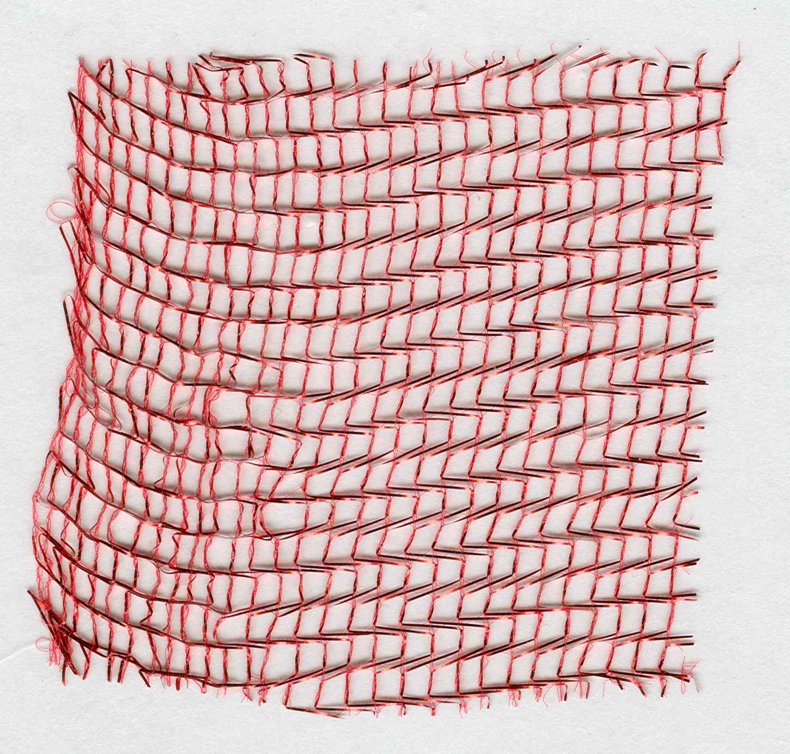
- HOCO readers:
- - HUMBUG: The Noble Grand Humbug - Christ
- - CLAMPAT: The Clampatriarch - Ironhorse
- - RECORDER: The Grand Noble Recorder - Popeye - _______________
- - HANGMAN: The Grand Imperturbable Hangman - Stinky
- - MUSICIAN: The Grand Musician - Klinky
- - ISCUTIS: The Roisterous Iscutis - Sparks
- - PLATRIX: The Royal Platrix - Mr.Clean – Dan McCarthy (will you...)
- - PETRIX: The Clamps Petrix - Dave-the-Dick (Humbugery)
- - MATRIX: The Clamps Matrix - Mr.Magoo (widows yet unwon)
- - VITRIX: The Clamps Vitrix - Dave Barnett (Californification)

REPORT “9” – Hawker
Chairman: Dean Hupp
Committee Members: Gary Karl, "Bare", Gary "Colonel Klink" Klinke, Jack Vinsant

- REVIEW EACH OF THE FOLLOWING & estimate date of completion...
- ______: Help from 1841: Bare,Gary Klinke,Jack Vinsant,Fred Willcox,_____?
- Fort Sutter books:
  - ______: 100 by 15NOV13, _____ who picks them up?
  - ______: how many more? _____ picked up by who? ____ when? ____
- ______: Need 3 tables: 1 for hawker, 2 for raffle items (better be 20’ tables)
- ______: T-shirts
- ______: Pin-of-the-day
- ______: Hats
- ______: What else for Bare?

Charter Doins Board Meeting Agenda Continued, Meeting Date: 15NOV13

Charter Doins Committee Reports - Bob “Ironhorse” Stevenson:

REPORT “10” – Raffle
Chairman: Kieth Kinne
Committee Members: Gary "Colonel Klink" Klinke, _____?, _____?

- REVIEW EACH OF THE FOLLOWING & estimate date of completion...
- Help from 1841: Gary Klinke, Fred Willcox, _____?
- What budget for the raffle?
- ITEMs for the raffle?
- Tattoo vouchers from Tattoo Inc., Precision Ink, Sunset Design, ...
- (Promotional) donations from local businesses ...
  - Business...
  - Business...
  - Business...
  - Business...
  - Business...
  - Business...
  - Business...
- What BIG TICKET ITEM(S) for the raffle?
  - idea...
  - idea...
  - idea...

Charter Doins Board Meeting Agenda Continued, Meeting Date: 15NOV13

Charter Doins Committee Reports - Russell "Christ" Holder:

REPORT “11” – Location
Chairman: NGH (Russell "Christ" Holder)
Committee Member(s): Gary Karl, Bob Farrell, Dean Hupp

- REVIEW EACH OF THE FOLLOWING & estimate date of completion...
- DONE: Location is reserved for Thu,...,Sun, 03,...,06APR14
- Location contact information, viz., YMCA Representative's contact information:
  - name name:Kelley Hutchinson
  - title: ???
  - address:Yolo County YMCA 1300 College St. Woodland Ca 95695
  - phone:530-662-6423
  - email: khutchison@ymcasuperiorcal.org
- Location is paid for, deposit of $400 paid to ______
  - 06JUN13: Bob Farrell paid $400.00 to the YMCA
  - 17JUN13: Dean paid Bob Farrell $400.00 for reimbursement of deposit, check # T002
- Location rental fee remaining is $1000
  - 13NOV13/Popeye: due 60 days prior to use, FEB 1ST 2013
  - payable to YMCA
  - ______: [who] will pay on this date
- Provide Insurance Form, due by ddmmmyy: ______
  - 29OCT13: Certificate done
  - _______: date to send to:Board Members
  - _______: date due to YMCA
- Provide Alcohol Form, due by ddmmmyy: ______
  - Dean is going to handle this:
  - 12NOV13: Dean will be collecting more info at the [15NOV13] meeting as to what we are actually serving to know what type of permit we need
  - ______: let whom ever know we will need a letter from the YMCA allowing us to serve liquor on the site
  - ______: At that time they (ABC) will let me know if we need county approval.
- Other permits:
  - 13NOV13/Popeye: check w/YMCA and see if they know of anything
  - 13NOV13/Popeye: Also we could check with the YOLO County folks
  - 13NOV13/Popeye: leave the pot undisturbed and just go with it
  - Ignorance is no excuse for the law.
- GaryK & BobF visit director to advise of possible subversive endeavors
- Flyer info: traveling north on I-5 take Exit 538, 113 North to Yuba City then turn north on N East St, then take 1st left on Coil Road & follow ECV signs
- Flyer ifto: traveling south on I-5 take Exit ___, ______________________ then turn north on N East St, then 1st left on Coil Road & follow ECV signs

Charter Doins Board Meeting Agenda Continued, Meeting Date: 15NOV13

Charter Doins Committee Reports - Russell "Christ" Holder:

REPORT “12” – Sign-In
Chairman: Dean Hupp
Committee Member(s): Holder, Dan McCarthy, Gene Breeland, BobS, BobF

- 12NOV13:Dean: No committee meeting as of yet.
- REVIEW EACH OF THE FOLLOWING & estimate date of completion...
- ______: (next)committee meeting...
- ______: attendance limit? Yes/no; yes, what? _________
- ______: Release of Liability forms
  - Review by date: _________
  - Approve by date: _________
  - Include with flyer
  - Print for on-hand at sign-in table
    - How many? _________
    - By date: _________
- ______: RSVP processing (this needs to be a single person): ____________
- ______: Help from 1841: Dean Hupp, Gene Breeland, Fred Willcox, _______?
- ______: Help from YB1?, 49?, other? Yes/no; who:_____? , _____? , _____?
- ______: Sign-in table attendants:
  - Keith Kinne: chk travl card, release of liability, registration form
  - Dean Hupp: review day-of forms, rcv payment, issue wrist bands
  - Gene Brelnd: A-M packets, review legibility
  - WalterHales: N-Z packets, review legibility
  - Someone????: PBC registration, review legibility
  - Contact more help by date: ____________
- ______: Sign-In hours of operation:
  - Prime Time: Thurs[...],Fri[...],Sat[...],Sun[...]
  - Off Hours: Thurs[...],Fri[...],Sat[...],Sun[...]
- ______: Number of staff at sign-in tables
  - prime time: [...]
  - off hours: [...]
- ______: Wrist bands... different for red-shirts vs. PBCs...
  - ______: Review catalog & pick color(s)
  - ______: purchase
- ______: Red-tag info: Health problems, Allergies, etc... of attendees... what all do we need to know? Where will we record it? How will be act on it?

REPORT “13” – Charter Doins T-Shirts
Chairman: Chairman: Dean Hupp
Committee Member(s): Holder, GaryK, BobF

- 12NOV13:Dean: Gary Karl will report at [15NOV13] meeting
- REVIEW EACH OF THE FOLLOWING & estimate date of completion...
- What t-shirt ideas are there? - see attachment “K”
- ______: who is our new T-shirt artist? _______________________________
- ______: New artist contact info: _____________________________________
- ______: what do we want him to prepare?
- ______: what has he prepared?...
- ______: I know I want something really cool, not “just OK”!
- ______: Want sample ideas to consider by _____________________________
- ______: black “Charter” T-shirts for security; for all 1841 members...?
- ______: pre-pay package container is what?
- ______: pin of the day
- ______: hats (free hats for all volunteers)
  - how many for volunteers ________
  - how many for sale? _____________

Charter Doins Board Meeting Agenda Continued, Meeting Date: 15NOV13

Charter Doins Committee Reports - Russell "Christ" Holder:

REPORT “14” – Security
Chairman: Chairman: Paul Laue
Committee Member(s): Kevin Jenkins, BobS, _____? _____?

- REVIEW EACH OF THE FOLLOWING & estimate date of completion...
- Free hat for all security staff volunteers
- Security staff T-shirts
  - labeled “NOT REGULATOR”...
  - how many?
  - From where?
- handy-talkies for NGH & security team members...
- golf cart for Paul?
- Gate attendant
- Parking areas and parking attendants/assistants
- Camping areas and camping attendants/assistants
- Help from 1841: Paul Laue, Fred Willcox, _____?, _____?, _____?
- Help from YB1: _____?, _____?, _____?
- Help from #49: _____?, _____?, _____?
- Help from LSD3: Bluecrow?, _____?, _____?
- black “Charter” T-shirts for security

REPORT “15” – Publication
Chairman: Chairman: Russell "Christ" Holder
Committee Member(s): GaryK, BobF, _____? _____?

- REVIEW EACH OF THE FOLLOWING & estimate date of completion...
- ATTENTION: ON FLYER “THIS IS A RED-SHIRT EVENT, NO CITIZENS ALLOWED!”
- Preliminary flyer - see attachment “I”
- Flyer prepare for mailing by: when??? New Years Day??? Valentines day???
- Flyer prepare in .jpg and .pdf format
- $75, $100PBC, $120retreand before Halloween
- $85, $110PBC, $130retreand before Valentines Day
- $95, $120PBC, $140retreand day of
- Pre-paid Sign-in: check off, give sheepskin & traveling card, give T-shirt voucher
- Include check list of options attendee wants (shirt, pin, etc.)
- Include local MOTEL locations and contact info
- NOTICE: Friday – PBCs will be on setup crew
- Sign-in: LEDGIBLE, prepare/give sheepskin & traveling card, give T-shirt voucher
- Sheepskins: FOUNDING/CHARTER/MEMBER drafts provided in attachment “B”
- Traveling Card: FOUNDING/CHARTER/MEMBER drafts provided in attachment “C”
- Sheepskin tubes from USPO, who gets them?>>>_
- Extra mtg,not mandatory:review Officers Responsibilities,HOCO,etc:__ __
- DIGRESSION: Dean... publishing?...

Charter Doins Board Meeting Agenda Continued, Meeting Date: 15NOV13

Charter Doins Committee Reports - Russell "Christ" Holder:

REPORT “16” – Closing Ceremony/Wrap-up
Chairman: Rusl Holder
Committee Member(s): Mike Young, Bob Stevenson

- REVIEW EACH OF THE FOLLOWING AND ENUMERATE ANYTHING THAT IS DATE CRITICAL
- Rusl: call on GaryK
  - Gary: Peanutbutter’s vision for 1841
  - ______: Main bullets of presentation:
    - one...
    - two...
- Rusl: call on MikeY
  - 12NOV13/Mike: presentation of the charter will come from the sublime [Ludemann] and probably the proctor representative [Waterman] and a couple YB1 folks [Moose,...].
  - Gary how was this handled in Idaho & Oregon ? ?
  - Mike: receive chapter charter from proctors
- Rusl: call on BobS
  - BobS: present check to...
  - *** NOT SURE THIS WILL WORK... THIS SHOULD BE A SURPRISE TO ALL, ESPECIALLY THE RECEIPIENT BUT I HAVE BEEN HEARING THIS CHECK AND AMOUNT AND RECEIPIENT BEING DISCUSSED... SO... RECOMMENDING CANCEL THIS AND DO SOME OTHER TIME... IF EVER...
  - ______: OR WE COULD EMAIL THE BUG AND ASK THAT HE ATTEND THE DOINS AND BE PREPARED TO RECEIVE A CHECK FOR $$$...
- Rusl: announce PBC sheepskins available after grounds check...

ATTACHMENT “A” – Charter Doins Menu

What other meat dishes should be considered?
What other “green” dishes should be considered?
What other starches should be considered?
What other deserts should be considered?
What other munchies should be considered?

What other chapters help when? All together or individual meal or...

Thu-Bkfst
Thu-brunch
Thu-Lunch
Thu-linner - chips & dip
Thu-Dinner - meat loaf,green beans,macaroni salad,bread
Thu-desert - banana cream pie
Fri-Bkfst - sweetrolls,bananas,OJ,coffee
Fri-brunch - oatmeal cookies, apples
Fri-Lunch - foot long submarine sammiches
Fri-linner - chips & dip
Fri-Dinner - steak,green salad,corn on the cob,bread
Fri-desert - cupcakes & icecream
Sat-Bkfst - eggs,bacon,pancakes,OJ,coffee
Sat-brunch - hard boiled eggs, oranges
Sat-Lunch - mustard dogs, chili dogs, Polish dogs, Krout dogs
Sat-linner - crackers,salomi,cheeze
Sat-Dinner - PIG,potatoe salad,cowboy beans,bread
Sat-desert - cake & icecream
Sun-Bkfst - eggs,sausage,biscuits,gravey,OJ,coffee
Sun-brunch
Sun-Lunch
Sun-linner
Sun-Dinner
Sun-desert

ATTACHMENT “B” – Sheepskin preliminary

Need place for Date: ________
Need other “face” pictures, but, here’s the idea...
Need rubber stamps: FOUNDING MEMBER, CHARTER MEMBER

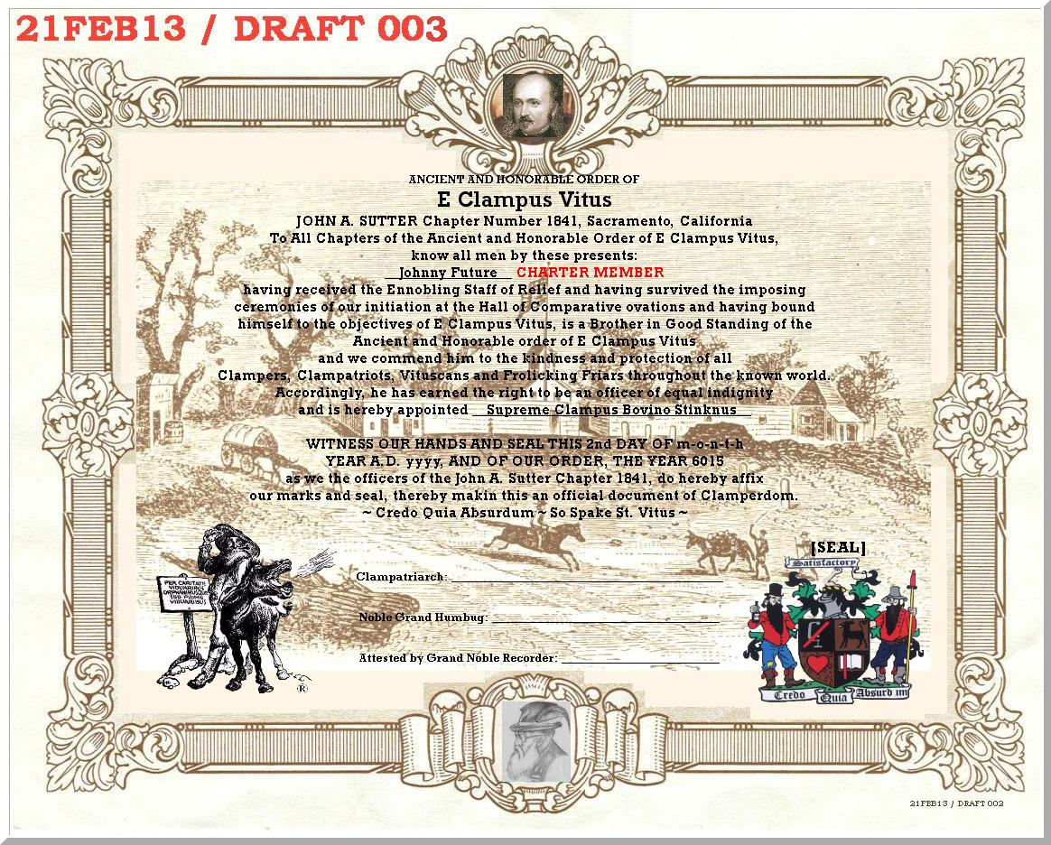

Detail of seal/date:
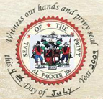

Also, consider Sutter’s Fort for background on the traveling card...
ATTACHMENT “C” – Traveling Card preliminary

Probably replace these images with “face” pictures...

 | 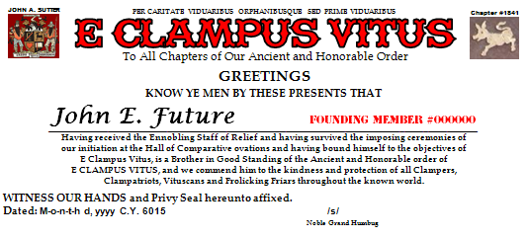
  Name: _______________________
  Phone: _______________________
  Street: _______________________
  City/Zip: _______________________
  email: _______________________
  FOUNDING
  MEMBER
  #000000
 | 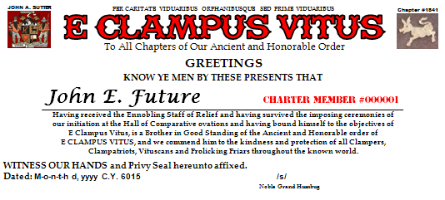
  Name: _______________________
  Phone: _______________________
  Street: _______________________
  City/Zip: _______________________
  email: _______________________
  CHARTER
  MEMBER
  #000001
 | 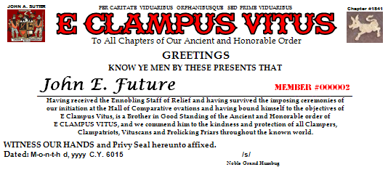
  Name: _______________________
  Phone: _______________________
  Street: _______________________
  City/Zip: _______________________
  email: _______________________
  MEMBER
  #000002

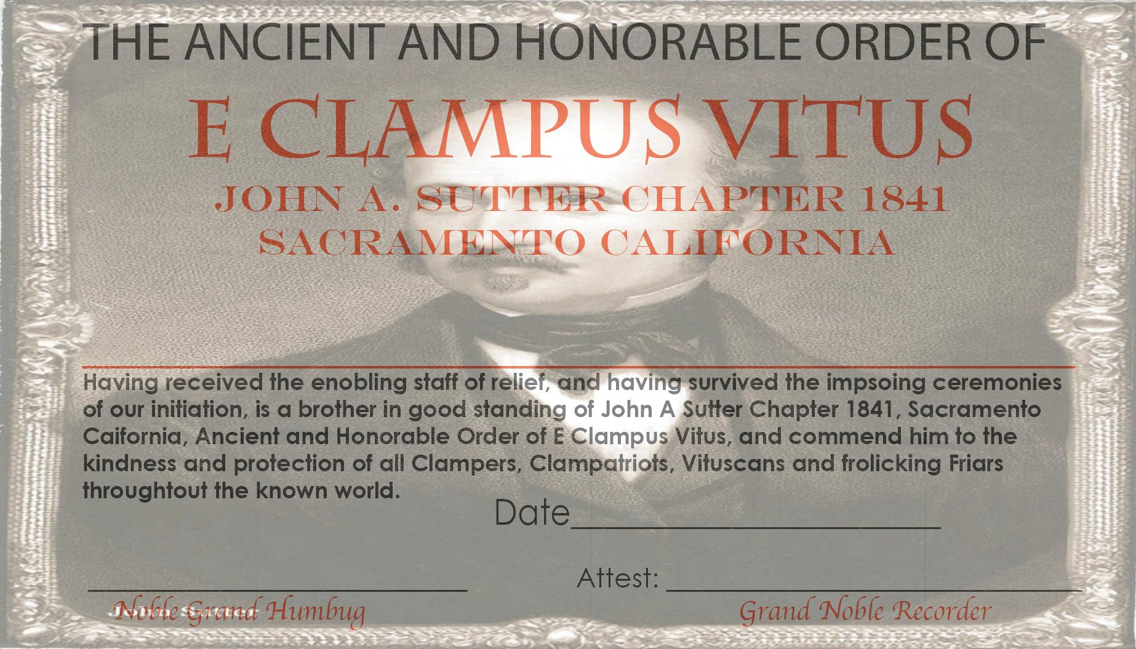

ATTACHMENT “H” –
ATTACHMENT “I” – Charter Doins Flyer

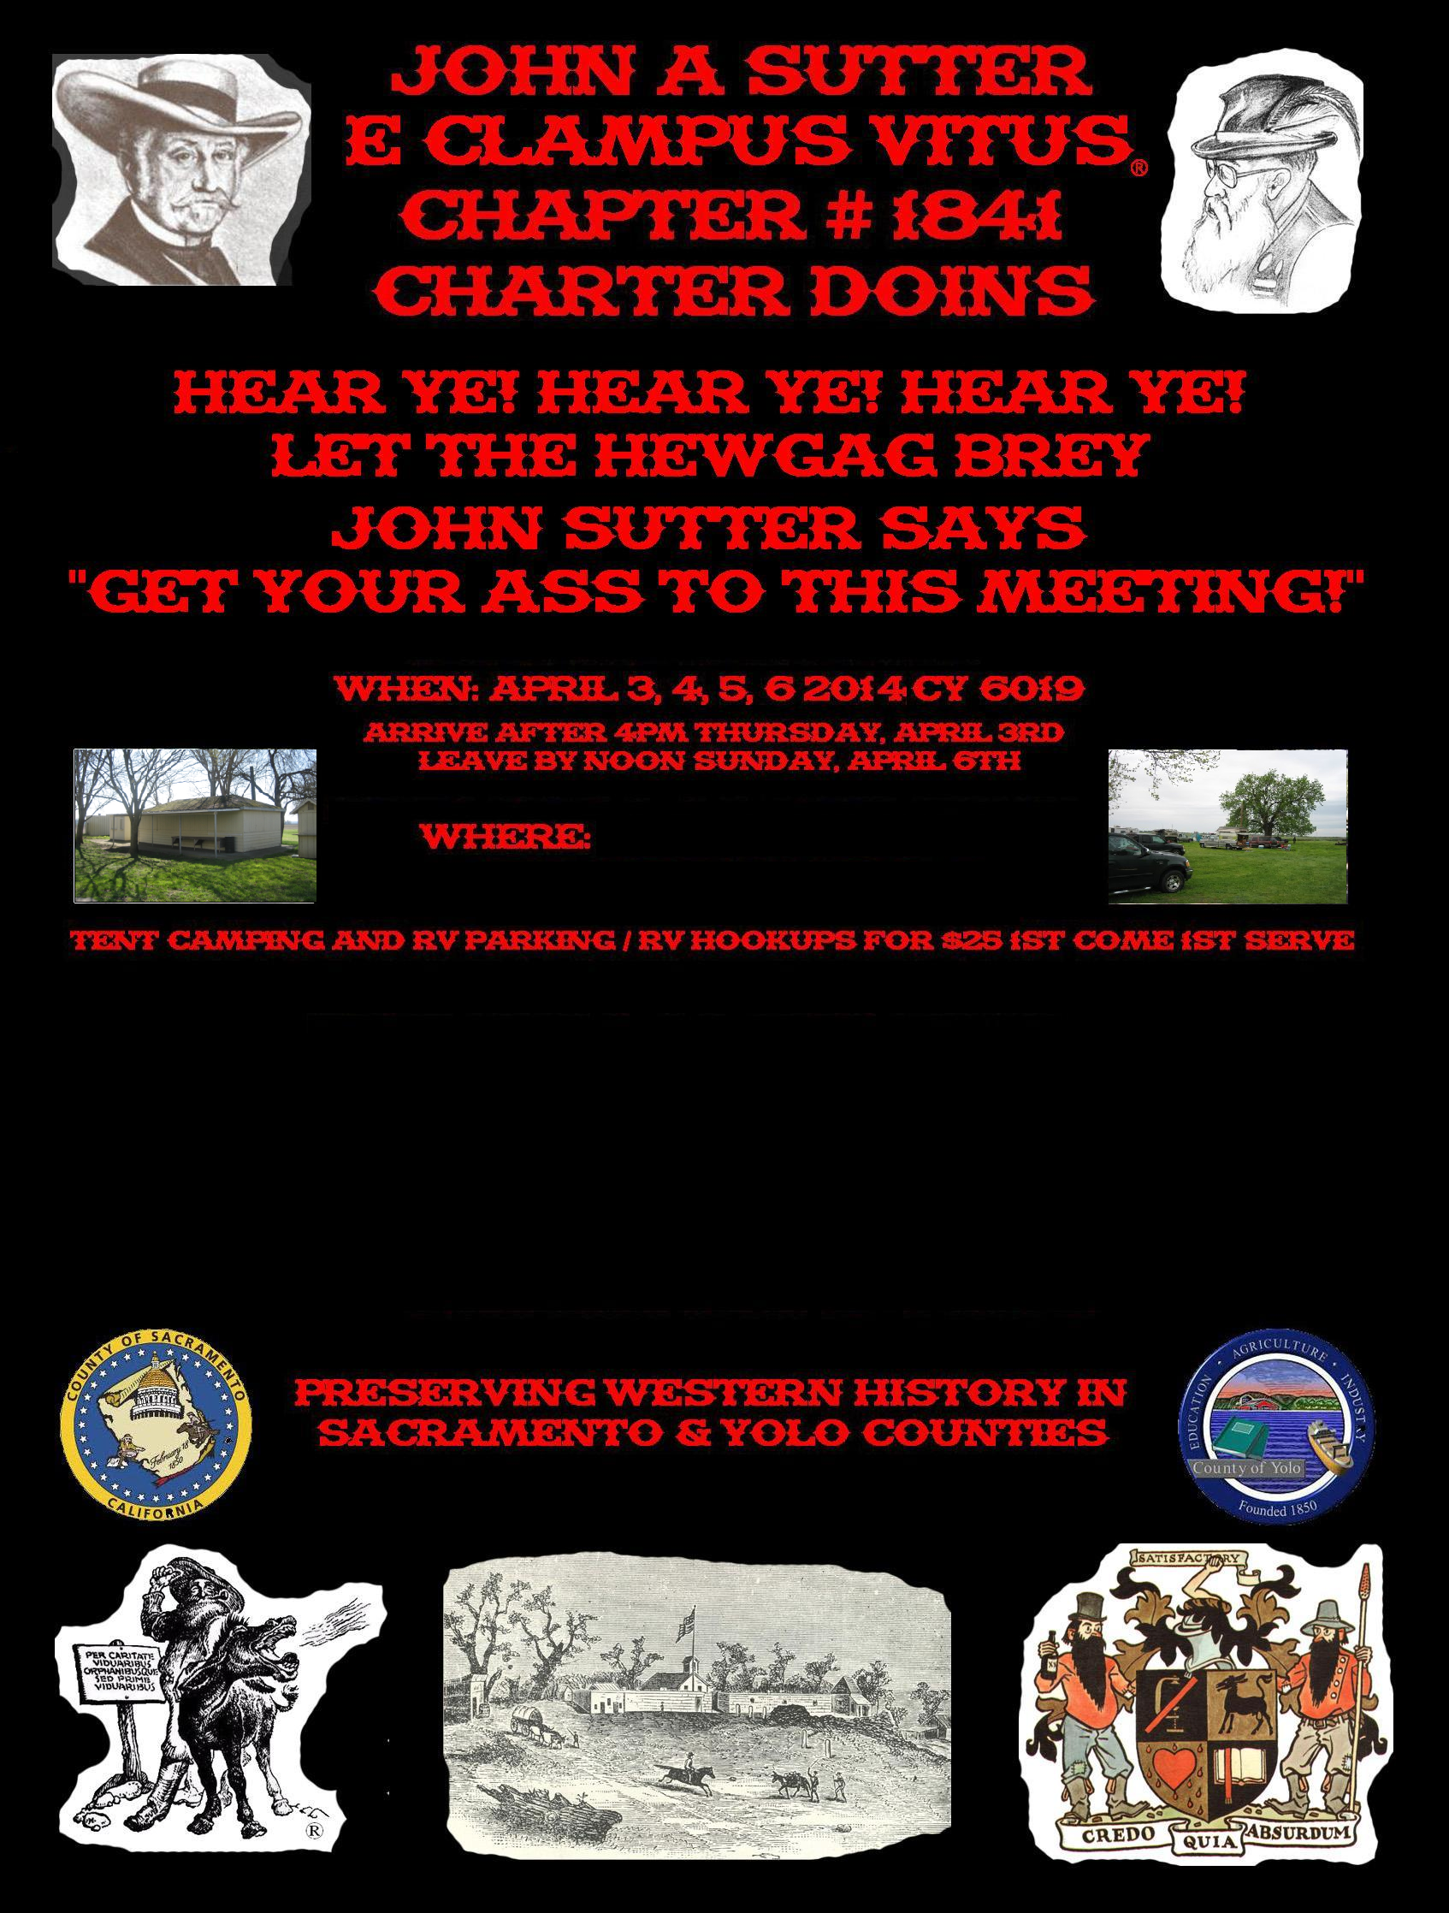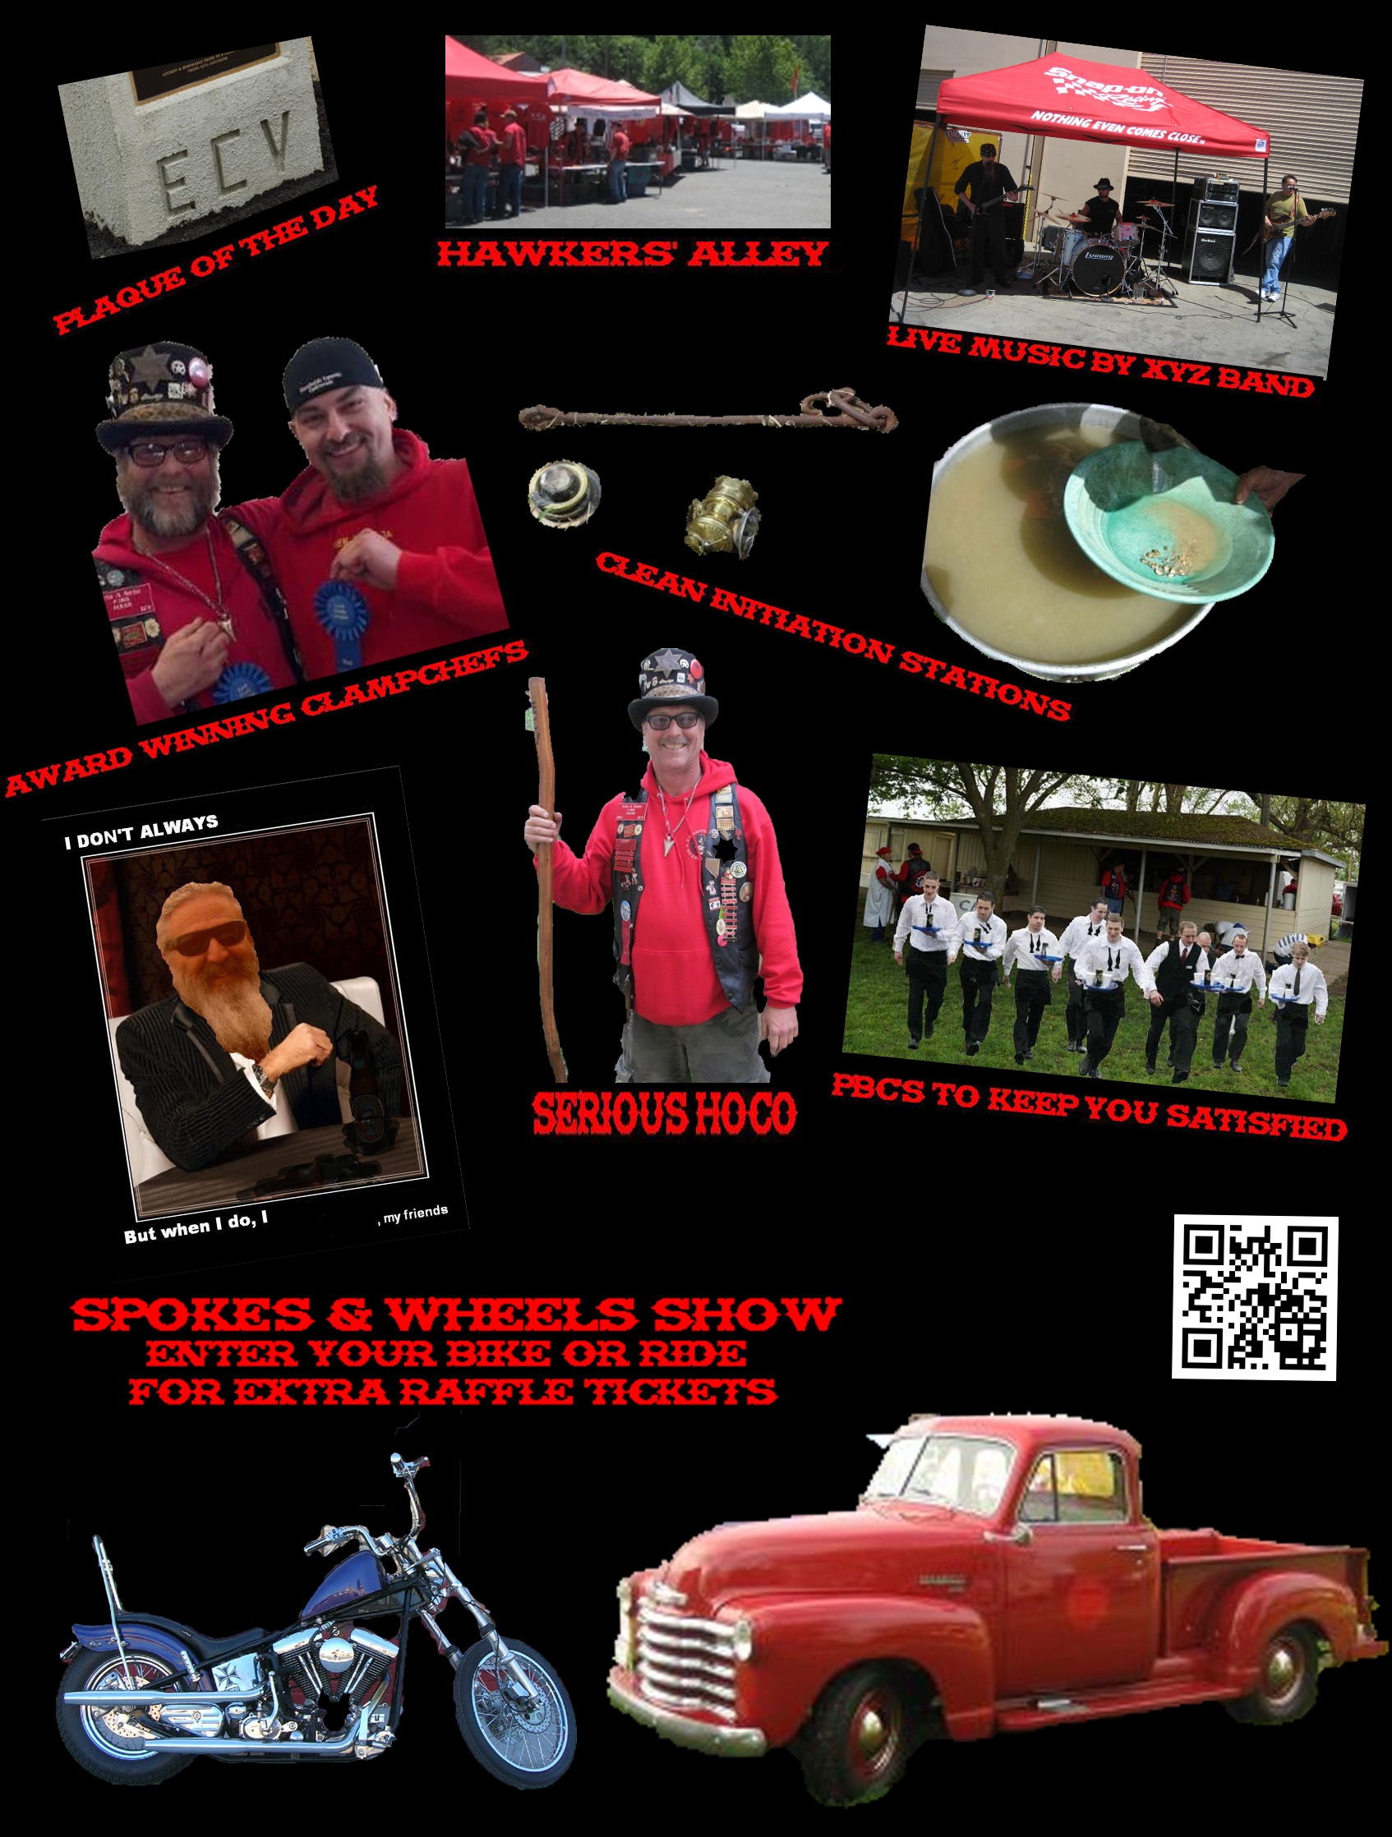

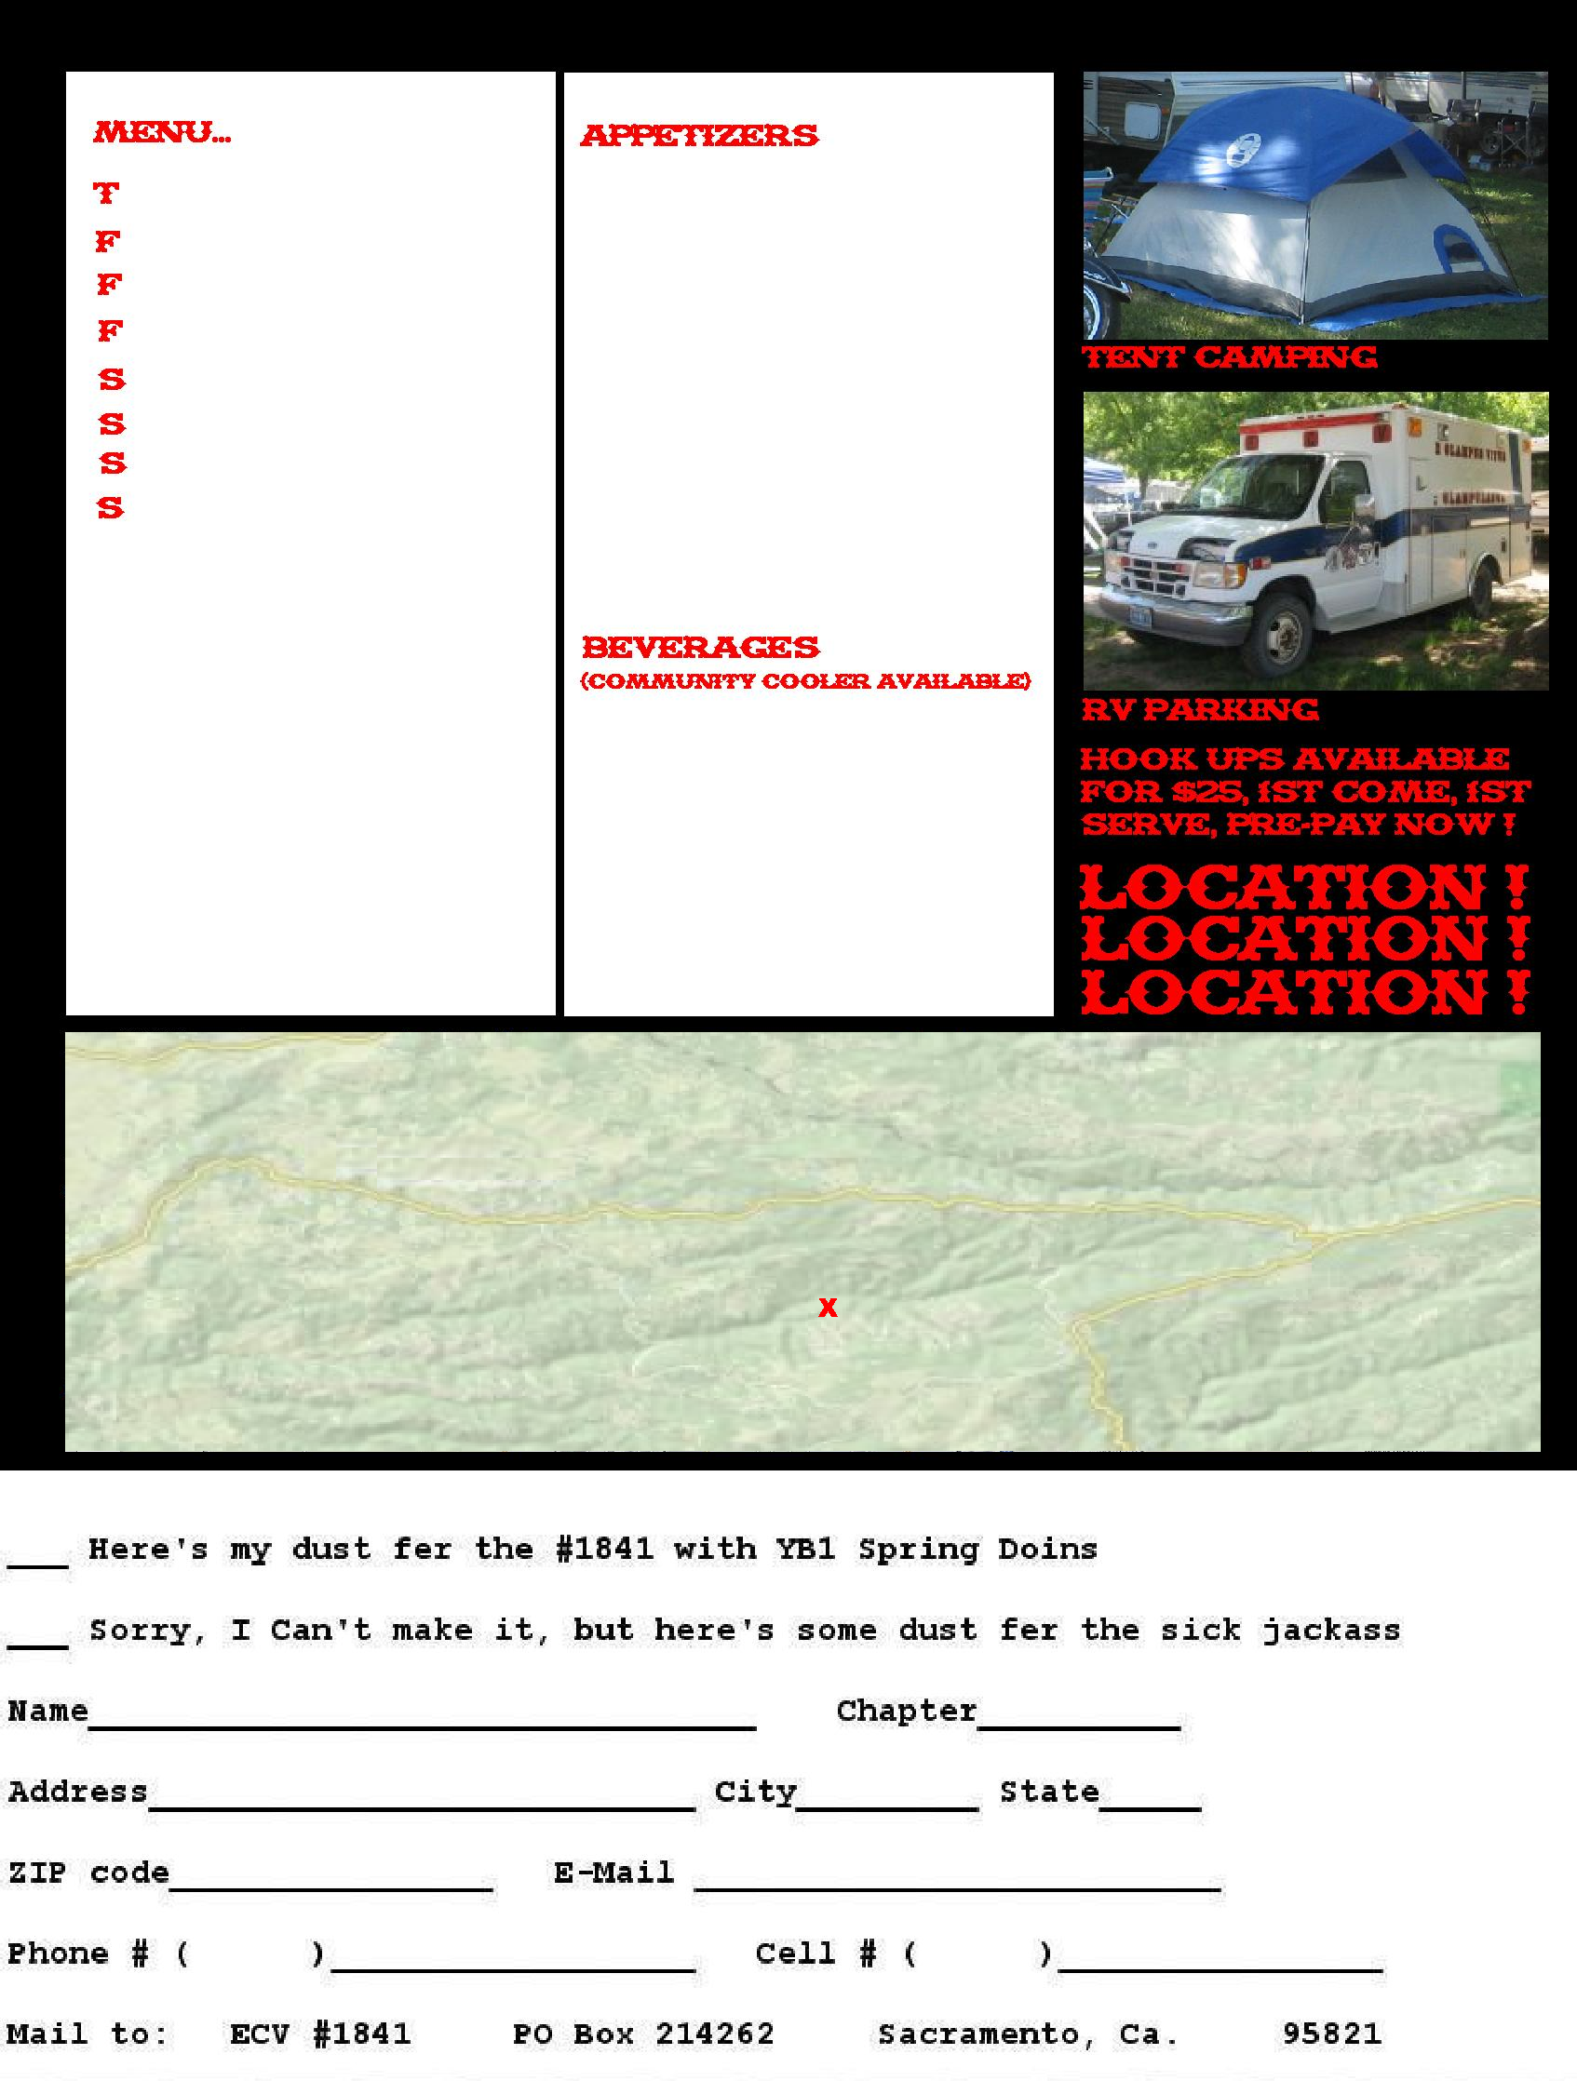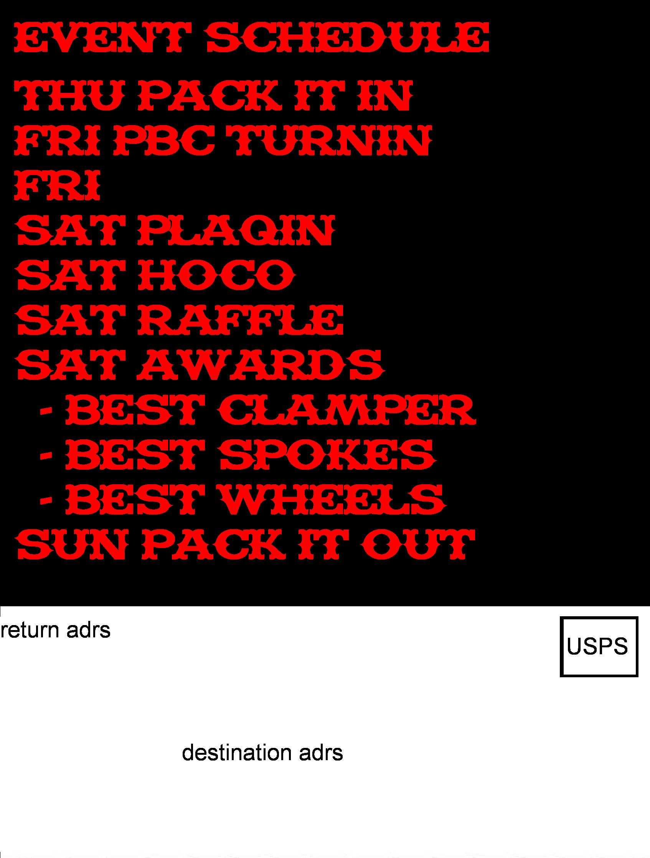

Page 2, front: Release of liability and indemnity agreement

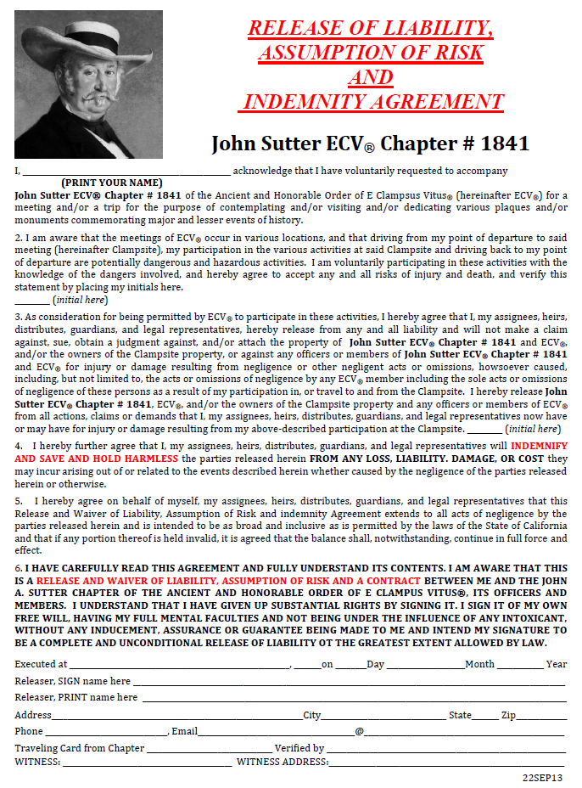

Page 2, back: doins’ rub coupon and sign-up sheet

Sign-up:  * PRINT LEGIBLY *  Name: ___________  Adrs: ___________  Chap: ___________  Asshole? (Y/N): _  Talent contest:  - YOYO _________  - Sing _________  - Gitar _________  - Piano _________  - pig fukn ______  - other: ________  HotRod/Motorcycle  Show entry:  year: __________  make: __________  model: __________  color: __________  4sale? (Y/N): ___  Tent/pickup Camping available  Rv’s(no hookups):  1st 100 RV’s, 1st come – 1st park:  RV length: ______  Hotel/Motels:  - Motel 6  - Holiday Inn  - ... | Here’s my rub (paying for more than one red-shirt ~ copy this form and submit for each red-shirt)  & my PBC(s) $100 ea  I am hosted Hawker for chapter #____  I can’t make it, but here’s to feed the sick jackass  T-Shirts $25 @ doins  (S,M,L,XL,XX,XXX,4X)  $20 each with prepay  Charter doins pin  [img] $15 @ doins  $10 each with prepay  Charter doins hat  [img] $20 @ doins  $15 each with prepay  PRE-PAY TOTAL::::::::  Mail pre-pay form and $ to:  John A. Sutter  P.O.Box ######  Sacto CA ##### | ✓ $80  #___ PBC(s) $______  Subtract ✓ $80  $_____  Size ___  Qty ___  Subtotal $_____  Qty ___  Subtotal $_____  Qty ___  Subtotal $_____  $$$$$$$$$$$$$$_____  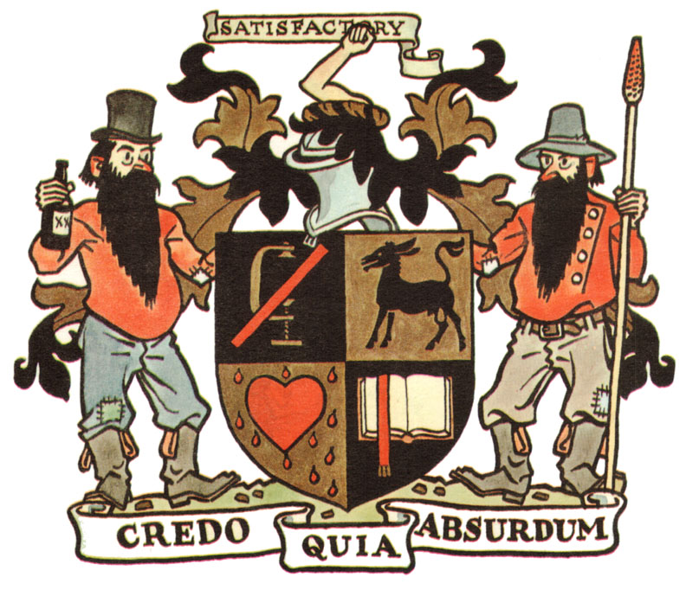
ATTACHMENT “J” – Business Cards – completed...

ATTACHMENT “K” – Charter Doins T-Shirts

Quantity | Front | &Back | w/Pocket | Total |  | Notes:
24-47 | 7.00 | 2.00 | 4.00 | 13.00
43-71 | 6.00 | 1.50 | 4.00 | 11.50 |  | w/oPocket
72-95 | 5.50 | 1.25 | 4.00 | 10.75 |  | +$2 instead of +$4
96-143 | 5.00 | 1.00 | 4.00 | 10.00
144-191 | 4.75 | 0.89 | 4.00 | 9.64 |  | w/Pocket
192-288 | 4.50 | 0.75 | 4.00 | 9.25 |  | might be +$3.50
289-575 | 4.25 | 0.60 | 4.00 | 8.85
576+ | 4.00 | 0.50 | 4.00 | 8.50 |  | 6# 100% cotton pre-shrunk

Ideas for the front, back:

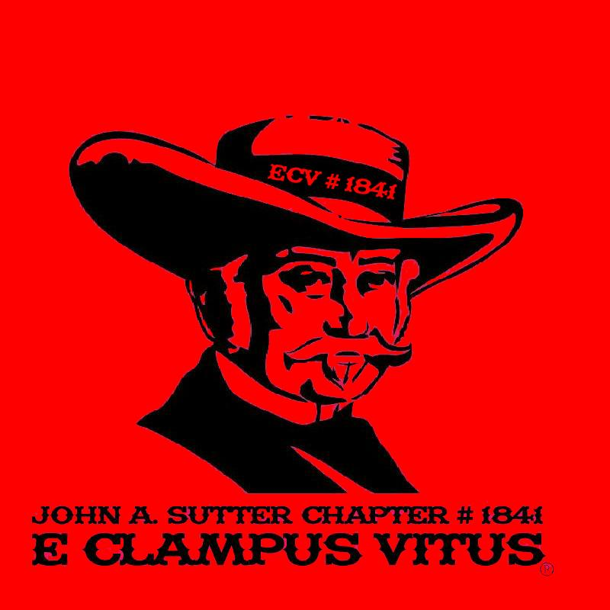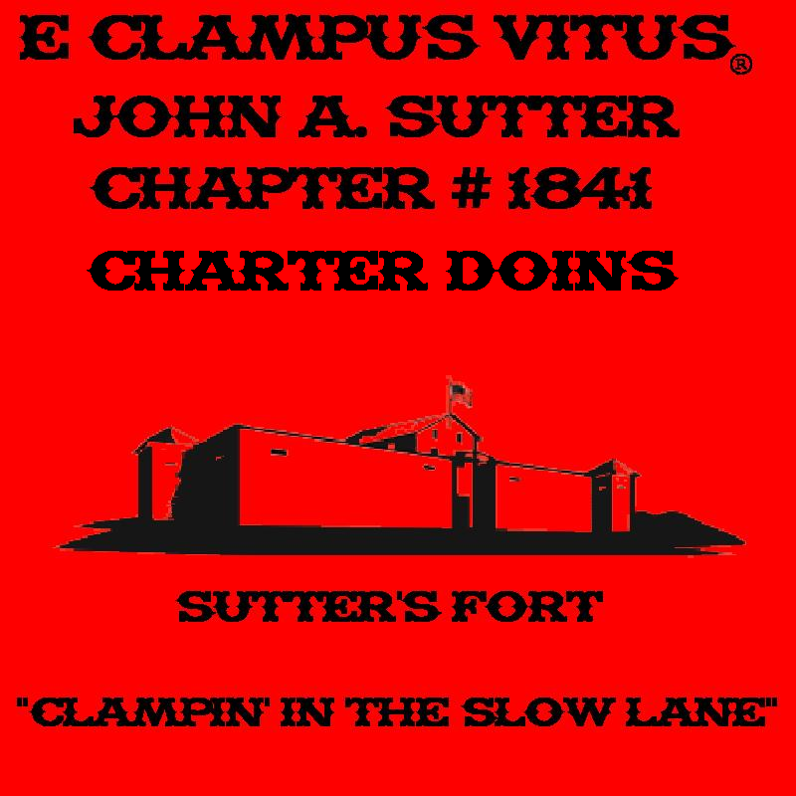

Ideas for the back:




