John A. Sutter Chapter #1841

Monthly Board Meeting Agenda, Meeting Date: 07OCT13

Call to Order: s/b at or about 6:30pm

Pledge to the flag

Roll Call of Board Members:
P = Present, A = Absent, X = Xcused absence
___ NGH Russell "Christ" Holder
___ VNGH Gary “Everready” Karl
___ GNR Bob Farrell
___ GDR Dean Hupp
___ Hangman Kevin "Stinky" Jenkins
___ Damn Fool Doorkeeper Paul "Sparks" Laue
___ Board Member at Large Fred "Mr Magoo" Willcox
___ Board Member at Large David "Dave the dick" Andre
___ Board Member at Large Kieth "Hardshell" Kinne
___ Graybeard Gary “Everready” Karl
___ Graybeard Mike “Gunshot” Young
___ Clampatriarch Bob "Iron Horse" Stevenson

NGH Report:
- 1841/49 Poker Run to the WOCO... $120... Kevin... badges???
- ...
VNGH Report:
- Everready...

GNR Report:

- Bob...
GDR Report:

- Dean...

Hangman Report:

Damn Fool Doorkeeper Report:

Appointed Reports:

Website Report: ecv1841.com is current...

Committee Reports:

Financial Committee Report:
- NGH: accountant is done, has STUFF to return to Dean, can meet to discuss...
- NGH: business license...
- NGH: state & federal filings...
- NGH: propose we join the West Sacramento Historical Society...
- I could understand $25 for membership as new member John A. Sutter,
but, not $100...
- can offer an illustrated advertising link on our website (which we
normally sell for $75/year) plus $25
- what say you?

Monthly Board Meeting Agenda Continued, Meeting Date: ____________

Plaque committee Report:
- Current Chairman: Kevin Jenkins
- Sutterville Brewery monument on Sutterville road - it is down,tentative date for a work party is FRIDAY, October 11th at 9:30 for repair; Klinke is in charge of notifying the media... STATUS: ______________
- West Sac VFW hall - received permission yet?... STATUS: ______________
- research on a plaquin' spot for charter doins... STATUS: ______________
- the old Odd Fellows hall in Elk Grove - building has been plaqued, but is scheduled to be torn down; question is if the plaque still remains on the building & if it does can we get a hold of the new owners and see if we can place the plaque on the property after it has been re-done (turned into a parking lot)... STATUS: ______________
- NGH: what plaque(s) is/are DEFFINATELY planned for this year B4 GC?...

Historian Committee Report:
Current Chairman: Fred Willcox

Greetings Committee Report:
Current Chairman: Fred Willcox
- New PBCs’ phone numbers to Fred...

Hawker/Raffle Committee Report:
Current Chairman: Paul Laue

Parade Committee Report:
Current Chairman: Fred Willcox
- FIRE TRUCK IS READY FOR WHAT?
- Elk Grove Veterans Day Parade, w/Fire Truck... STATUS: ______________
- Christmas Parade, w/Fire Truck... STATUS: ______________

Security Committee Report:
Current Chairman: Dave “Dave-the-sick” Andre

Other committee(s)...

Old Business: Brother ______ “______” ______ reported
- Business Cards –$43/1000 eVistaPrint or print locally, my recommendation is to bribe Gunshot to print them... MSWord.doc with 3rd option sent to Gunshot with recommendation for 10 for each board member and 10 for each general meeting attendee for a total of 250 cards; see attachment J

- Officer Duties...
  - Gary Karl, progress report on Officer Duties review: ______________
  - electronic signatures...
___ board member
Monthly Board Meeting Agenda Continued, Meeting Date: ____________

- Halloween Bash
- pass pot luck sign-up sheet around
- Location: VFW Hall
- Date: Sat/26OCT13
- RSVP: ***
- FLYER: $ for Kinkos printing/label/mail
- RUB: $20/person
- Entertainment: Barnstormers
- Committees:
- What time can we begin decorating? ____________
- BUDGET for decorations,candy,candy bowls,table cloths,plates,flatware: what else?... _______________________________________________________
- BUDGET for what else (bread? Soda? Water?): ____________
- 2 TO 6 red shirts coming from 7-11

- [special award that shall not be spoken aloud or recorded in the minutes]

Charter Doins Committes:
WELL NOW GENTLEMENT, THE CHARTER DOINS IS NOW ONLY 6 MONTHS AWAY AND SO FAR ALL WE HAVE IS A LOCATION... YOU WANT IT TO BE AN “OFF THE HOOK” SUCCESS THEN WE NEED TO PLAN ACCORDINGLY... SOOOOO... WE CAN TALK ABOUT IT NOW OR WAIT A FEW MONE MONTHS... WHAT-DA-YA-WANNA-DO?... YA WANNAA GO HOME NOW AND POUND YER PUD OR YA WANNA TAKE CARE OF BUSINESS???...
Location, Chairman: NGH (Russell "Christ" Holder)
Committee Member(s): Gary Karl, Bob Stevenson, Dave Young
- Location is satisfactory
Facilities, Chairman: Mike "Gunshot" Young
Committee Member(s): Walter Hales
- Pavillion at chosen location...
- On-site/off-site refrigeration
- LARGE tent (in case of rain)
- 1841 BBQ, IOOF BBQ, SFD BBQ on trailer
- Gary 2-burner, Floyd 2-burner, 49 cook gear???
- Who will contact YB1? 49?
Food/Cook, Chairman: Gary "Everready" Karl
Committee Member(s): Bob Farrell, Dean Hupp, Ben Peccaianti
- Lets discuss the menu provided in attachment “A”

- What ideas for menu items?
- BBQ Beef is a re-do
Initiation, Chairman: Kevin "Stinky" Jenkins
Committee Member(s): Dave Barnett?, Derrick DeAnda?
- Need MUCH MUCH MORE help...
- white coats will be labeled “REGULATOR”... how many? From where?
- Work project: weeding, cleaning, depending on site...
- Artifact ID, gold panning, rocky road to Dublin
- Bowling ball station from LSD3?
- ... station from YB1?... from 49?
- ... ass kicking station, stamp mill, other station ideas...
- ... miner’s lunch of beans/beans/beans w/o flatware...
- Black Robes – Gary Karl will provide the robes
- HOCO update/readers:
- - HUMBUG: The Noble Grand Humbug - Christ
- - CLAMPAT: The Clampatriarch – Everready - Ironhorse
- - RECORDER: The Grand Noble Recorder - Popeye - _______________
- - HANGMAN: The Grand Imperturbable Hangman - Stinky
- - MUSICIAN: The Grand Musician - Klinky
- - ISCUTIS: The Roisterous Iscutis - Sparks
- - PLATRIX: The Royal Platrix - Mr.Clean – Dan McCarthy (will you...)
- - PETRIX: The Clamps Petrix - Dave-the-Dick (Humbugery)
- - MATRIX: The Clamps Matrix - Mr.Magoo (widows yet unwon)
- - VITRIX: The Clamps Vitrix - Ironhorse – Dave Barnett (Californification)
Signage, Chairman: Kevin "Stinky" Jenkins
Committee Member(s): Dave Andre
Entertainment, Chairman: Mike “Gunshot” Young
Committee Member(s): Dave Barnett, Derrick DeAnda
- Rubber Band
- The “Mystery Tent”
- What else for entertainment?
Hawker/Raffle, Chairman: Paul Laue
Committee Member(s): Gary "Colonel Klink" Klinke, Jack Vinsant
- What BIG TICKET ITEM for the raffle?
- Fort Sutter books... how many? _________... who picks them up? _________
- Need 3 tables: 1 for hawker, 2 for raffle items (better be 20’ tables)
- What t-shirt ideas are there? - see attachment “K”
Sign-In, Chairman: Dean Hupp
Committee Member(s): Dan McCarthy, Gene Breeland, ... who else ...
- Review completeness/correctness of the sign-in sheets and release of liability sheets
- Red-tag info: Health problems, Alergies, etc... of attendees... what all do we need to know? Where will we record it? How will be act on it?
- Wrist bands... different for red-shirts vs. PBCs...
Security, Chairman: Paul Laue
Committee Member(s): .. who ...
- handy-talkies for NGH & security team members...
- golf cart for Paul?
Charter Doins T-Shirts, Committee Chairman... who ..._________________________
- who is our new T-shirt artist?...
- New artist contact info: _____________________________________
- what do we want him to prepare?
- what has he prepared?...
- I know I want something really cool, not just OK!?
- Want sample ideas to consider by _____________________________
Publication, Chairman: Russell "Christ" Holder
Committee Member(s): Gary Karl,
- Preliminary flyer - see attachment “I”
- Flyer prepare for mailing by: when??? New Years Day??? Valentines day???
- Flyer prepare in .jpg and .pdf format
- $75, $100PBC, $120retreand before Halloween
- $85, $110PBC, $130retreand before Valentines Day
- $95, $120PBC, $140retreand day of
- Pre-paid Sign-in: check off, give sheepskin & traveling card, give T-shirt voucher
- Sign-in: LEDGIBLE, prepare/give sheepskin & traveling card, give T-shirt voucher
- Sheepskins: FOUNDING/CHARTER/MEMBER drafts provided in attachment “B”
- Traveling Card: FOUNDING/CHARTER/MEMBER drafts provided in attachment “C”
- Sheepskin tubes from USPO, who gets them?>>>_
- Extra mtg,not mandatory:review Officers Responsibilities,HOCO,etc:__ __
- DIGRESSION: Dean... publishing?...
Libation, Chairman: Dean Hupp
Committee Member(s): Gary "Colonel Klink" Klinke, Jack Vinsant
- ____ - keg cooling
- Rusl – contact Mid-Cal Cycle re their beer trike attachment “H”
Neighboring Chapters Committee, Chairman______, Committee Member(s):_____,_____
- Which chapters?... YB1, 49, 69, Sam Brannon, Chief Truckee, . . .
- What types of support do we want to solicit?
Monthly Board Meeting Agenda Continued, Meeting Date: ____________

New Business:
- Any???...

Good of the Order:
- NGH: 50/50/50/50 – who wants a ticket ? ? ?

Adjourn Meeting

- NGH: I would entertain a motion to adjourn...

KNUCKLEHEADS FOREVER!

ATTACHMENT “A” – Charter Doins Menu

What other meat dishes should be considered?
What other “green” dishes should be considered?
What other starches should be considered?
What other deserts should be considered?
What other munchies should be considered?

What other chapters help when? All together or individual meal or...

Thu-Bkfst
Thu-brunch
Thu-Lunch
Thu-linner - chips & dip
Thu-Dinner - meat loaf,green beans,macaroni salad,bread
Thu-desert - banana cream pie
Fri-Bkfst - sweetrolls,bananas,OJ,coffee
Fri-brunch - oatmeal cookies, apples
Fri-Lunch - foot long submarine sammiches
Fri-linner - chips & dip
Fri-Dinner - steak,green salad,corn on the cob,bread
Fri-desert - cupcakes & icecream
Sat-Bkfst - eggs,bacon,pancakes,OJ,coffee
Sat-brunch - hard boiled eggs, oranges
Sat-Lunch - mustard dogs, chili dogs, Polish dogs, Krout dogs
Sat-linner - crackers,salomi,cheeze
Sat-Dinner - PIG,potatoe salad,cowboy beans,bread
Sat-desert - cake & icecream
Sun-Bkfst - eggs,sausage,biscuits,gravey,OJ,coffee
Sun-brunch
Sun-Lunch
Sun-linner
Sun-Dinner
Sun-desert

ATTACHMENT “B” – Sheepskin preliminary

Need place for Date: ________
Need other “face” pictures, but, here’s the idea...
Need rubber stamps: FOUNDING MEMBER, CHARTER MEMBER

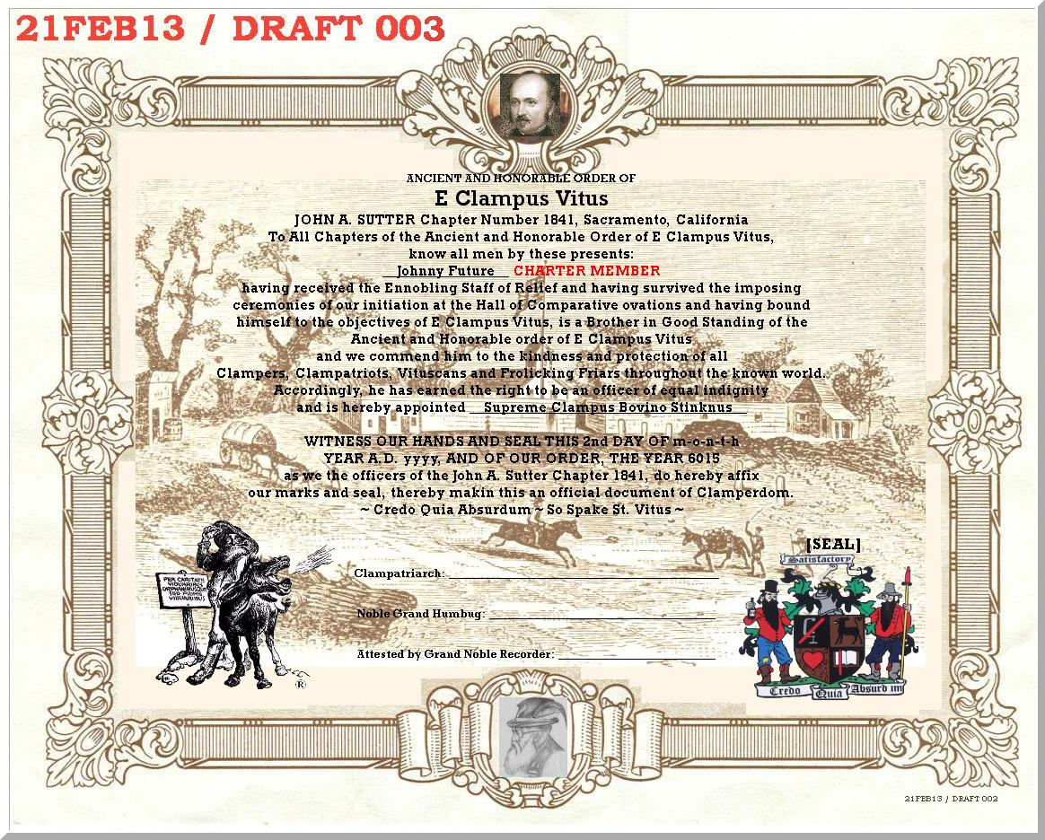

Detail of seal/date:
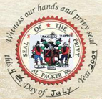

Also, consider Sutter’s Fort for background on the traveling card...
ATTACHMENT “C” – Traveling Card preliminary

Probably replace these images with “face” pictures...

 | 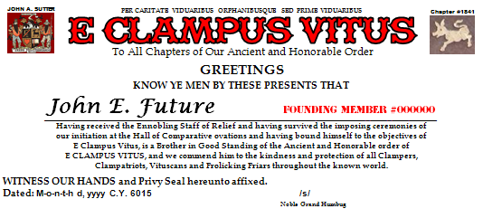
  Name: _______________________
  Phone: _______________________
  Street: _______________________
  City/Zip: _______________________
  email: _______________________
  FOUNDING
  MEMBER
  #000000
 | 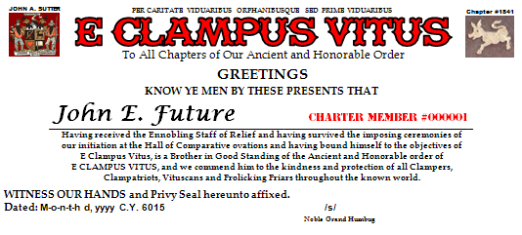
  Name: _______________________
  Phone: _______________________
  Street: _______________________
  City/Zip: _______________________
  email: _______________________
  CHARTER
  MEMBER
  #000001
 | 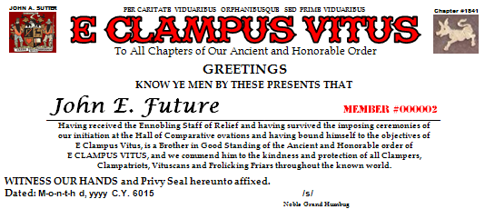
  Name: _______________________
  Phone: _______________________
  Street: _______________________
  City/Zip: _______________________
  email: _______________________
  MEMBER
  #000002

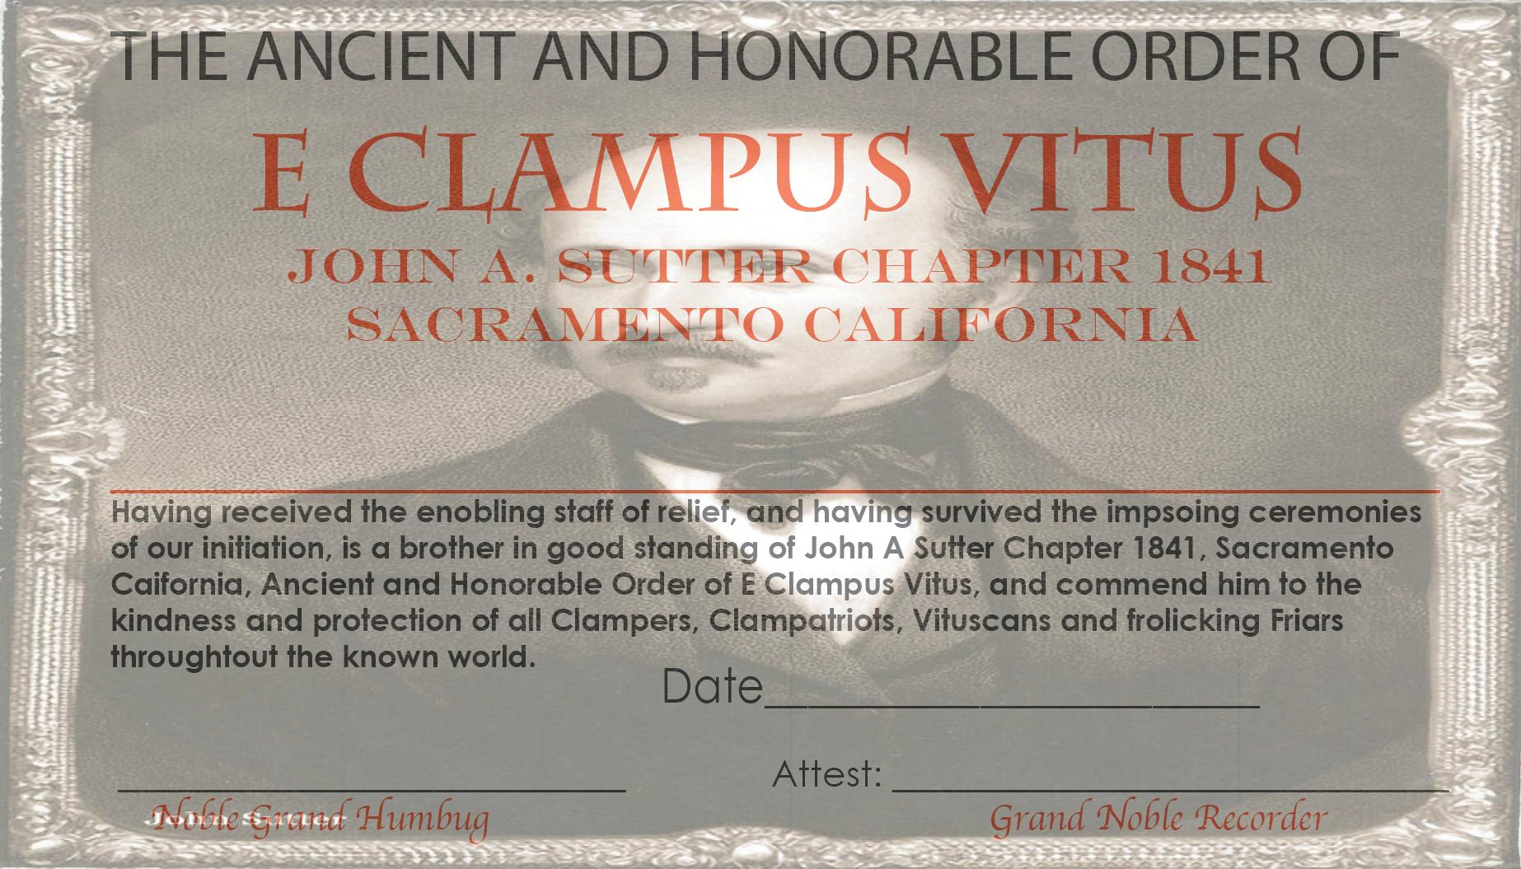

ATTACHMENT “H” –
ATTACHMENT “I” – Charter Doins Flyer

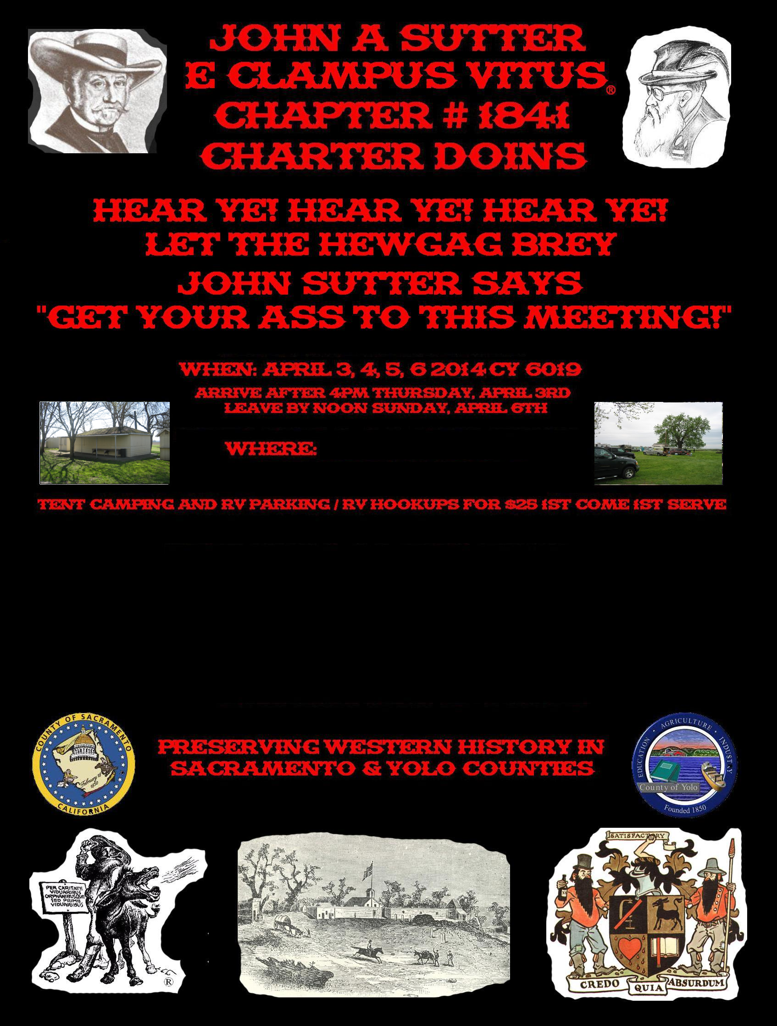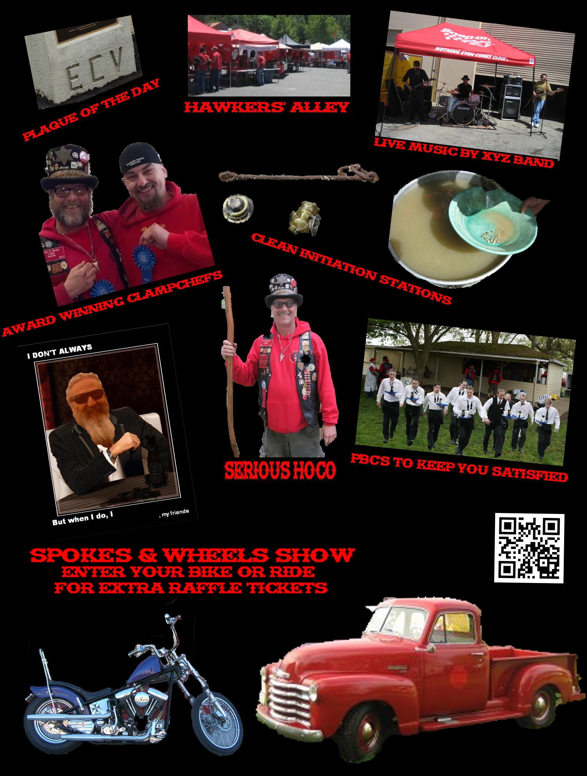

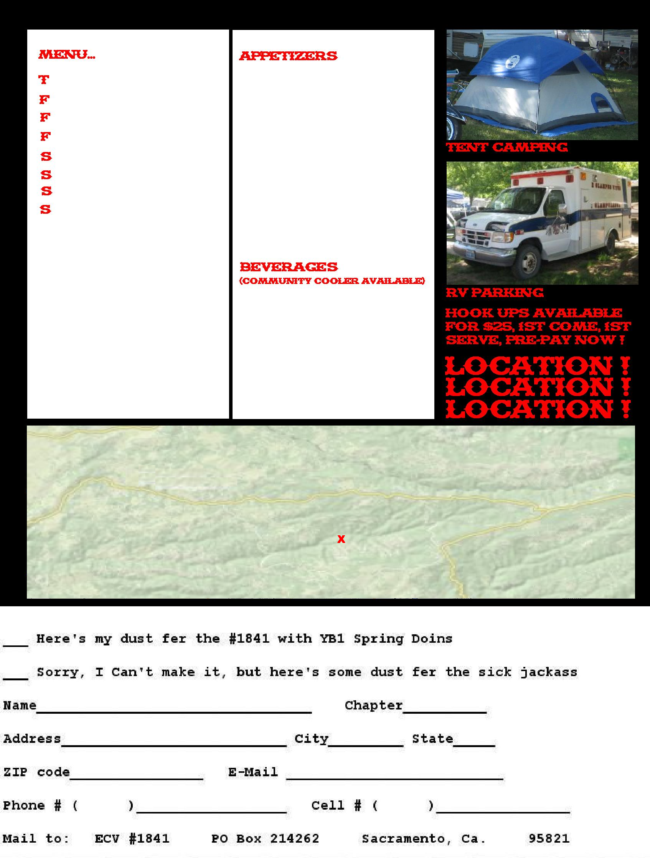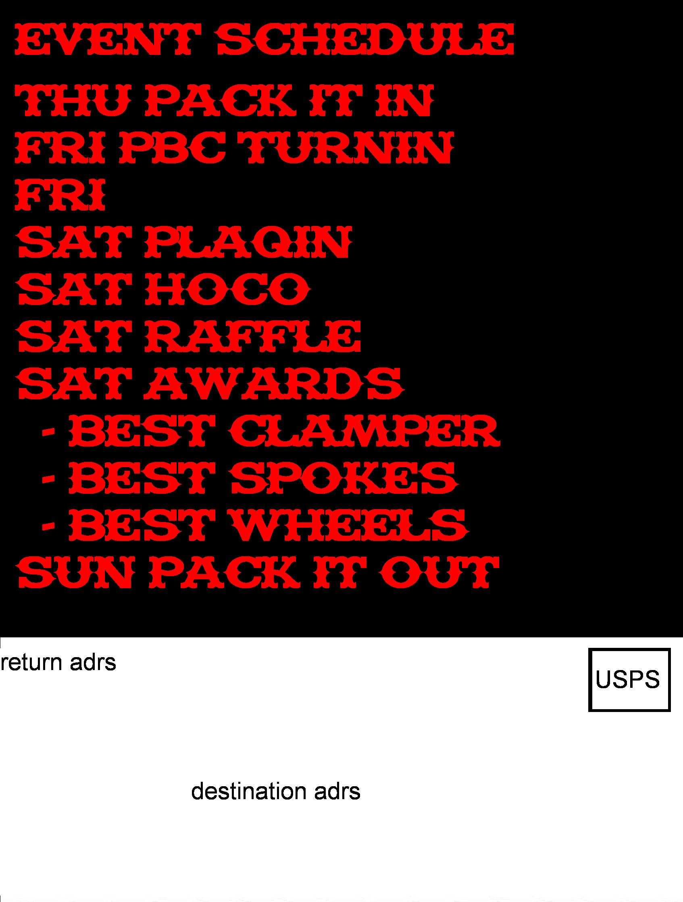
ATTACHMENT “J” – Business Cards

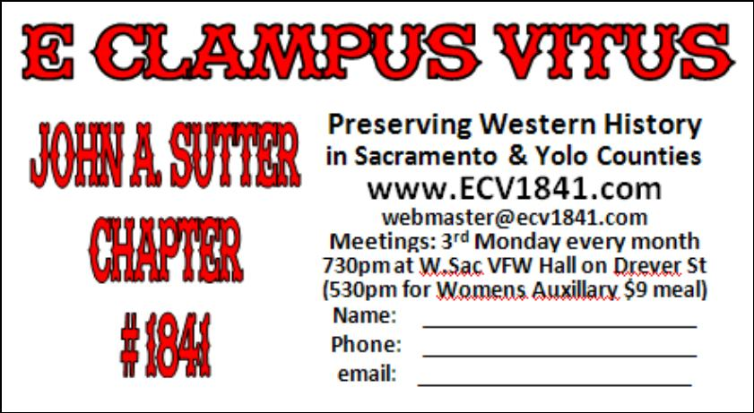

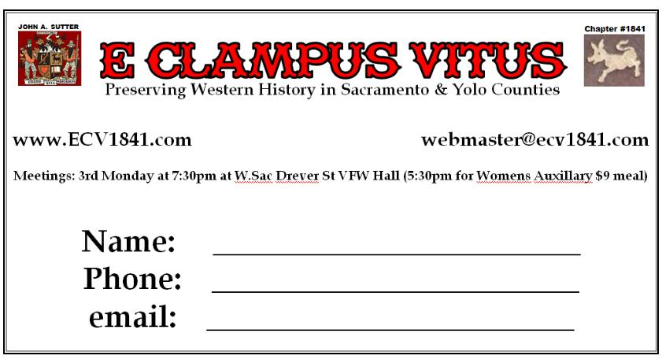

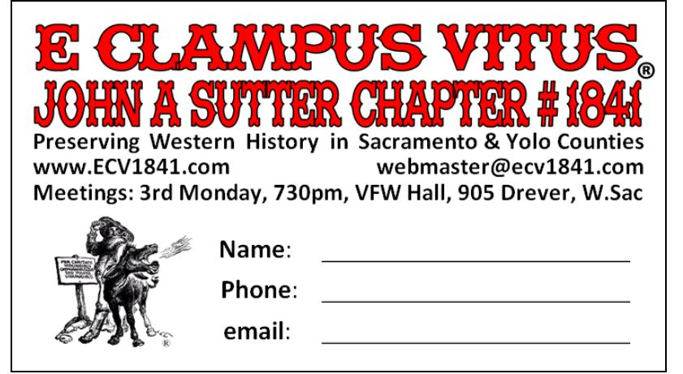

ATTACHMENT “K” – Charter Doins T-Shirts

Quantity | Front | &Back | w/Pocket | Total |  | Notes:
24-47 | 7.00 | 2.00 | 4.00 | 13.00
43-71 | 6.00 | 1.50 | 4.00 | 11.50 |  | w/oPocket
72-95 | 5.50 | 1.25 | 4.00 | 10.75 |  | +$2 instead of +$4
96-143 | 5.00 | 1.00 | 4.00 | 10.00
144-191 | 4.75 | 0.89 | 4.00 | 9.64 |  | w/Pocket
192-288 | 4.50 | 0.75 | 4.00 | 9.25 |  | might be +$3.50
289-575 | 4.25 | 0.60 | 4.00 | 8.85
576+ | 4.00 | 0.50 | 4.00 | 8.50 |  | 6# 100% cotton pre-shrunk

Ideas for the front, back:

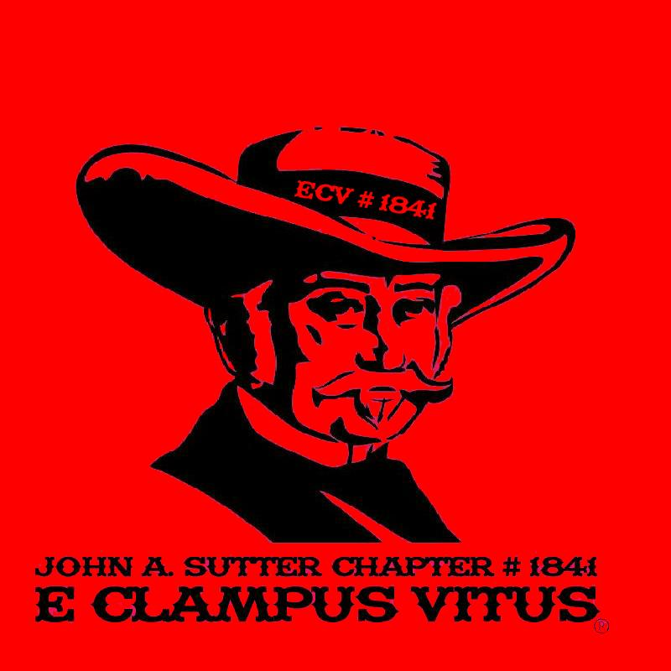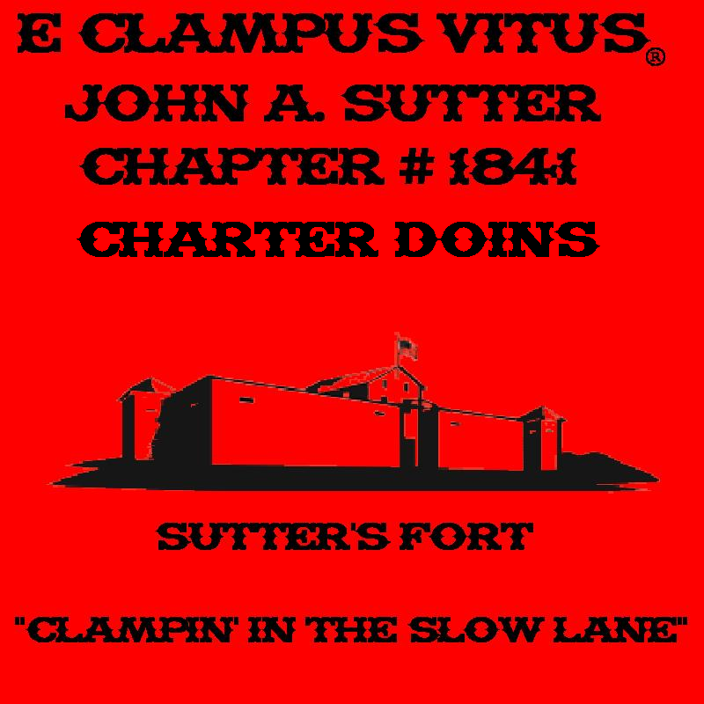

Ideas for the back:


