John A. Sutter Chapter #1841

Monthly Board Meeting Agenda, Meeting Date: 05AUG13

Call to Order: s/b at or about 6:30pm

Roll Call of Board Members:
P = Present, A = Absent, X = Xcused absence
___ NGH Russell "Christ" Holder
___ VNGH Gary “Everready” Karl
___ GNR Bob Farrell
___ GDR Dean Hupp
___ Hangman Kevin "Stinky" Jenkins
___ Damn Fool Doorkeeper Kieth "Hardshell" Kinne
___ Board Member at Large Fred "Mr Magoo" Willcox
___ Board Member at Large David "Dirty Dave" Barnett (2nd Hangman)
___ Board Member at Large Paul "Sparks" Laue
___ Graybeard Gary “Everready” Karl
___ Graybeard Mike “Gunshot” Young
___ Graybeard Bob "Iron Horse" Stevenson
Roll Call of Non-Board Members:
P = Present, A = Absent, X = Xcused absence
___ 2nd GDR Dan McCarthy *** TALK TO DAN ***
___ 2nd Damn Fool Doorkeeper Dave “Dave the Dick” Andre

NGH Report:
- Penny was 1st in class, new class schedule is on Tuesday nights
- ...
VNGH Report:
- Everready...

GNR Report:

- Bob...
GDR Report:

- Dean...

Hangman Report:

Damn Fool Doorkeeper Report:

Appointed Reports:

Website Report: ecv1841.com is current...

Hawker Report: none given.

Historian Report:

2nd GDR Report:

2nd Damn Fool Doorkeeper Report:

Raffleman Report:

Grub Boss Report:

Photographer Report:

Monthly Board Meeting Agenda Continued, Meeting Date: ____________

Committee Reports:
- Organizational Chart - handout (orgChart130525rl.pdf), see Attachment G
- NOTE: in addition to attending board/general meetings, Committee Chairmen are expected to meet/communicate as needed with committee members in order to accomplish work in progress, and, report status at board/general meetings.

Financial Committee Report:
- Current Chairman: Dean Hupp
- Committee Member(s): Dan McCarthy, Gene Breeland
- NGH: collect all financial documentation for the accountant
- NGH: Dean in order to be sure you and the accountant are “on the same page,” here it the accountant’s the contact information – pls contact the accountant to arrange a time to meet and discuss general ledger entries.
- NGH: account is making progress...
- NGH: give missing info to GaryK...

Plaque committee Report:
- Current Chairman: Kevin Jenkins
- NGH: what plaque(s) is/are planned for this year...

Historian Committee Report:
Current Chairman: Fred Willcox
Committee Member(s): Gene Breeland
NGH: do you have/need/want other committee members

Hawker/Raffle Committee Report:
Current Chairman: Paul Laue
Committee Member(s): Gary Klinke, Jack Vinsant

Parade Committee Report:
Current Chairman: Fred Willcox
Committee Member(s): Gary "Colonel Klink" Klinke
NGH: do you have/need/want other committee members

Security Committee Report:
Current Chairman: Kieth "Hardshell" Kinne
Committee Member(s): Dave Andre, Dean Hupp, Derrick DeAnda, Marty Padilla

Other committee(s)...

Old Business: Brother ______ “______” ______ reported
- Liberty Cemetery flag pole project
- Letter: see attachment E, FYI
- 20JUN13: emailed letter to 69 Humbug
- 17JUL13: Dave Hamilton asked for a copy of the letter...
- No reply from 69 Humbug to date...
- JAS1841 / JWM49 2nd Annual "Rolling Thunder Poker Run to the WOCO"... 14SEP13... Sacramento - Plymouth - Murphys
- Met w/49, 49 doing BBQ, Floyd is onboard!
- Poker run route – Dean? +Plymouth/Fiddletown/Pioneer/RailroadFlat/Murphys
- Flyer – Rusl...
- Baachez, Dean... got baachez??? ... see Attachment F;
- Business Cards –$43/1000 eVistaPrint or print locally, my recommendation is to bribe Gunshot to print them... how many???... my recommendation is 3rd option; see attachment J
- Officer Duties... DO NOT have electronic signatures from...
___ VNGH Gary “Everready” Karl
___ 2nd GDR Dan McCarthy
___ Hangman Kevin "Stinky" Jenkins
___ Graybeard Bob "Iron Horse" Stevenson

Monthly Board Meeting Agenda Continued, Meeting Date: ____________

New Business: Brother ______ “______” ______ reported
- Fall Doins
- Type: overnighter
- Location: Portuguese Hall – Gary... still good to go... right???
- Date: Fri,Sat,Sun/09,10,11AUG13
- Flyer printing/mailing: done
- Flyer adrs labels: done
- Facilities
- - electricity, table, and 4 chairs for tattoo... who can guarantee???
- - LARGE tent (in case of rain)...do we care???...who can guarantee???
- - ...what else???
- Food/Cook, Chairman: Gary "Everready" Karl
- - Menu good to go???
- - Steaks good to go???
- - ...what else???
- Initiation
- - Work project: weeding, cleaning, painting, ...???
- - Artifact ID, gold panning, rocky road to Dublin, ...???
- - ...
- - ...
- HOCO Black Robes - who will take this on
- - (10/13people:robes90/117'/rope60/78')
- - someone said “borrow from someone” ...whutz up???
- HOCO update/readers
- - HUMBUG: The Noble Grand Humbug - Christ
- - CLAMPAT: The Clampatriarch – Everready - Ironhorse
- - RECORDER: The Grand Noble Recorder - Popeye - _______________
- - HANGMAN: The Grand Imperturbable Hangman - Stinky
- - MUSICIAN: The Grand Musician - Klinky
- - ISCUTIS: The Roisterous Iscutis - Sparks
- - PLATRIX: The Royal Platrix - Mr.Clean – Dan McCarthy (will you...)
- - PETRIX: The Clamps Petrix - Dave-the-Dick (Humbugery)
- - MATRIX: The Clamps Matrix - Mr.Magoo (widows yet unwon)
- - VITRIX: The Clamps Vitrix - Ironhorse – Dave Barnett (Californification)
- Signage, Chairman: Kevin "Stinky" Jenkins
- - Bob Farrell...
- Hawker/Raffle, Chairman: Paul Laue
- - Rusl: smoked samon / wadkuh...
- - ...
- Publication
- - adrs lables - done
- - stamps/mailed - done
- - facebook... Kevin? DaveB? DaveA? BobF? do this now???
- Halloween Bash
- Location: VFW Hall
- Date: Sat/26OCT13
- RSVP: ***
- FLYER: *** want ready by when?
- RUB: $20/person
- Entertainment: book ASAP...
- Committees:

Monthly Board Meeting Agenda Continued, Meeting Date: ____________

Charter Doins Committes:
Location, Chairman: NGH (Russell "Christ" Holder)
Committee Member(s): Gary Karl, Bob Stevenson, Dave Young
- Location is satisfactory
Facilities, Chairman: Mike "Gunshot" Young
Committee Member(s): Walter Hales
- Pavillion at chosen location...
- On-site/off-site refrigeration
- LARGE tent (in case of rain)
- 1841 BBQ, IOOF BBQ, SFD BBQ on trailer
- Gary 2-burner, Floyd 2-burner, 49 cook gear???
- Who will contact YB1? 49?
Food/Cook, Chairman: Gary "Everready" Karl
Committee Member(s): Bob Farrell, Dean Hupp, Ben Peccaianti
- Lets discuss the menu provided in attachment “A”

- What ideas for menu items?
Initiation, Chairman: Kevin "Stinky" Jenkins
Committee Member(s): Dave Barnett, Derrick DeAnda
- Work project: weeding, cleaning, depending on site...
- Artifact ID, gold panning, rocky road to Dublin
- Bowling ball station from LSD3?
- ... station from YB1?... from 49?
- ... other station ideas...
- Black Robes – who will take this on (10/13people:robes90/117’/rope60/78’)
- HOCO update/readers:
- - HUMBUG: The Noble Grand Humbug - Christ
- - CLAMPAT: The Clampatriarch – Everready - Ironhorse
- - RECORDER: The Grand Noble Recorder - Popeye - _______________
- - HANGMAN: The Grand Imperturbable Hangman - Stinky
- - MUSICIAN: The Grand Musician - Klinky
- - ISCUTIS: The Roisterous Iscutis - Sparks
- - PLATRIX: The Royal Platrix - Mr.Clean – Dan McCarthy (will you...)
- - PETRIX: The Clamps Petrix - Dave-the-Dick (Humbugery)
- - MATRIX: The Clamps Matrix - Mr.Magoo (widows yet unwon)
- - VITRIX: The Clamps Vitrix - Ironhorse – Dave Barnett (Californification)
Signage, Chairman: Kevin "Stinky" Jenkins
Committee Member(s): Dave Andre
Entertainment, Chairman: Mike “Gunshot” Young
Committee Member(s): Dave Barnett, Derrick DeAnda
- Rubber Band
- The “Mystery Tent”
- What else for entertainment?
Hawker/Raffle, Chairman: Paul Laue
Committee Member(s): Gary "Colonel Klink" Klinke, Jack Vinsant
- What BIG TICKET ITEM for the raffle?
- What t-shirt ideas are there? - see attachment “K”
Publication, Chairman: Russell "Christ" Holder
Committee Member(s): Gary Karl,
- Preliminary flyer - see attachment “I”
- Flyer prepare for mailing by: when??? New Years Day??? Valentines day???
- $75, $100PBC, $120retreand before Halloween
- $85, $110PBC, $130retreand before Valentines Day
- $95, $120PBC, $140retreand day of
- Pre-paid Sign-in: check off, give sheepskin & traveling card, give T-shirt voucher
- Sign-in: LEDGIBLE, prepare/give sheepskin & traveling card, give T-shirt voucher
- Sheepskins: FOUNDING/CHARTER/MEMBER drafts provided in attachment “B”
- Traveling Card: FOUNDING/CHARTER/MEMBER drafts provided in attachment “C”
- Sheepskin tubes from USPO, who gets them?>>>_
- Extra mtg,not mandatory:review Officers Responsibilities,HOCO,etc:__ __
- DIGRESSION: Dean... publishing?...
Libation, Chairman: Dean Hupp
Committee Member(s): Gary "Colonel Klink" Klinke, Jack Vinsant
- ____ - keg cooling
- Rusl – contact Mid-Cal Cycle re their beer trike attachment “H”
Neighboring Chapters Committee, Chairman______, Committee Member(s):_____,_____
- Which chapters?... YB1, 49, 69, Sam Brannon, Chief Truckee, . . .
- What types of support do we want to solicit?

Good of the Order:
- NGH: 50/50/50/50 – who wants a ticket ? ? ?
- NGH: Paul... your on...

Adjourn Meeting

- NGH: I would entertain a motion to adjourn...

KNUCKLEHEADS FOREVER!

ATTACHMENT “A” – Charter Doins Menu

What other meat dishes should be considered?
What other “green” dishes should be considered?
What other starches should be considered?
What other deserts should be considered?
What other munchies should be considered?

What other chapters help when? All together or individual meal or...

Thu-Bkfst
Thu-brunch
Thu-Lunch
Thu-linner - chips & dip
Thu-Dinner - meat loaf,green beans,macaroni salad,bread
Thu-desert - banana cream pie
Fri-Bkfst - sweetrolls,bananas,OJ,coffee
Fri-brunch - oatmeal cookies, apples
Fri-Lunch - foot long submarine sammiches
Fri-linner - chips & dip
Fri-Dinner - steak,green salad,corn on the cob,bread
Fri-desert - cupcakes & icecream
Sat-Bkfst - eggs,bacon,pancakes,OJ,coffee
Sat-brunch - hard boiled eggs, oranges
Sat-Lunch - mustard dogs, chili dogs, Polish dogs, Krout dogs
Sat-linner - crackers,salomi,cheeze
Sat-Dinner - PIG,potatoe salad,cowboy beans,bread
Sat-desert - cake & icecream
Sun-Bkfst - eggs,sausage,biscuits,gravey,OJ,coffee
Sun-brunch
Sun-Lunch
Sun-linner
Sun-Dinner
Sun-desert

ATTACHMENT “B” – Sheepskin preliminary

Need place for Date: ________
Need other “face” pictures, but, here’s the idea...
Need rubber stamps: FOUNDING MEMBER, CHARTER MEMBER

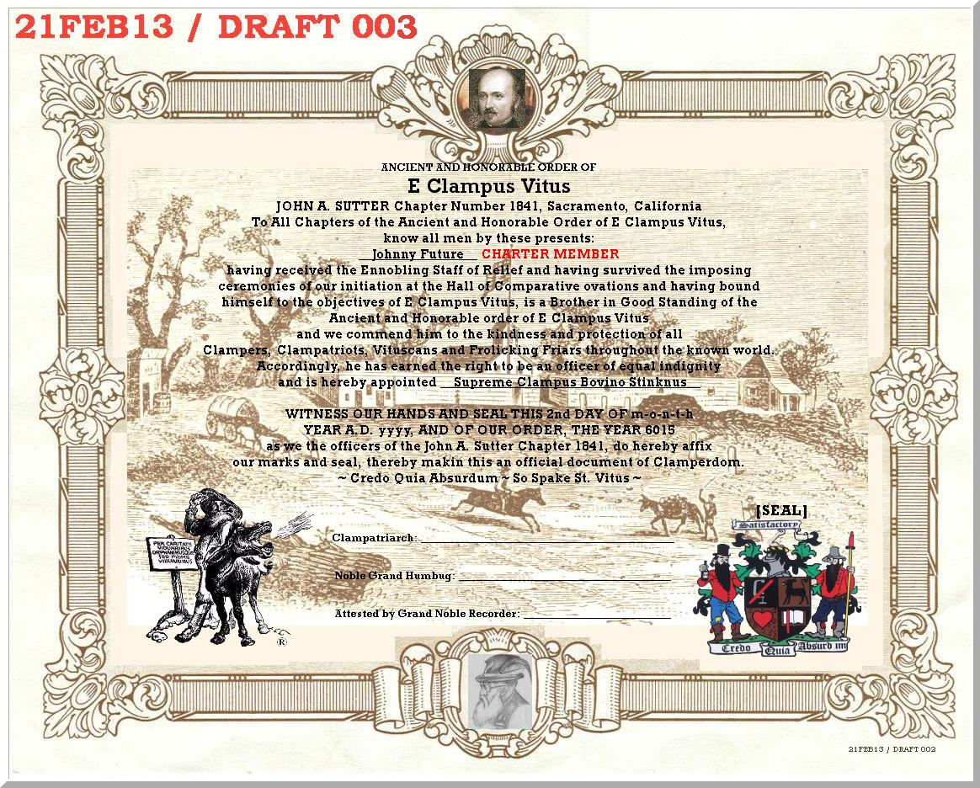

Detail of seal/date:
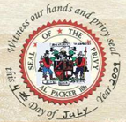

Also, consider Sutter’s Fort for background on the traveling card...
ATTACHMENT “C” – Traveling Card preliminary

Probably replace these images with “face” pictures...

 | 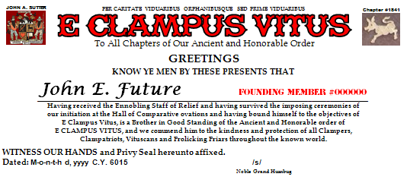
  Name: _______________________
  Phone: _______________________
  Street: _______________________
  City/Zip: _______________________
  email: _______________________
  FOUNDING
  MEMBER
  #000000
 | 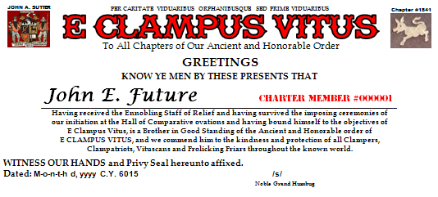
  Name: _______________________
  Phone: _______________________
  Street: _______________________
  City/Zip: _______________________
  email: _______________________
  CHARTER
  MEMBER
  #000001
 | 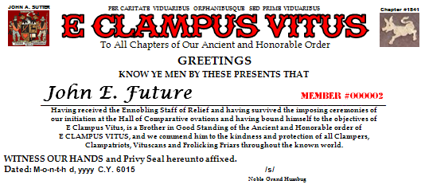
  Name: _______________________
  Phone: _______________________
  Street: _______________________
  City/Zip: _______________________
  email: _______________________
  MEMBER
  #000002

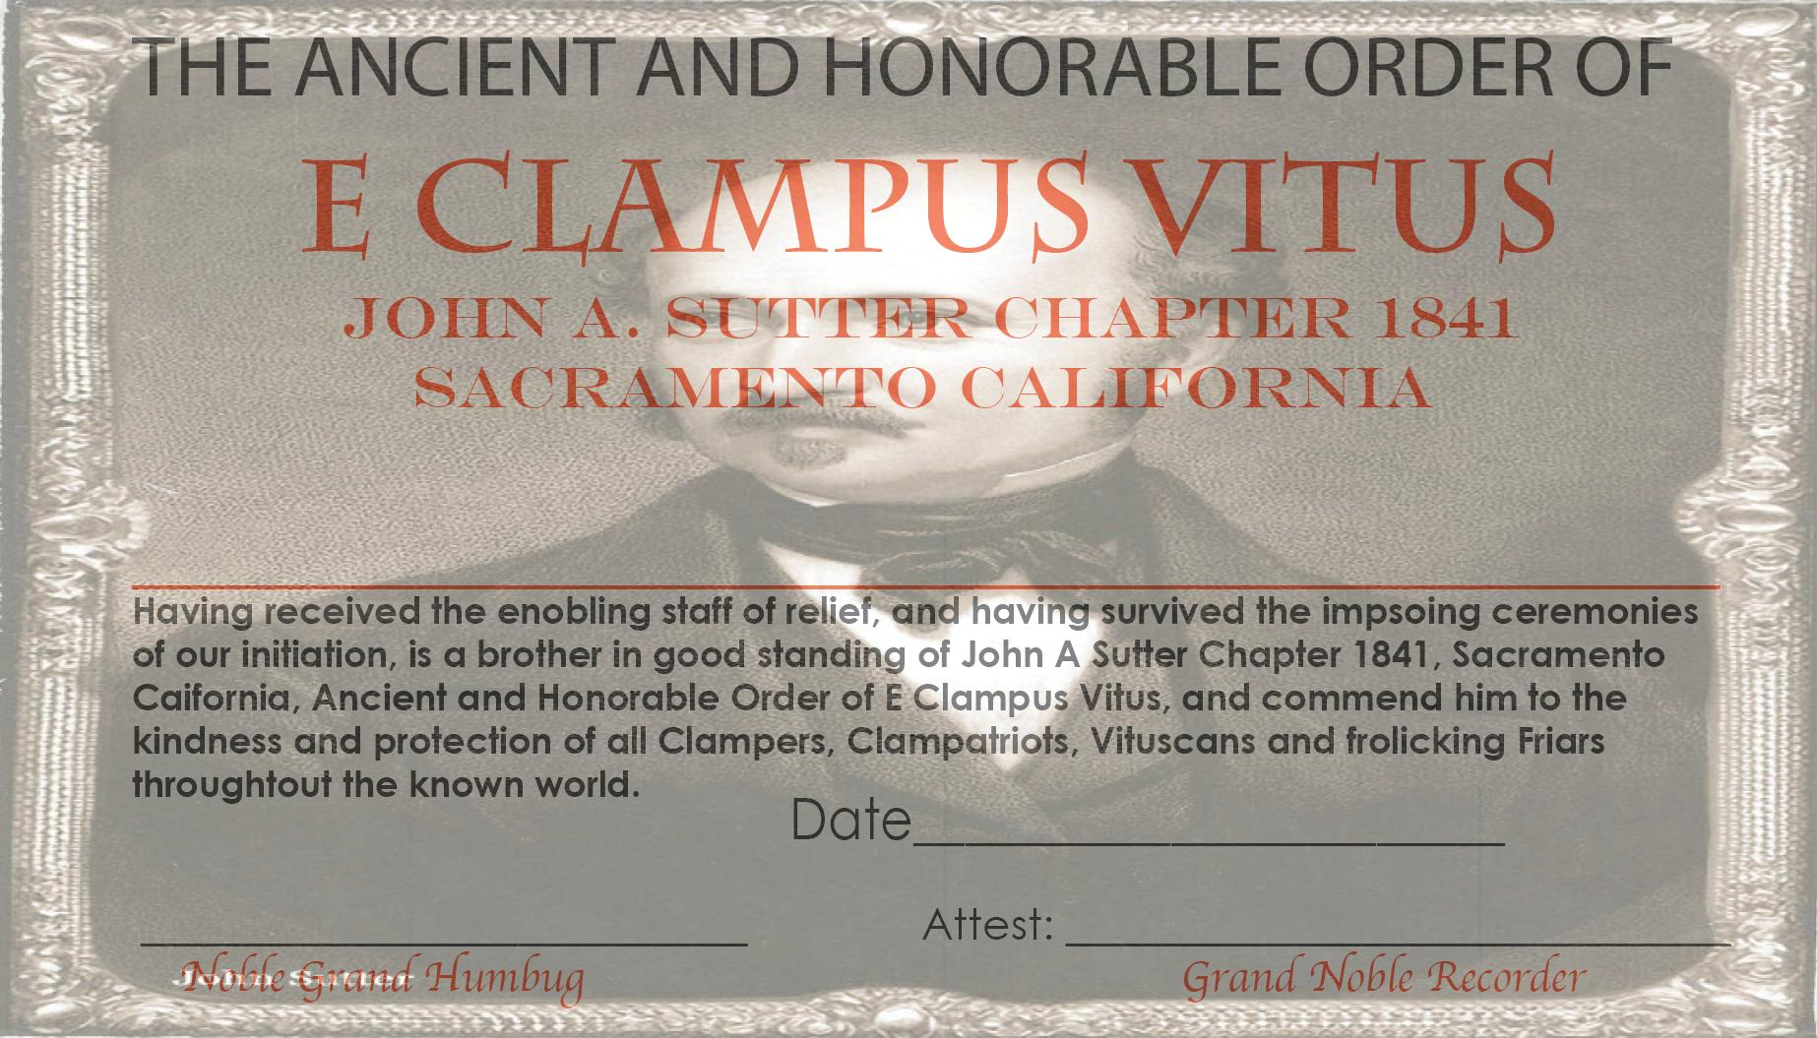

ATTACHMENT “E” – Liberty Cemetery Flag Pole Project, FYI
-------- Original Message --------
Subject: | ECV1841: Liberty Cemetery Flag Pole Project and...
Date: | Thu, 20 Jun 2013 09:17:20 -0700
From: | Russell Holder <russellholder@earthlink.net>
Reply-To: | russellholder@earthlink.net
To: | o0bigdawg0o@gmail.com
CC: | Gary Karl - home <Clamperman@rocketmail.com>, Mike Young <Mike_R_Young@yahoo.com>, Bob Stevenson <ironhorseECV3@hotmail.com>

Howdy Dawg,

Concerning the Liberty Cemetery Flag Pole Project, it was indicated that members of 69 wanted to meet with members of 1841 Saturday night at Grand Council, and, we were available for that evening, however, the circumstances were the circumstances and the meeting dint occur.

What is the Liberty Cemetery Flag Pole Project you ask? Some members of 1841 met with the caretaker of the Liberty Cemetery in August of 2012 and were moved by the concerns expressed by the caretaker regarding the vandalism that occurs by bay area raiders on Halloween night which includes the defacing of monuments and the digging up of those entered for the purpose of harvesting skulls, and, about the flag pole which is not substantial and needs to be relocated. The caretaker was promised a Halloween night watch and a new flagpole.

Time slipped away and the flag pole was not relocated by Halloween night, however, there was a contingency of concerned citizens who camped out at the cemetery on Halloween night, and, although most of those citizens are in fact red shirts, this was not a “red shirt event” and so there was no ECV attire or other ECV signage. This contingency was visited by the sheriff, who had been advised by the caretaker of the night watch contingency, and by four unknown citizens who claimed to be local folks who just like to walk around in a cemetery on Halloween night and read the writing on the monuments, and, whether the Liberty Cemetery was on the bay area raiders’ agenda for that Halloween night or not, the cemetery remained undisturbed that Halloween.
More time slipped away, and, although Dave Hamilton requested we delay the project until after he became Noble Grand Humbug in October 2013, we still felt that this easy flag pole relocation project should have been completed already and planned to have it completed by the 12th of July 2014 - it would have been in the location specified by the caretaker, at an engineered depth demanded by the height, with a plaqueless concrete base (which may have had "ECV" embedded in the concrete) anchored sufficiently to withstand the forces of nature and discourage vandalism, with a “summer” flag and a “winter” flag which would be changed seasonally, and, with a solar powered light to illuminate the flag at night, and now, the flagpole has still not yet been relocated and I am sad to report... well... read on...

Those of us Clampers who gave the caretaker our word to provide a flagpole according to the caretaker’s description/requirements are men of honor and our word is our bond, and, we believe that you and the 69 Brothers are men of honor and likewise your word is your bond, and, furthermore, we believe that because the 1841 Brothers and the 69 Brothers are all brothers and men of honor and likewise our word is our bond, therefore, upon further consternation, consideration and discussion, which included recalling that the $2 soft boundary trespass agreement has been resended, we do therefore pass to you honorable 69 Brothers the task promised to the caretaker by the 1841 Brothers because the 69 Brothers are honorable men of their word and on the grand scheme of things are therefore bound by the word given by their Brothers who are men of their word.

We do, at this time, want to take this opportunity to ask for your pardon for passing to the 69 Brothers the task promised to the caretaker, whose contact information is available if you need it, and, ask that you and your fellow 69 Brothers bear no hard feelings because the caretaker expected a flagpole LAST SUMMER and now you will be bearing the responsibility of keeping our word and hopefully you will complete this project in a more timely manner than we did not.

Likewise we pass the Halloween night watch to you for the same reasons as stated above with our sincere apology for obligating you for a task you may not have been of a mind to take on, but, it is a worthy effort, so hopefully there will be no hard feelings on this matter either.

So let it be written, so let it be done.

Satisfactory,
Russell “Christ” Holder
Chapter #1841 NGH
KF!
ATTACHMENT “F” – Baachez for 1841 Officers

John A. Sutter
Chapter # 1841
Nobel Grand Humbug
John A. Sutter
Chapter # 1841
Vice Nobel Grand Humbug
John A. Sutter
Chapter # 1841
Nobel Grand Recorder
John A. Sutter
Chapter # 1841
Gold Dust Receiver
John A. Sutter
Chapter # 1841
Hangman
John A. Sutter
Chapter # 1841
Damn Fool Doorkeeper
John A. Sutter
Chapter # 1841
Board Member
John A. Sutter
Chapter # 1841
Board Member
John A. Sutter
Chapter # 1841
Board Member

ATTACHMENT “G” – 1841 Organizational Chart
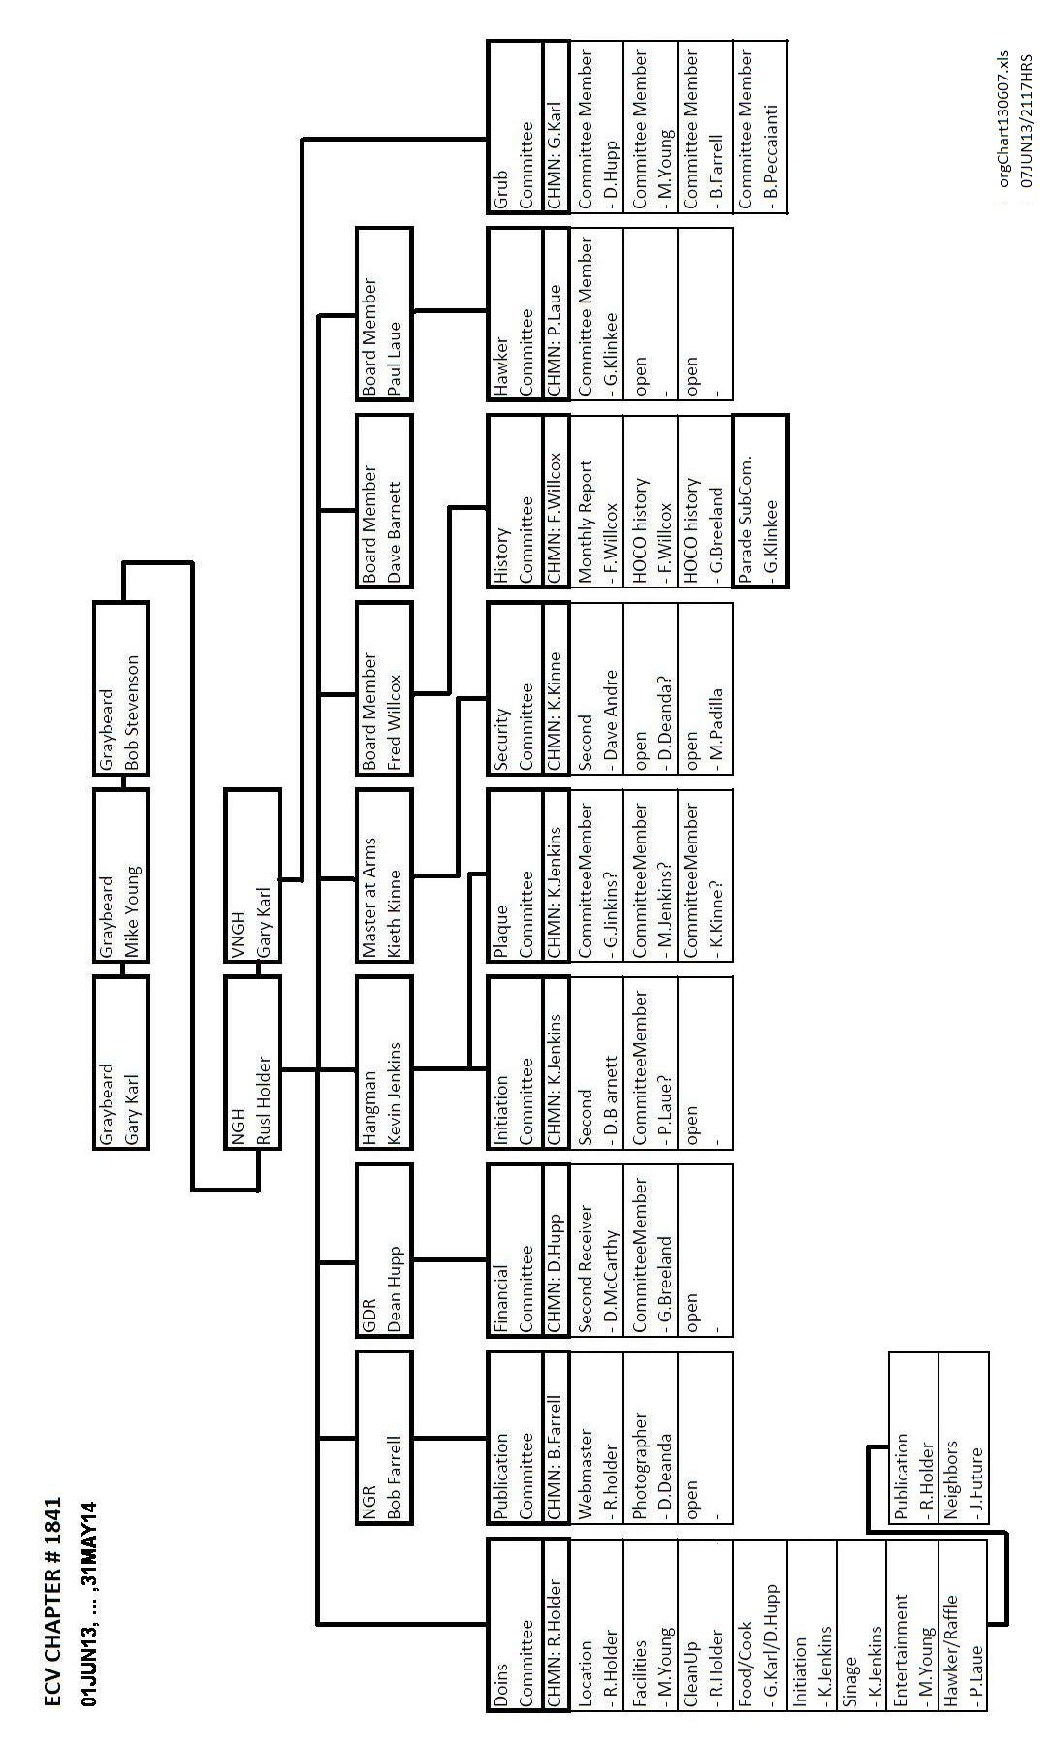
ATTACHMENT “H” –
ATTACHMENT “I” – Charter Doins Flyer

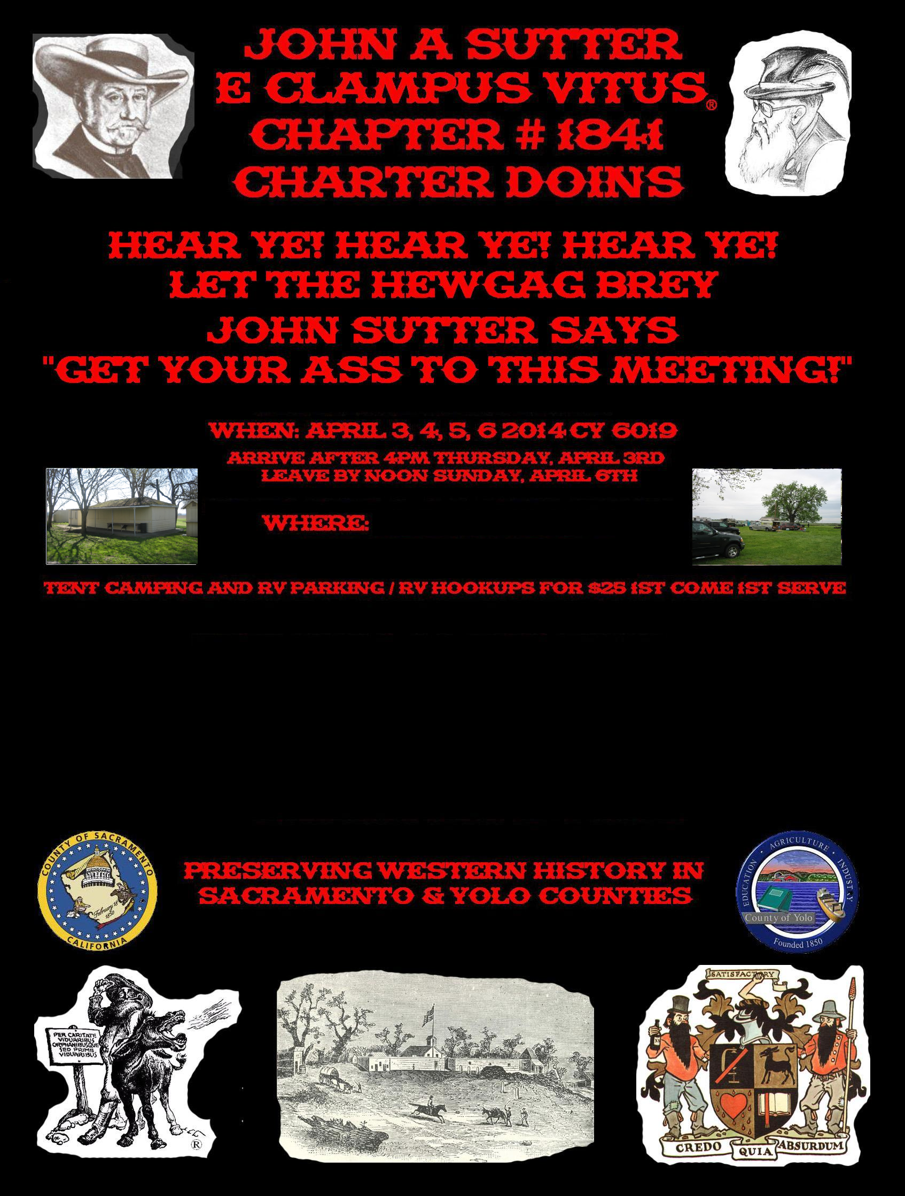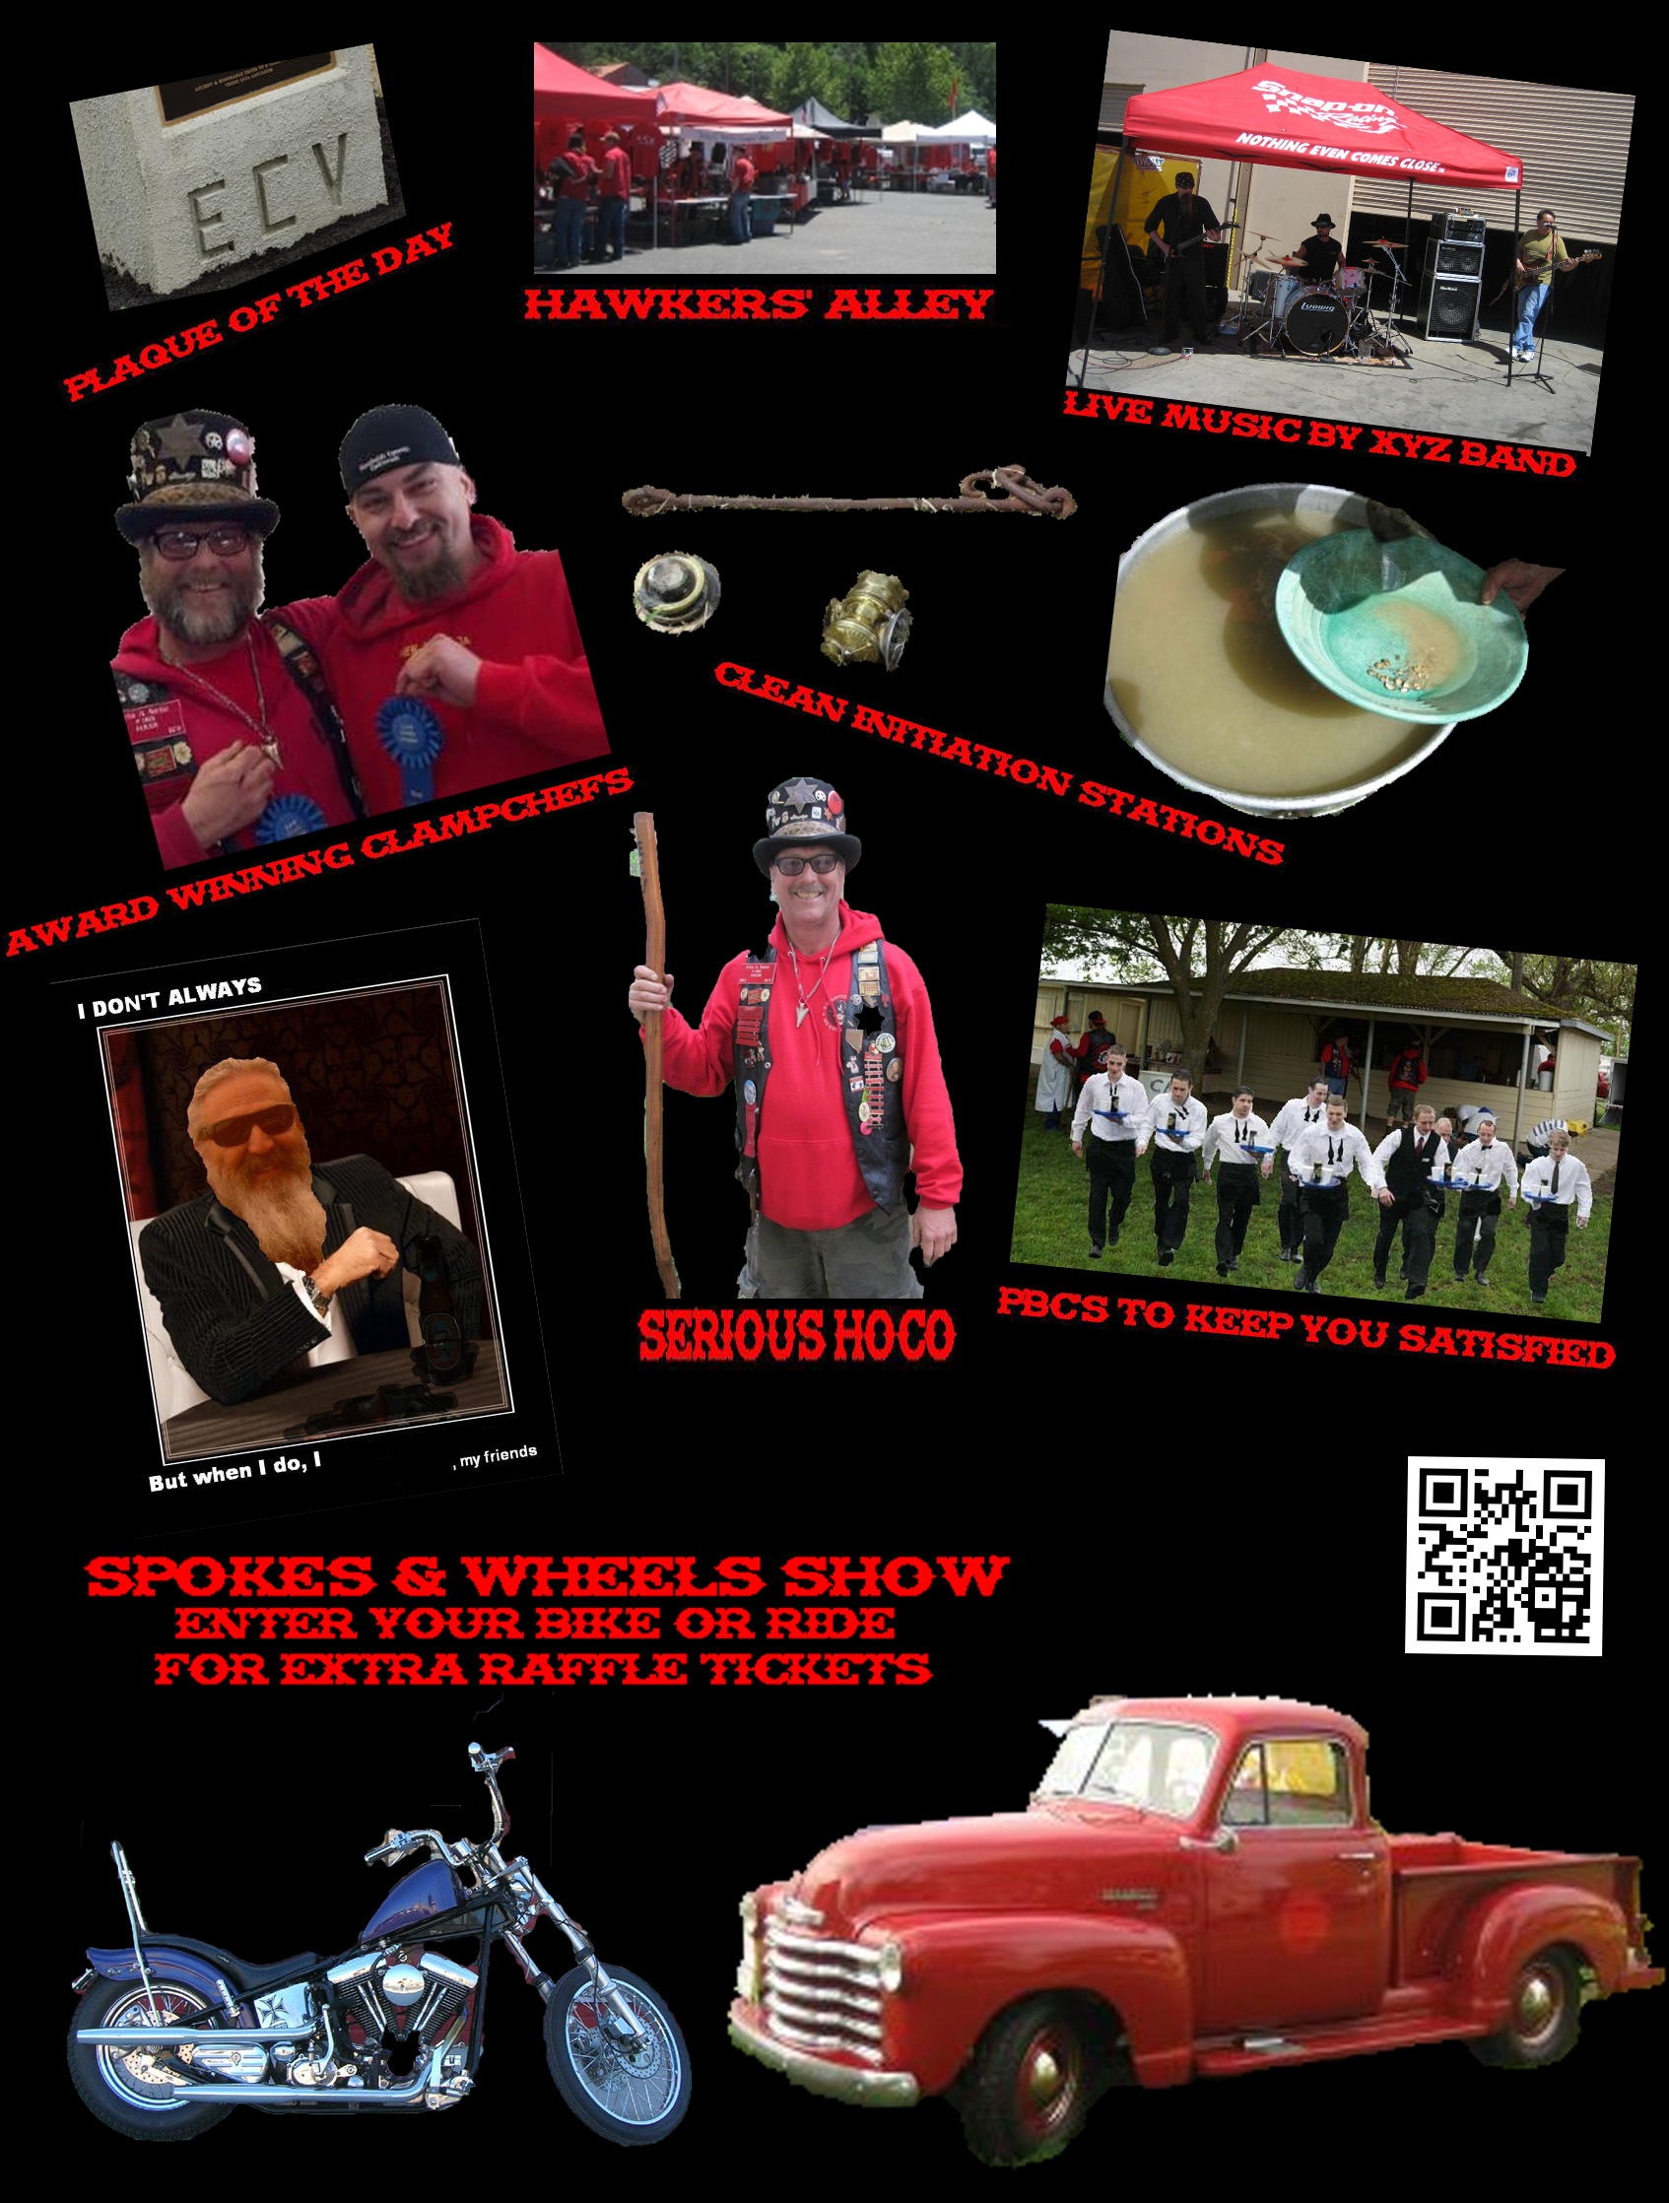

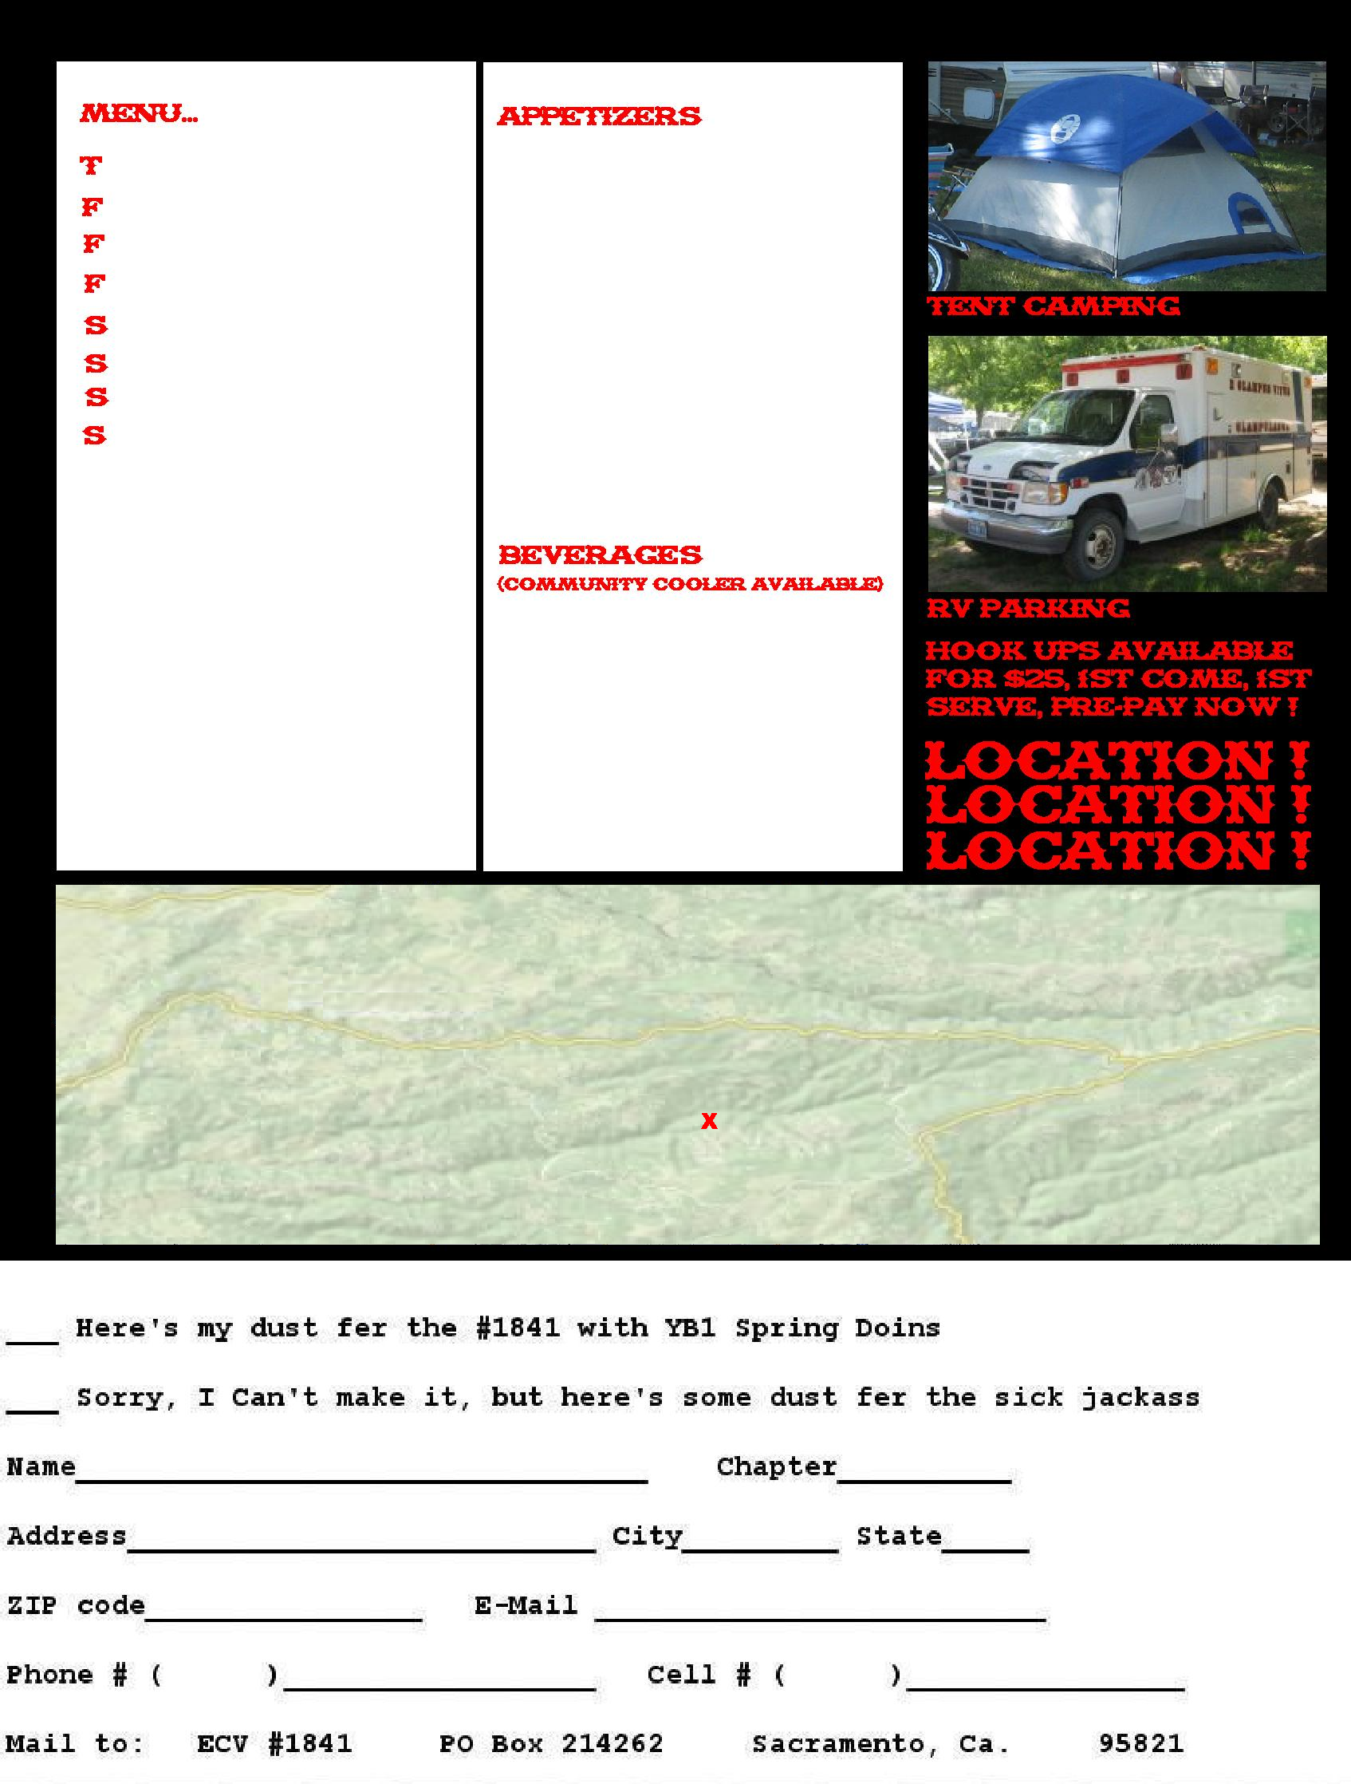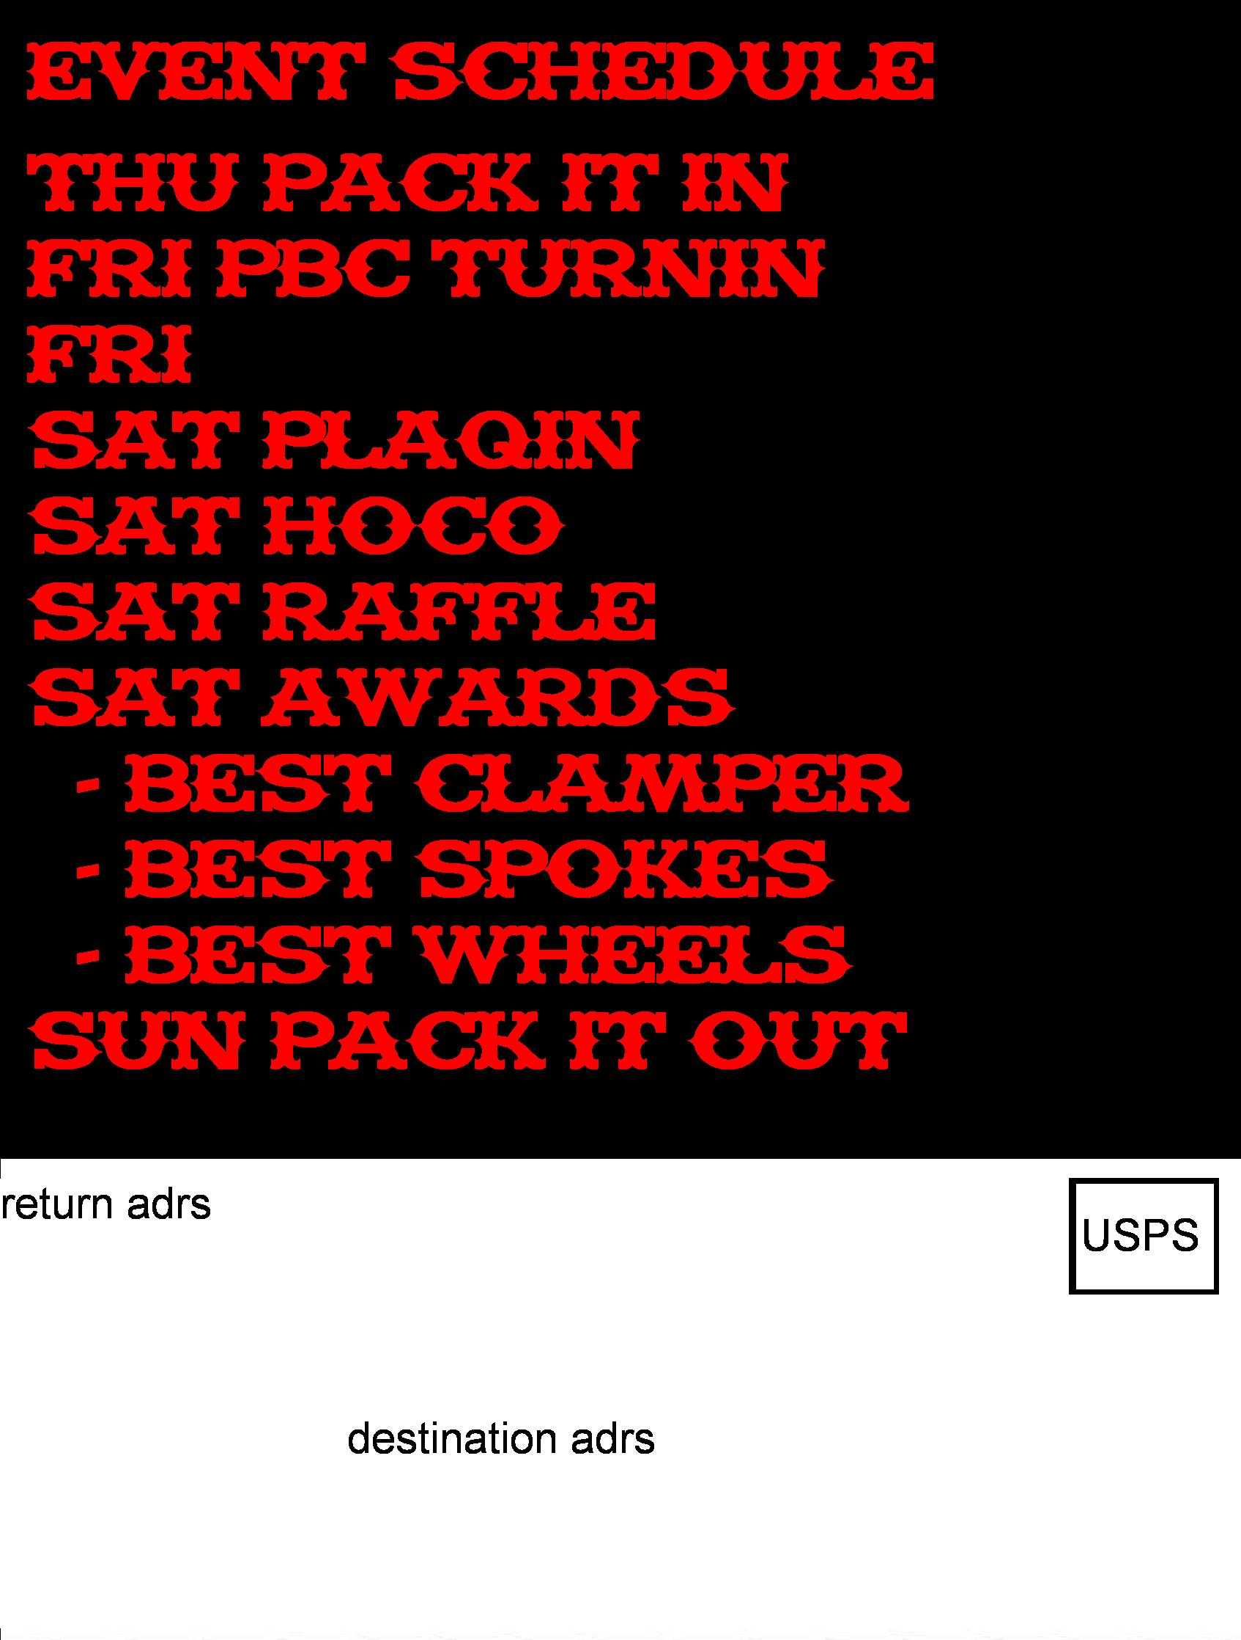
ATTACHMENT “J” – Business Cards

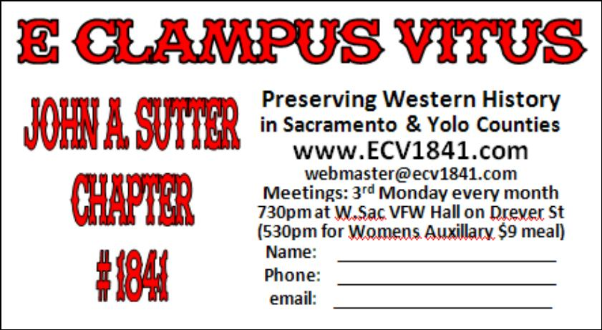

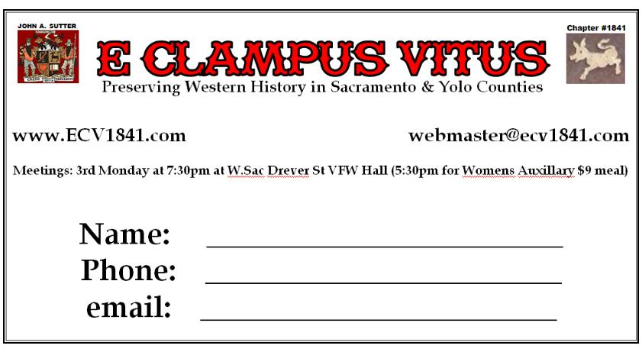

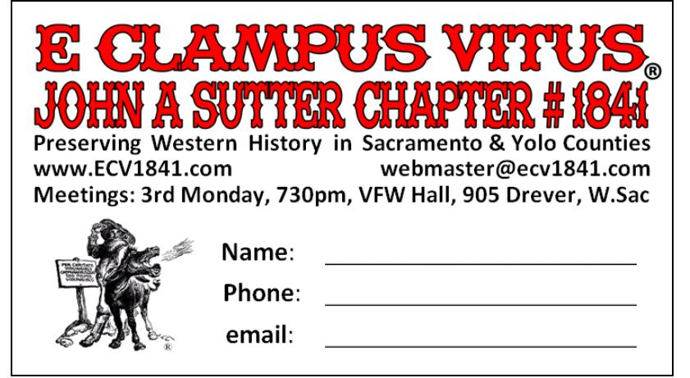

ATTACHMENT “K” – Charter Doins T-Shirts

Quantity | Front | &Back | w/Pocket | Total |  | Notes:
24-47 | 7.00 | 2.00 | 4.00 | 13.00
43-71 | 6.00 | 1.50 | 4.00 | 11.50 |  | w/oPocket
72-95 | 5.50 | 1.25 | 4.00 | 10.75 |  | +$2 instead of +$4
96-143 | 5.00 | 1.00 | 4.00 | 10.00
144-191 | 4.75 | 0.89 | 4.00 | 9.64 |  | w/Pocket
192-288 | 4.50 | 0.75 | 4.00 | 9.25 |  | might be +$3.50
289-575 | 4.25 | 0.60 | 4.00 | 8.85
576+ | 4.00 | 0.50 | 4.00 | 8.50 |  | 6# 100% cotton pre-shrunk

Ideas for the front, back:

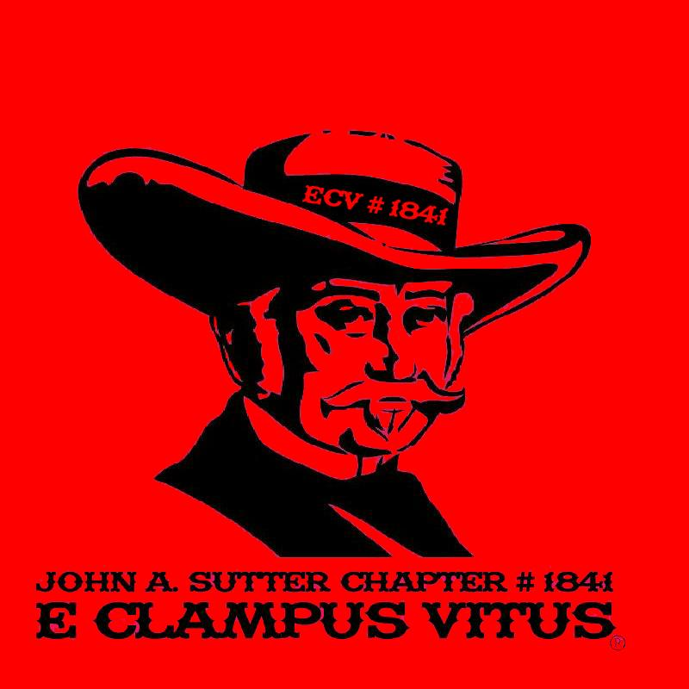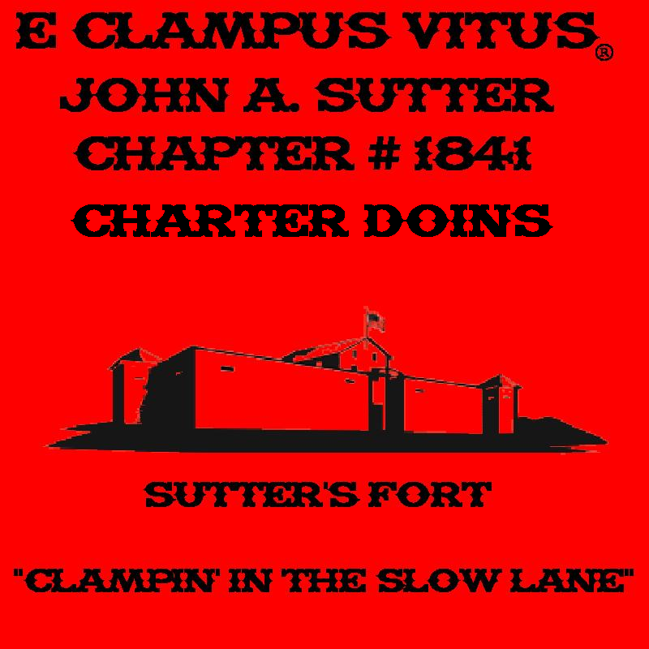

Ideas for the back:


